

**Faculty of Engineering & Technology**

**Electrical & Computer Engineering Department**

**Computer Networks – ENEE2360**

**Project Report**

**Prepared by:**

|  |  |  |
| --- | --- | --- |
| Name | ID | Section |
| Sara Al-lahaleh | 1211083 | 1 |
| Malak Ammar | 1211470 | 1 |
| Asmaa Fares | 1210084 | 3 |

**Instructor:** Ibrahim Nemer , Imad Tarteer

**Date**: 14/06/2024.

I

# Abstract

This project, focuses on designing and simulating a network using Cisco Packet Tracer. We developed a network topology featuring a core network with five routers and several subnetworks, including a data center and three company branches, ensuring efficient IP address allocation based on a student ID-derived scheme. The project involved configuring various devices, implementing OSPF routing, and conducting IP subnetting. We also captured and analyzed TCP, DHCP, and ICMP packets using Wireshark to gain insights into communication protocols. Extensive testing validated network connectivity, including accessing a custom website from different PCs. This project enhances practical networking skills and prepares us for real-world challenges.

**Table of Contents**

Table of Contents

Abstract 2

Table of figures 4

List of Tables 6

Part 1: Wireshark 7

Part 2: Packet Tracer 14

Part 2.0: IP Subnetting & Assignment 14

Part 2.1: Topology 18

Part 2.2: Configuring Servers 33

Part 2.3: Routing Protocols 36

Part 2.4: Testing & Troubleshooting 39

Conclusion 87

# Table of figures

*Figure 1:Topology (Network layout) 6*

*Figure 2:Topology with IPs 9*

*Figure 3:Router R1 configuration 10*

*Figure 4: Router R1 interface se2/0 configuration 11*

*Figure 5: Router R1 interface se3/0 configurationS 11*

*Figure 6: Router R2 configuration 12*

*Figure 7: Router R2 interface se3/0 configuration 13*

*Figure 8: Router R2 interface se2/0 configuration 13*

*Figure 9: Router R3 configuration 14*

*Figure 10: Router R3 interface se3/0 configuration 15*

*Figure 11: Router R3 interface se2/0 configuration 15*

*Figure 12: Router R4 office 1 configuration 16*

*Figure 13: Router R4 office 2 configuration 17*

*Figure 14: Router R4 interface se2/0 configuration 17*

*Figure 15: Router R4 interface se3/0 configuration 18*

*Figure 16: HTTP server configuration 19*

*Figure 17: DNS server configuration 20*

*Figure 18: Mail server configuration 21*

*Figure 19:PC 2_1 configuration 22*

*Figure 20:PC 2_2 configuration 22*

*Figure 21:PC 2_3 configuration 23*

*Figure 22:PC 3_1 configuration 24*

*Figure 23:PC 3_2 configuration 24*

*Figure 24: PC 41_1 configuration 25*

*Figure 25: PC 41_2 configuration 25*

*Figure 26: PC 41_3 configuration 26*

*Figure 27: PC 42_1 configuration 26*

*Figure 28: PC 42_2 configuration 27*

*Figure 29:configuring the HTTP server 28*

*Figure 30: the HTML code 30*

*Figure 31: configuring the DNS server for our domain 31*

*Figure 32: setting the users in the mail server 32*

*Figure 33: configuring OSPF for router 1 33*

*Figure 34: configuring OSPF for router 2 34*

*Figure 35: configuring OSPF for router 3 35*

*Figure 36: configuring OSPF for router 4 36*

*Figure 37 testing the ping command from pc2_1 39*

*Figure 38:8 testing the tracert command from pc2_1 41*

*Figure 39:testing the ping command from pc2_2 43*

*Figure 40: testing the tracert command from pc2_2 45*

*Figure 48: testing the tracert command from pc41_1 59*

*Figure 49: testing the ping command from pc41_2 61*

*Figure 50: testing the tracert command from pc41_2 63*

*Figure 51: testing the ping command from pc41_3 65*

*Figure 52:testing the tracert command from pc41_3 67*

*Figure 53: testing the ping command from pc42_1 69*

*Figure 54:testing the tracert command from pc42_1 71*

*Figure 55:testing the ping command from pc42_2 73*

*Figure 56: testing the tracert command from pc42_2 75*

*Figure 57:testing the ipconfig command for pc2_1 76*

*Figure 58:testing the ipconfig command for pc2_2 77*

*Figure 59:testing the ipconfig command for pc2_3 78*

*Figure 60: testing the ipconfig command for pc3_1 79*

*Figure 61: testing the ipconfig command for pc3_2 80*

*Figure 62:testing the ipconfig command for pc41_1 81*

*Figure 63: testing the ipconfig command for pc42_1 82*

*Figure 64: testing the ipconfig command for pc41_3 83*

*Figure 65:testing the ipconfig command for pc42_1 84*

*Figure 66: testing the ipconfig command for pc42_2 85*

*Figure 67:accessing* [*www.firstsem2024.com*](http://www.firstsem2024.com/) *from pc2_1 86*

*Figure 68:accessing* [*www.firstsem2024.com*](http://www.firstsem2024.com/) *from pc2_2 87*

*Figure 69:accessing* [*www.firstsem2024.com*](http://www.firstsem2024.com/) *from pc2_3 88*

*Figure 70:accessing* [*www.firstsem2024.com*](http://www.firstsem2024.com/) *from pc3_1 89*

*Figure 71:accessing* [*www.firstsem2024.com*](http://www.firstsem2024.com/) *from pc3_2 90*

*Figure 72:accessing* [*www.firstsem2024.com*](http://www.firstsem2024.com/) *from pc41_1 91*

*Figure 73:accessing* [*www.firstsem2024.com*](http://www.firstsem2024.com/) *from pc41_2 92*

*Figure 74:accessing* [*www.firstsem2024.com*](http://www.firstsem2024.com/) *from pc41_3 93*

*Figure 75:accessing* [*www.firstsem2024.com*](http://www.firstsem2024.com/) *from pc42_1 94*

*Figure 76:accessing* [*www.firstsem2024.com*](http://www.firstsem2024.com/) *from pc42_2 95*

*Figure 77: pc2_1 mail configuration 96*

*Figure 78: sending an email from pc2_1 to pc2_2 97*

*Figure 79: sending an email from pc2_1 to pc2_3 97*

*Figure 80: sending an email from pc2_1 to pc3_1 98*

*Figure 81: sending an email from pc2_1 to pc3_2 98*

*Figure 82: sending an email from pc2_1 to pc41_1 99*

*Figure 83: sending an email from pc2_1 to pc41_2 99*

*Figure 84: sending an email from pc2_1 to pc41_3 100*

*Figure 85: sending an email from pc2_1 to pc42_1 100*

*Figure 86: sending an email from pc2_1 to pc42_2 101*

# List of Tables

Table 1: subnetting details 8

## Part 1: Wireshark

Using Wireshark, capture few TCP, DHCP and ICMP packets. Show the packets and explain at least 4 fields of each packet.

* **TCP**

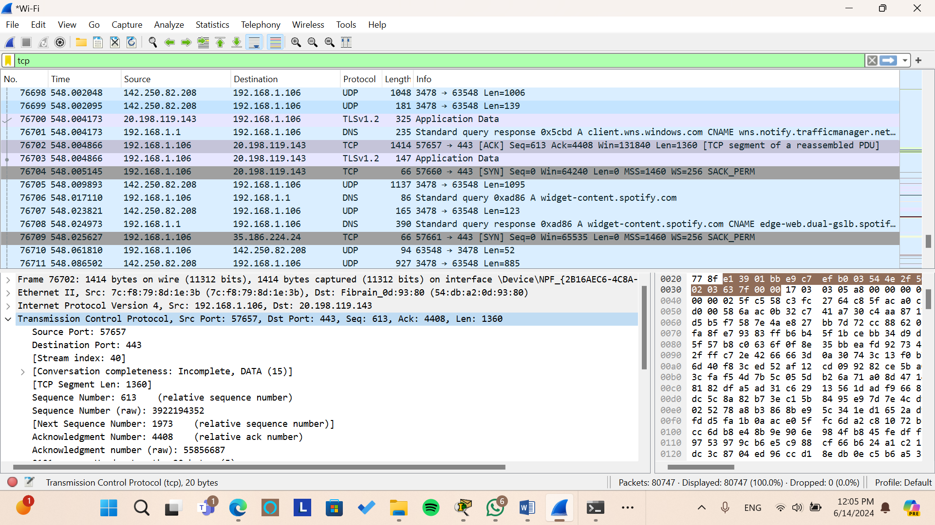

*Figure: TCP Packet Details*

Internet Protocol Version 4, Src: 192.168.1.106, Dst: 20.198.119.143

**Internet Protocol Version 4 (IPv4)**

IPv4 is a network layer protocol that provides an identification and location system for computers on networks and routes traffic across the internet. It uses a 32-bit address scheme allowing for a total of 4.3 billion unique addresses.

* **Fields Explanation**
* **IPv4 Header Fields**
* **Source IP Address (Src)**

**Field:** Src: 192.168.1.106

**Explanation:** This is the IP address of the device that sent the packet. In this case, the source IP address is 192.168.1.106. This address typically belongs to a device within a private network. The 192.168.x.x range is reserved for private use, meaning it is used within local networks and is not routable on the global internet.

* **Destination IP Address (Dst)**

**Field:** Dst: 20.198.119.143

**Explanation:** This is the IP address of the device that the packet is being sent to. In this case, the destination IP address is 20.198.119.143. This address is a public IP address, which is routable on the global internet. It could belong to a server, another computer, or any internet-connected device.

Transmission Control Protocol, Src Port: 57657, Dst Port: 443, Seq: 613, Ack: 4408, Len: 1360

* **Fields Explanation**
* **Source Port (Src Port)**

Src Port: 57657: This field indicates the port number on the sender's side of the TCP connection. In this example, the source port is 57657, which is a dynamically assigned port (also known as an ephemeral port) typically chosen by the client's operating system for the duration of the session.

* **Destination Port (Dst Port)**

Dst Port: 443: This field specifies the port number on the receiver's side of the TCP connection. In this example, the destination port is 443, which is commonly used for HTTPS traffic (secure web traffic).

* **Sequence Number (Seq)**

Seq: 613: This field represents the sequence number of the first byte of data in this segment. TCP uses sequence numbers to keep track of the bytes sent over a connection. In this example, the sequence number is 613. If this is the first segment in the communication, it means the first byte of this segment is the 613th byte of the entire data stream.

* **Acknowledgment Number (Ack)**

Ack: 4408: This field indicates the next byte that the sender of this segment expects to receive from the other party. It is used to acknowledge receipt of data. In this example, the acknowledgment number is 4408, meaning the sender has successfully received all bytes up to 4407 and is now expecting byte 4408 next.

* **Length (Len)**

Len: 1360: This field shows the length of the data payload in the TCP segment, in bytes. In this example, the length is 1360 bytes, meaning this TCP segment carries 1360 bytes of data.

* **DHCP**

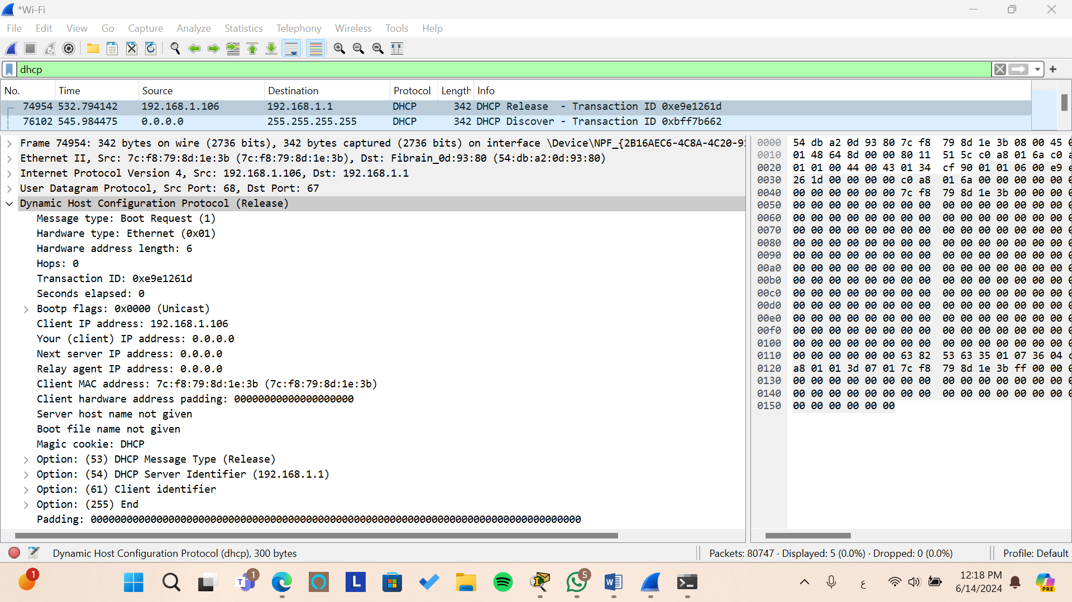

*Figure: DHCP Packet Details*

*Figure: DHCP Packet Details*

Internet Protocol Version 4, Src: 192.168.1.106, Dst: 192.168.1.1

* **Fields Explanation**
* **IPv4 Header Fields**
* **Source IP Address (Src)**

**Field:** Src: 192.168.1.106

**Explanation:** This is the IP address of the device that sent the DHCP packet. In this case, the source IP address is 192.168.1.106. This address typically belongs to a device within a private network, such as a computer or another networked device.

* **Destination IP Address (Dst)**

**Field: Dst:** 192.168.1.1

**Explanation:** This is the IP address of the DHCP server that is receiving the DHCP packet. In this case, the destination IP address is 192.168.1.1. DHCP servers are responsible for dynamically assigning IP addresses and other network configuration parameters to devices within a network.

Dynamic Host Configuration Protocol (Release)

* **Fields Explanation**
* **Message Type**

**Field**: Message type: Boot Request (1)

**Explanation**: This field indicates the type of DHCP message. In this case, it’s a "Boot Request," which means it's a message from a client to a server. The value 1 corresponds to a Boot Request.

* **Transaction ID**

**Field**: Transaction ID: 0xe9e1261d

**Explanation**: This field is a unique identifier for the DHCP transaction. It helps match requests with responses. The client generates this ID, and it is used by both the client and the server throughout the communication to keep track of the particular transaction.

* **Client IP Address**

**Field**: Client IP address: 192.168.1.106

**Explanation**: This field specifies the IP address of the client. In the context of a DHCP Release message, it indicates the IP address that the client is releasing back to the DHCP server.

* **Client MAC Address**

**Field**: Client MAC address: 7c:f8:79:8d:1e:3b (7c:f8:79:8d:1e:3b)

**Explanation**: This field contains the hardware (MAC) address of the client. It is used by the DHCP server to identify the client device. The MAC address is critical for the server to maintain a record of which device has been allocated which IP address.

* **ICMP**

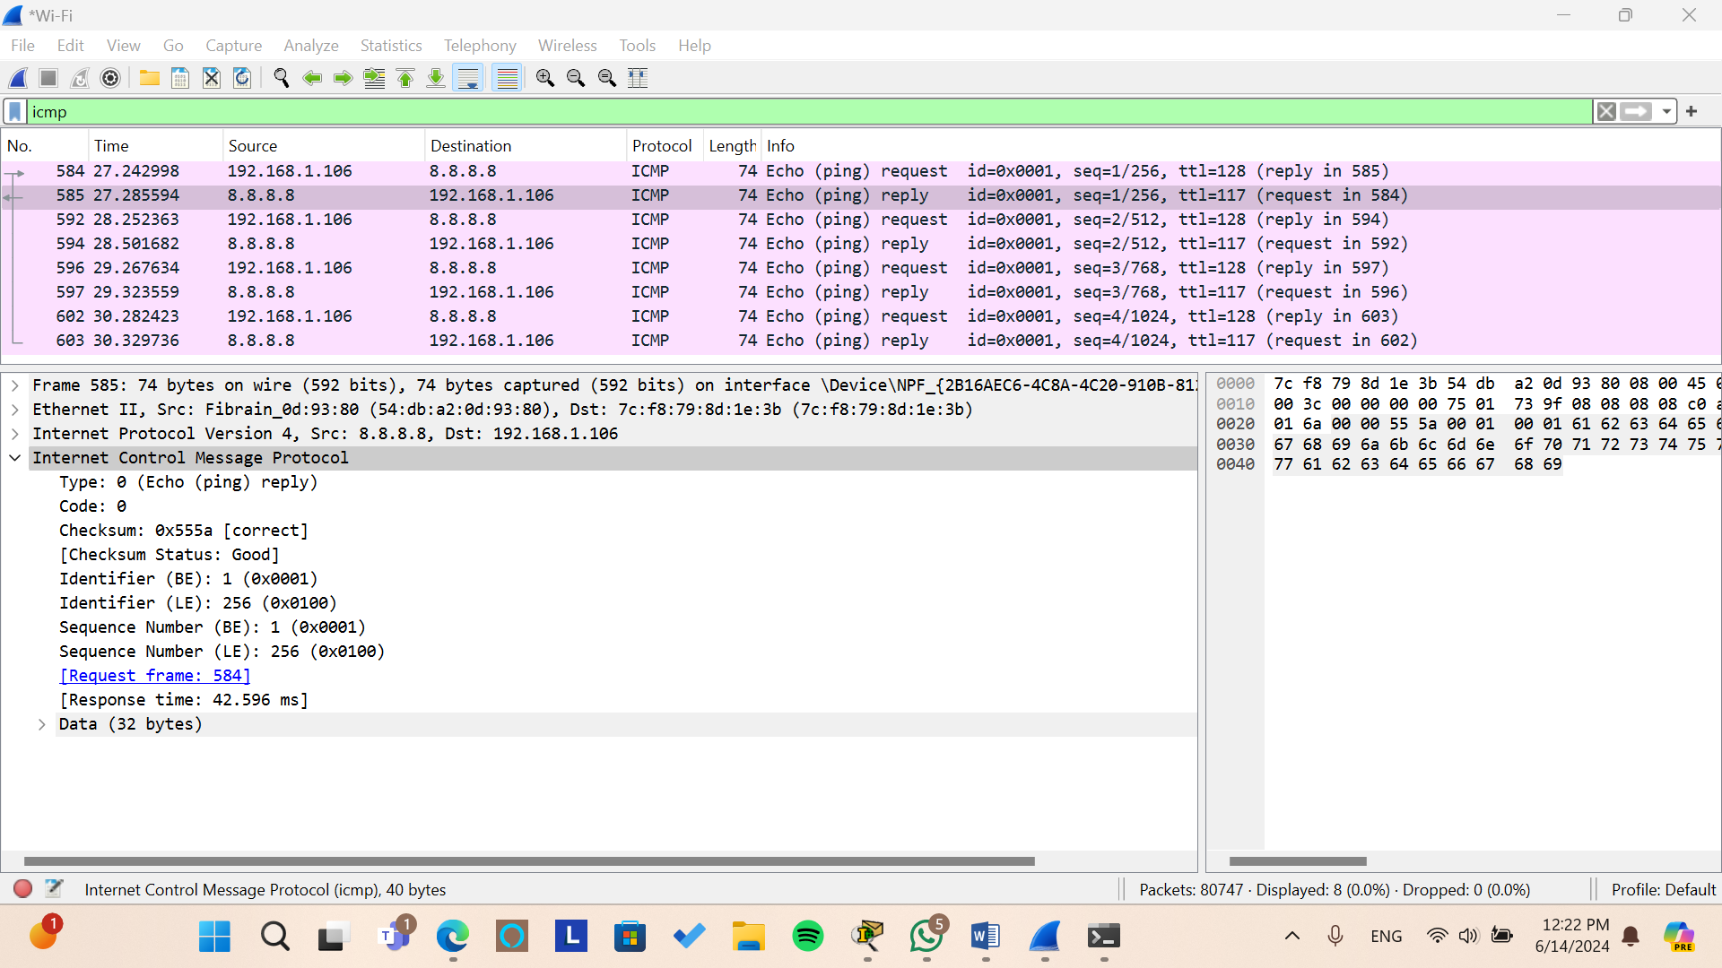

*Figure: ICMP Packet Details*

Internet Protocol Version 4, Src: 8.8.8.8, Dst: 192.168.1.106

* **Fields Explanation**
* **IPv4 Header Fields**
* **Source IP Address (Src)**

**Field:** Src: 8.8.8.8

**Explanation:** This is the IP address of the device that sent the ICMP packet. In this case, the source IP address is 8.8.8.8. This IP address belongs to Google's public DNS server. It's important to note that 8.8.8.8 is a well-known DNS resolver IP address used globally.

* **Destination IP Address (Dst)**

**Field:** Dst: 192.168.1.106

**Explanation:** This is the IP address of the device that the ICMP packet is being sent to. In this case, the destination IP address is 192.168.1.106. This is a private IP address typically assigned to a device within a local network (e.g., home or office network).

Internet Control Message Protocol

* **Fields Explanation**
* **Type**

**Field**: Type: 0 (Echo (ping) reply)

**Explanation**: This field indicates the type of ICMP message. A value of 0 corresponds to an Echo Reply, which is sent in response to an Echo Request (ping). This type of message is used to test the reachability of a host on an IP network.

* **Code**

**Field**: Code: 0

**Explanation**: This field provides additional information about the ICMP message type. For Echo Reply messages, the code is always 0. Different types of ICMP messages can have different codes, but in this case, the code 0 indicates a standard Echo Reply.

* **Checksum**

**Field**: Checksum: 0x555a [correct]

**Explanation**: The checksum is used for error-checking the header and data of the ICMP message. A correct checksum indicates that the data has not been corrupted during transmission. The value 0x555a is the computed checksum value for this packet, and [correct] means that the checksum has been verified as accurate.

* **Identifier**

**Field**: Identifier (BE): 1 (0x0001) and Identifier (LE): 256 (0x0100)

**Explanation**: The identifier is used to match Echo Requests with their corresponding Echo Replies. It helps in distinguishing between different ping sessions. The identifier is represented in both Big Endian (BE) and Little Endian (LE) formats. In Big Endian, the identifier is 1 (0x0001), and in Little Endian, it is 256 (0x0100).

* **Sequence Number**

**Field**: Sequence Number (BE): 1 (0x0001) and Sequence Number (LE): 256 (0x0100)

**Explanation**: The sequence number is used to match Echo Replies to Echo Requests and to keep track of the order of messages. Like the identifier, it is represented in both Big Endian (BE) and Little Endian (LE) formats. The sequence number in this example is 1 in Big Endian and 256 in Little Endian.

* **Data**

**Field**: Data (32 bytes)

**Explanation**: This field contains the data payload of the ICMP message. It is typically used to measure round-trip time and can include any arbitrary data. In this example, the payload is 32 bytes, which is a common size for ping requests.

## Part 2: Packet Tracer

### Part 2.0: IP Subnetting & Assignment

1. You are required to assign the IP addresses of the routers and end devices with respect to **one of the student IDs** in your group as follows:

* Assume the ID is 121**2031** then the IP is 1**20**.**31**.4.0/**23**.
* Design the required IP Addressing scheme and subnets using the above address space and the number of devices in **Table 2** and the topology given in **Figure 1**.

1. Note that any solution without including the ID as above **will not be accepted**.
2. Include a table in your report with the following information for all subnets (edge and core).

As shown in the figure above, we have a network consisting of **10 subnets**. To determine the subnets, detach each interface from its host or router. Since the id is **1210084 (Asmaa’s ID)**, then the IP is **100.84.4.0/23**.

* **First, we look for number of bits needed for each network**
* **Data Center**: 50 end devices $→$ needs 6 bits (Including network & broadcast IPs)
* **Company A**: 26 end devices $→$ needs 5 bits (Including network & broadcast IPs)
* **Company B**: 29 end devices $→$ needs 5 bits (Including network & broadcast IPs)
* **Company C Office One**: 10 end devices $→$ needs 4 bits (Including network & broadcast IPs)
* **Company C Office Two**: 15 end devices $→$ needs 5 bits (Including network & broadcast IPs)
* **Next, we look for IP address for each network using subnetting**

**Main IP: 100.84.00000100.00000000/23**

**1) 100.84.00000100.00000000/24 $→$**  No network needs 8 bits.

**2) 100.84.00000101.00000000/24 $→$**  No network needs 8 bits.

**Next IP Used: 100.84.00000100.00000000/24**

**1) 100.84.00000100.00000000/25 $→$**  No network needs 7 bits.

**2) 100.84.00000100.10000000/25 $→$**  No network needs 7 bits.

**Next IP Used: 100.84.4.00000000/25**

**1) 100.84.4.00000000/26 $→$**  **Data Center network needs 6 bits.**

**2) 100.84.4.01000000/26**

**Next IP Used: 100.84.4.01000000/26**

**1) 100.84.4.01000000/27 $→$**  **Company A** **network needs 5 bits.**

**2) 100.84.4.01100000/27 $→$**  **Company B network needs 5 bits.**

**Next IP Used: 100.84.4.10000000/25**

**1) 100.84.4.10000000/26 $→$**  No network needs 6 bits.

**2) 100.84.4.11000000/26 $→$**  No network needs 6 bits.

**Next IP Used: 100.84.4.10000000/26**

**1) 100.84.4.10000000/27 $→$**  **Company C Office Two** **network needs 5 bits.**

**2) 100.84.4.10100000/27 $→$**  No network needs 5 bits.

**Next IP Used: 100.84.4.10100000/27**

**1) 100.84.4.10100000/28 $→$**  **Company C Office One** **network needs 4 bits.**

**2) 100.84.4.10110000/28 $→$**  No network needs 4 bits.

**Next IP Used: 100.84.4.10110000/28**

**1) 100.84.4.10110000/29 $→$**  No network needs 3 bits.

**2) 100.84.4.10111000/29 $→$**  No network needs 3 bits.

**Next IP Used: 100.84.4.10110000/29**

**1) 100.84.4.10110000/30 $→$**  **Link One-Two** **needs 2 bits.**

**2) 100.84.4.10110100/30 $→$** **Link One-Four** **needs 2 bits.**

**Next IP Used: 100.84.4.10111000/29**

**1) 100.84.4.10111000/30 $→$**  **Link Two-Three** **needs 2 bits.**

**2) 100.84.4.10111100/30 $→$** **Link Four-Three** **needs 2 bits.**

**Next IP Used: 100.84.5.00000000/24**

**1) 100.84.5.00000000/25 $→$**  No network needs 7 bits.

**2) 100.84.5.10000000/25 $→$** No network needs 7 bits.

**Next IP Used: 100.84.5.00000000/25**

**1) 100.84.5.00000000/26 $→$**  No network needs 6 bits.

**2) 100.84.5.01000000/26 $→$** No network needs 6 bits.

**Next IP Used: 100.84.5.00000000/26**

**1) 100.84.5.00000000/27 $→$**  No network needs 5 bits.

**2) 100.84.5.00100000/27 $→$** No network needs 5 bits.

**Next IP Used: 100.84.5.00000000/27**

**1) 100.84.5.00000000/28 $→$**  No network needs 4 bits.

**2) 100.84.5.00010000/28 $→$** No network needs 4 bits.

**Next IP Used: 100.84.5.00000000/28**

**1) 100.84.5.00000000/29 $→$**  No network needs 3 bits.

**2) 100.84.5.00001000/29 $→$** No network needs 3 bits.

**Next IP Used: 100.84.5.00000000/29**

**1) 100.84.5.00000000/30 $→$**  **Link Four-Five** **needs 2 bits.**

**2) 100.84.5.00000100/30**

* **The Table below shows the IP Addresses Details**

|  |  |  |  |  |  |  |
| --- | --- | --- | --- | --- | --- | --- |
| **Subnet** | **Subnet Mask “using the slash notation”** | **Network IP** | **Broadcast IP** | **First IP** | **Last IP** | **Maximum number of IPs in this subnet** |
| **Company A** | **255.255.255.224/27** | **100.84.4.64/27** | **100.84.4.127/27** | **100.84.4.65/27** | **100.84.4.174/27** | **Hosts: 30** |
| **Company B** | **255.255.255.224/27** | **100.84.4.96/27** | **100.84.4.127/27** | **100.84.4.97/27** | **100.84.4.126/27** | **Hosts: 30** |
| **Company C Office 1** | **255.255.255.240/28** | **100.84.4.160/28** | **100.84.4.175/28** | **100.84.4.161/28** | **100.84.4.174/28** | **Hosts: 14** |
| **Company C Office 2** | **255.255.255.224/27** | **100.84.4.128/27** | **100.84.4.159/27** | **100.84.4.129/28** | **100.84.4.158/28** | **Hosts: 30** |
| **Data Center** | **255.255.255.192/26** | **100.84.4.0/26** | **100.84.4.63/26** | **100.84.4.1/26** | **100.84.4.62/26** | **Hosts: 62** |
| **R1-R2**  **Link** | **255.255.255.252/30** | **100.84.4.176/30** | **100.84.4.179/30** | **100.84.4.177/30** | **100.84.4.178/30** | **Hosts: 2** |
| **R1-R4**  **Link** | **255.255.255.252/30** | **100.84.4.180/30** | **100.84.4.183/30** | **100.84.4.181/30** | **100.84.4.182/30** | **Hosts: 2** |
| **R3-R4**  **Link** | **255.255.255.252/30** | **100.84.4.188/30** | **100.84.4.191/30** | **100.84.4.189/30** | **100.84.4.190/30** | **Hosts: 2** |
| **R2-R3**  **Link** | **255.255.255.252/30** | **100.84.4.184/30** | **100.84.4.187/30** | **100.84.4.185/30** | **100.84.4.186/30** | **Hosts: 2** |
| **R4-R5**  **Link** | **255.255.255.252/30** | **100.84.5.0/30** | **100.84.5.3/30** | **100.84.5.1/30** | **100.84.5.2/30** | **Hosts: 2** |

### Part 2.1: Topology

1. Build the topology given in **Figure 1** using packet tracer based on the IP addressing scheme you designed in **Part0**.

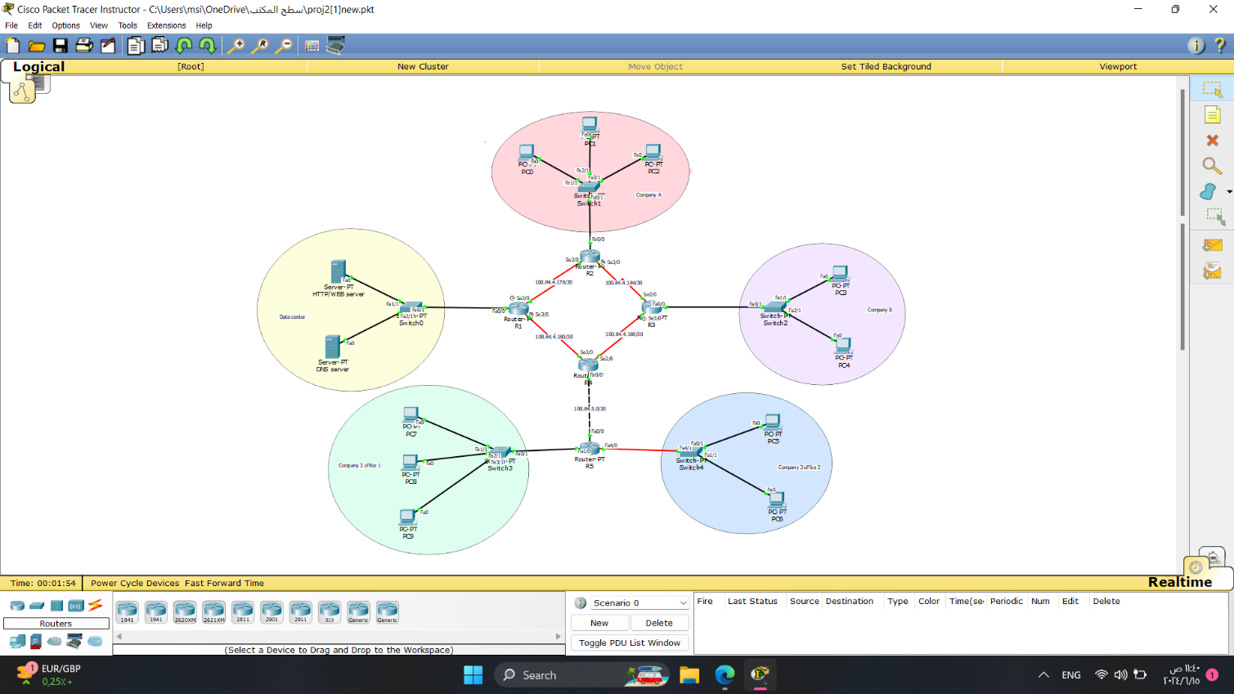

In this section, we constructed a topology using **Packet Tracer**, based on the IP addresses determined in **Part 0**. As illustrated in the figure above, the topology is divided into the following areas:

**- Data center**: **Yellow area (100.84.4.0/26)**

**- Company A**: **Pink area (100.84.4.64/27)**

**- Company B**: **Purple area (100.84.4.96/27)**

**- Company C Office 1**: **Blue area (100.84.4.160/28)**

**- Company C Office 2**: **Green area (100.84.4.128/27)**

**- Core**: **Area 0**

We assigned IP addresses to each area and then configured the IPs for the end systems and routers **statically**.

1. Configure the interfaces of all routers as instructed in the figure.

* **Router One**

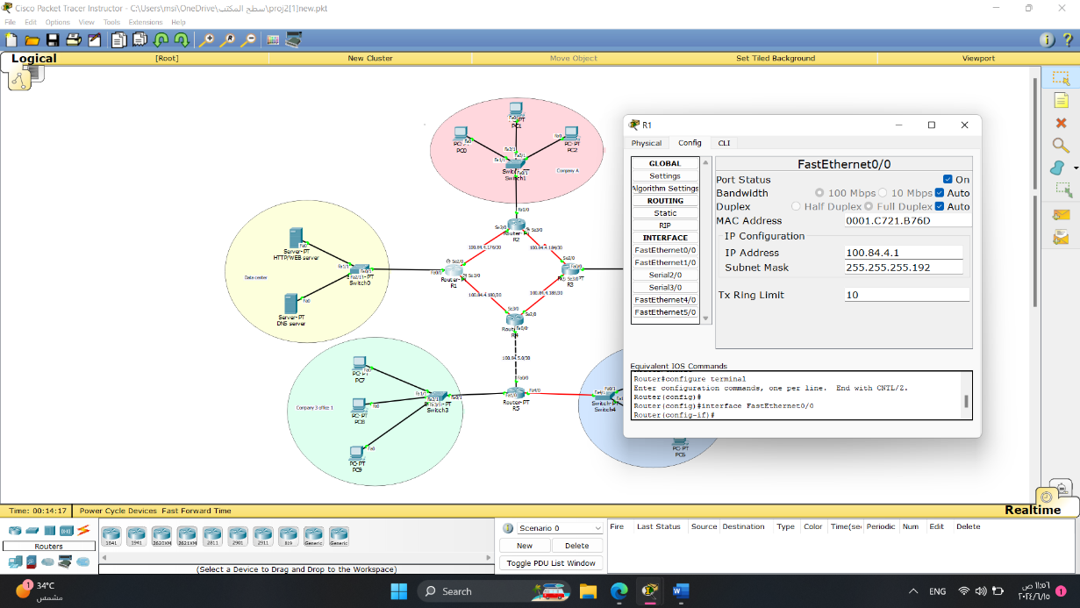

For Router R1 – fa0/0, we assigned the first IP address after the network IP (**100.84.4.1**) with a subnet mask of **255.255.255.192**.

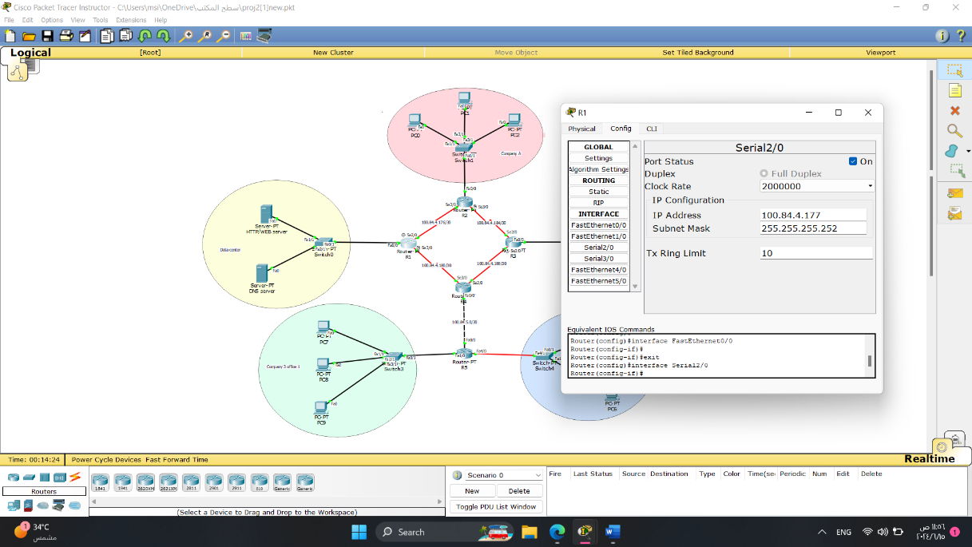

For Router R1 – se2/0, we assigned the first IP address after the network IP (**100.84.4.177**) with a subnet mask of **255.255.255.252**.

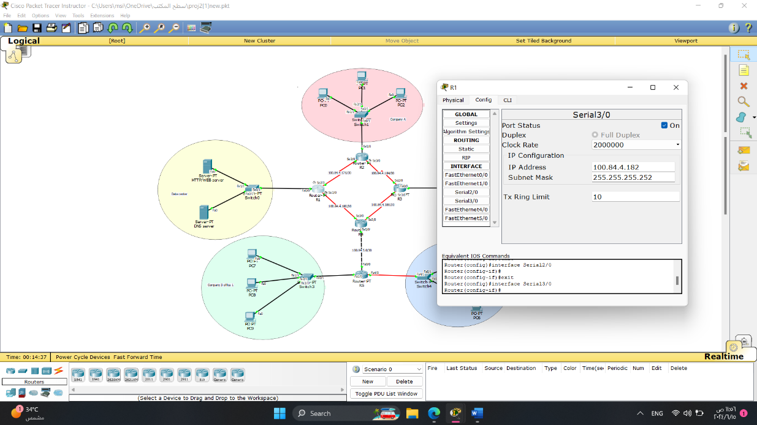

For Router R1 – se3/0, we assigned the first IP address after the network IP (**100.84.4.182**) with a subnet mask of **255.255.255.252**.

* **Router Two**

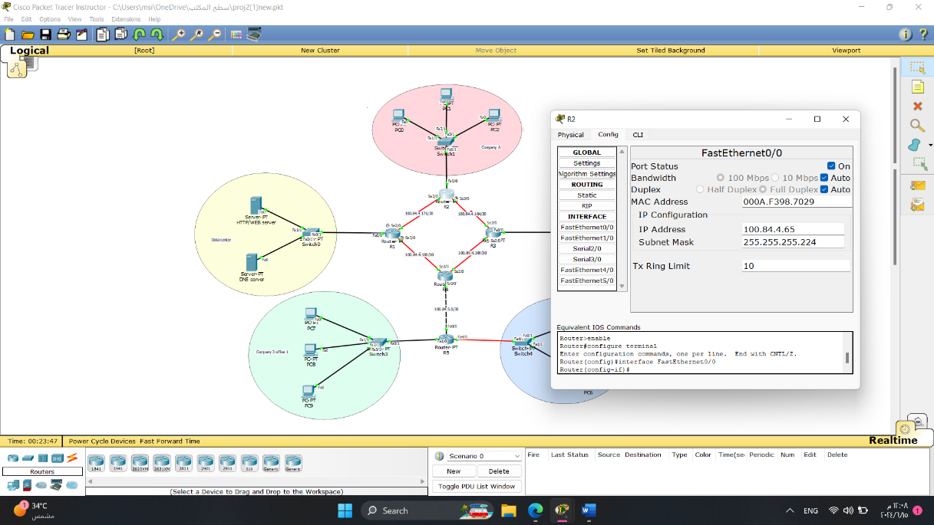

For Router R2 – fa0/0, we assigned the first IP address after the network IP (**100.84.4.65**) with a subnet mask of **255.255.255.224**.

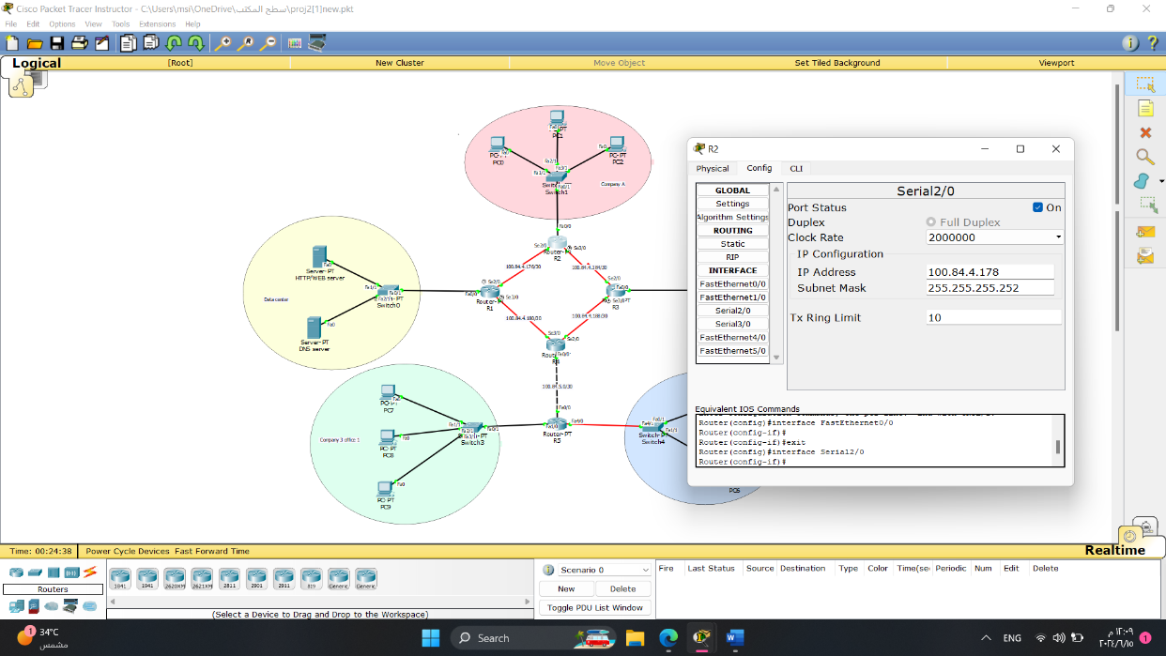

For Router R2 – se2/0, we assigned the first IP address after the network IP (**100.84.4.178**) with a subnet mask of **255.255.255.252**.

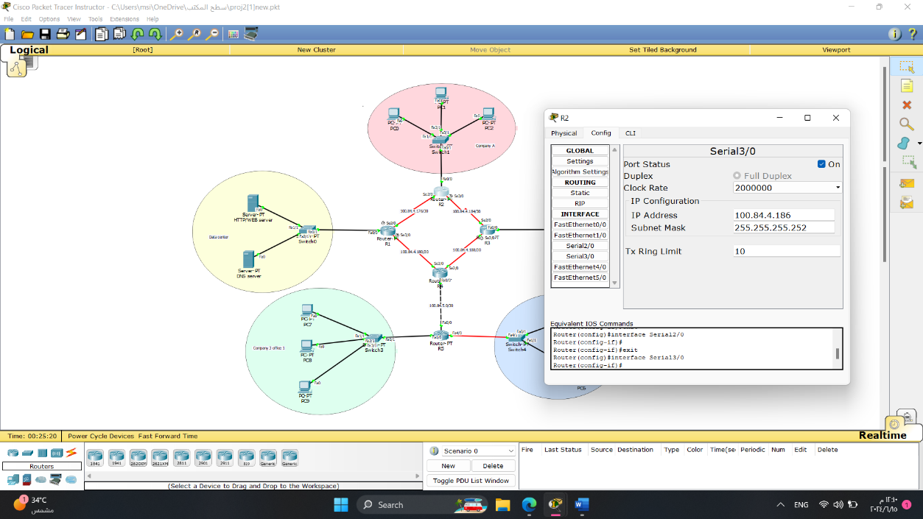

For Router R2 – se3/0, we assigned the first IP address after the network IP (**100.84.4.186**) with a subnet mask of **255.255.255.252**.

* **Router Three**

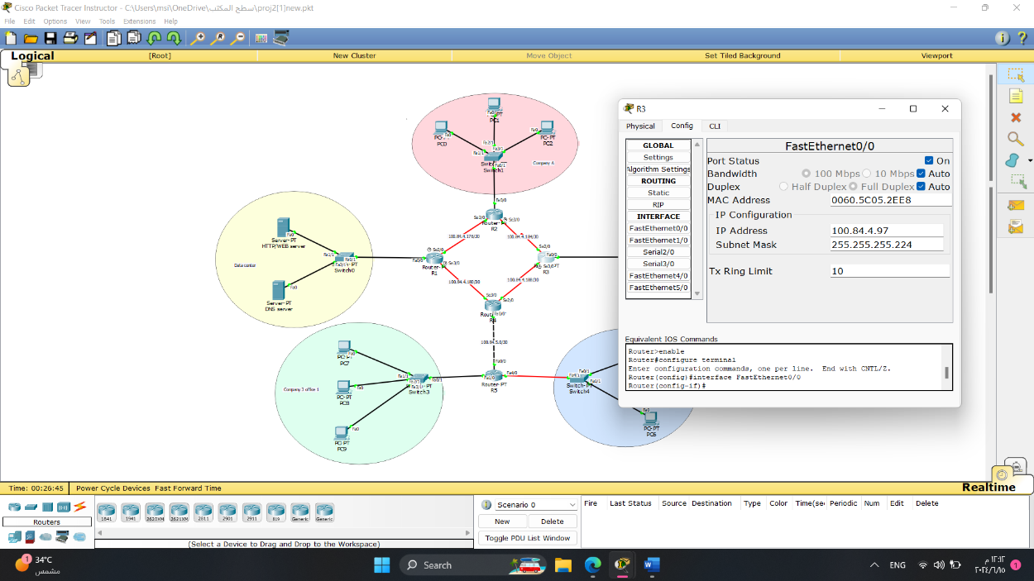

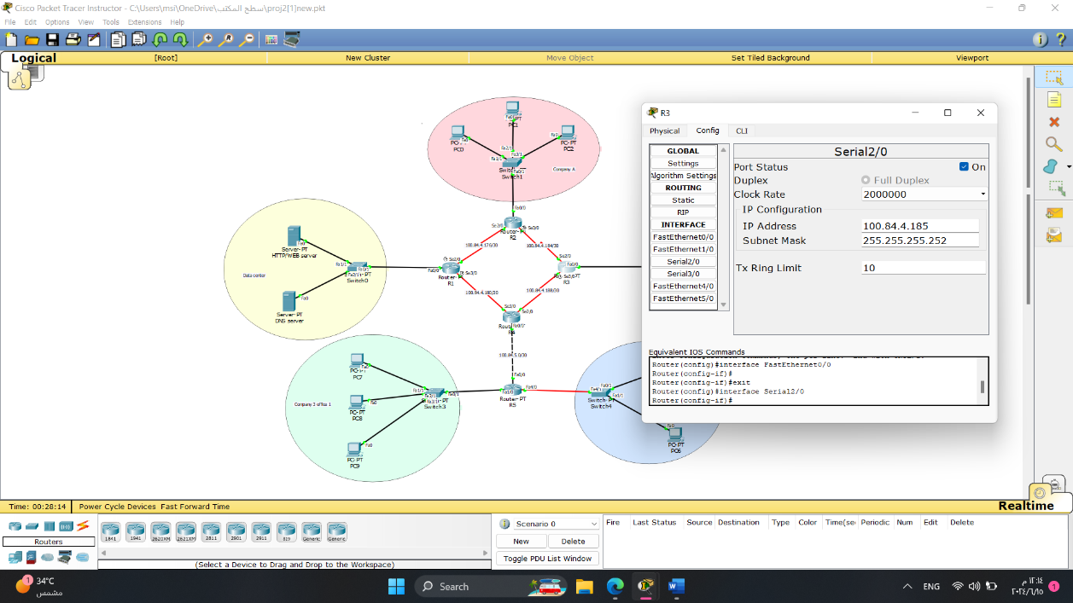For Router R3 – fa0/0, we assigned the first IP address after the network IP (**100.84.4.97**) with a subnet mask of **255.255.255.224**.

For Router R3 – se2/0, we assigned the first IP address after the network IP (**100.84.4.185**) with a subnet mask of **255.255.255.252**.

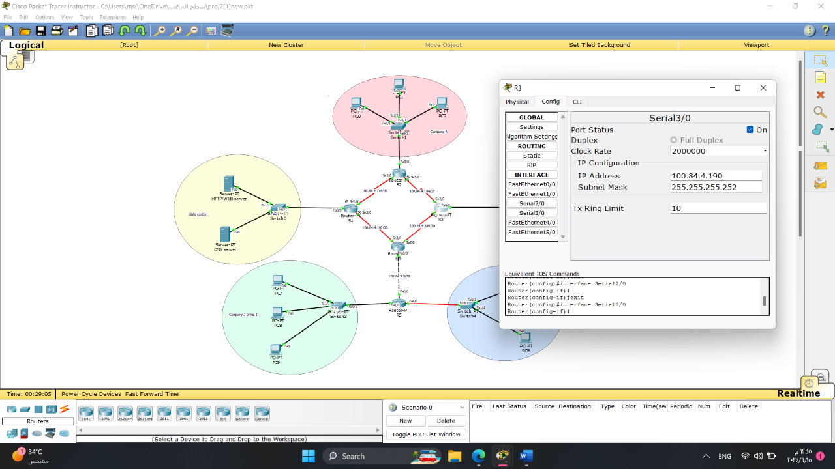

For Router R3 – se3/0, we assigned the first IP address after the network IP (**100.84.4.190**) with a subnet mask of **255.255.255.252**.

* **Router Four**

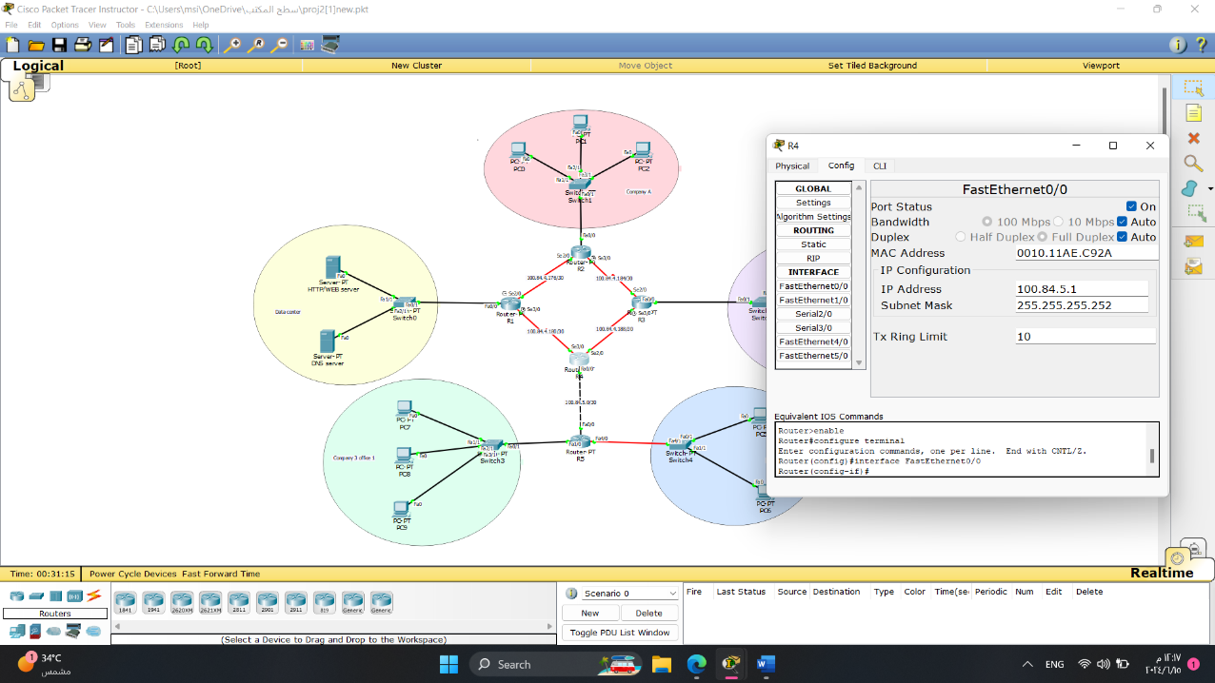

For Router R4 – fa0/0, we assigned the first IP address after the network IP (**100.84.5.1**) with a subnet mask of **255.255.255.252**.

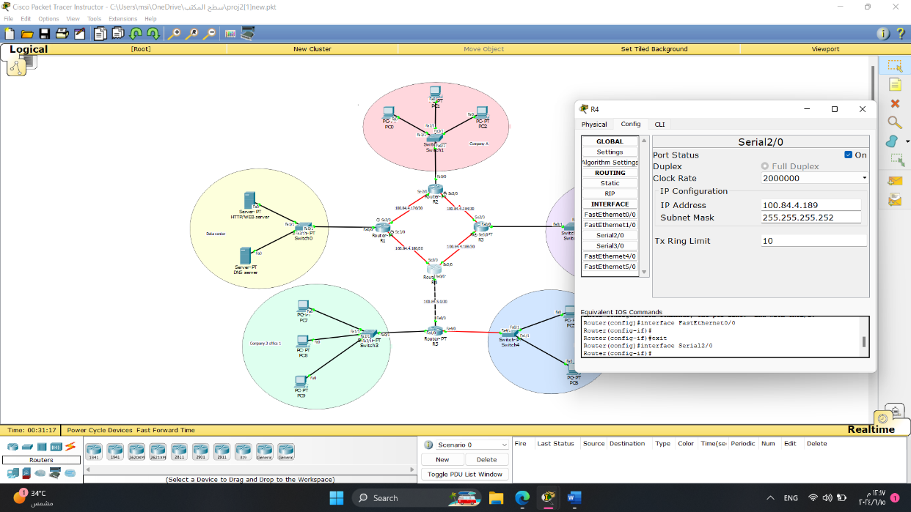

For Router R4 – se2/0, we assigned the first IP address after the network IP (**100.84.4.189**) with a subnet mask of **255.255.255.252**.

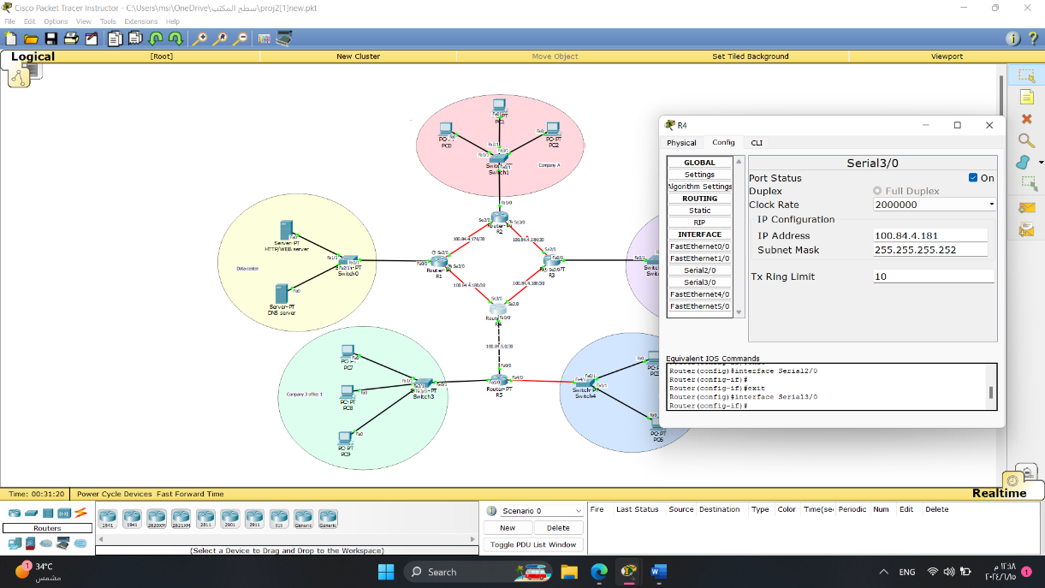

For Router R4 – se3/0, we assigned the first IP address after the network IP (**100.84.4.181**) with a subnet mask of **255.255.255.252**.

* **Router Five**

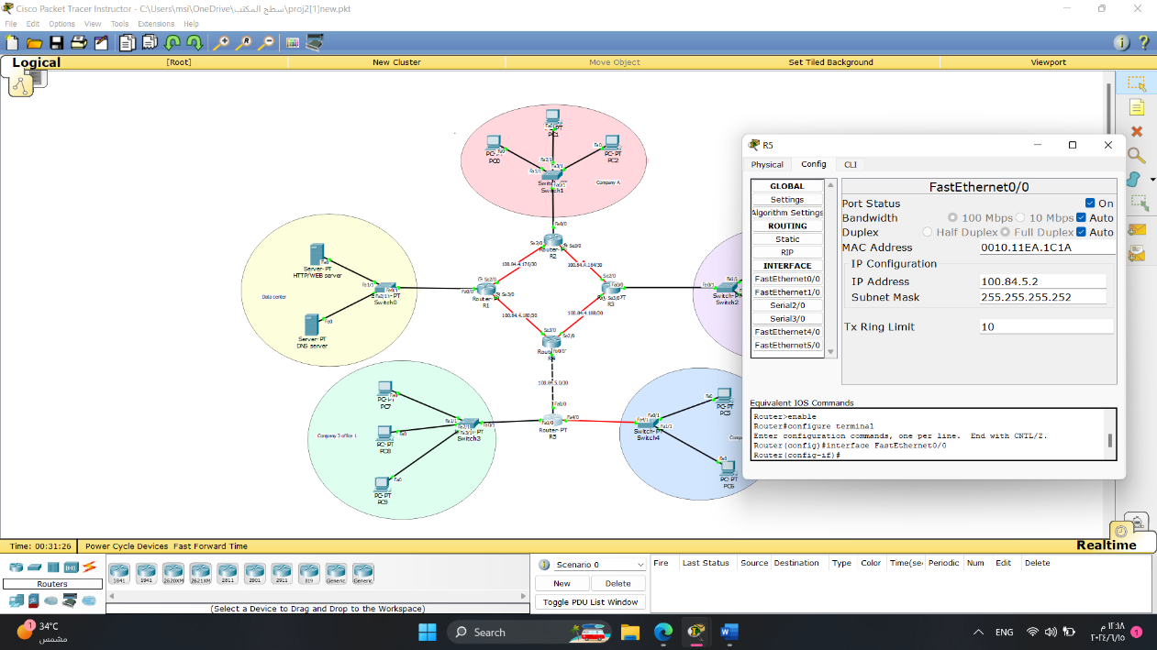

For Router R5 – fa0/0, we assigned the first IP address after the network IP (**100.84.5.2**) with a subnet mask of **255.255.255.252**.

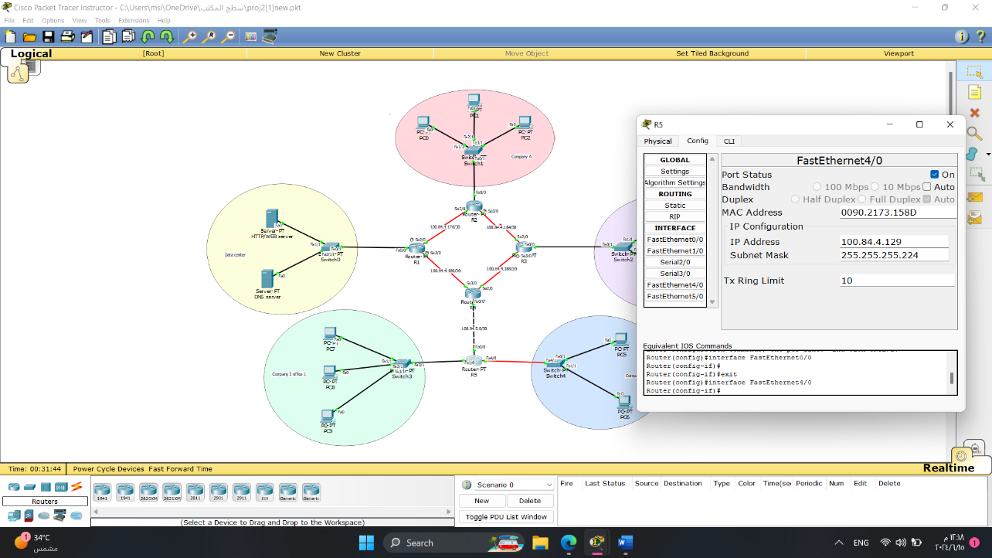

For Router R5 – fa4/0, we assigned the first IP address after the network IP (**100.84.4.129**) with a subnet mask of **255.255.255.224**.

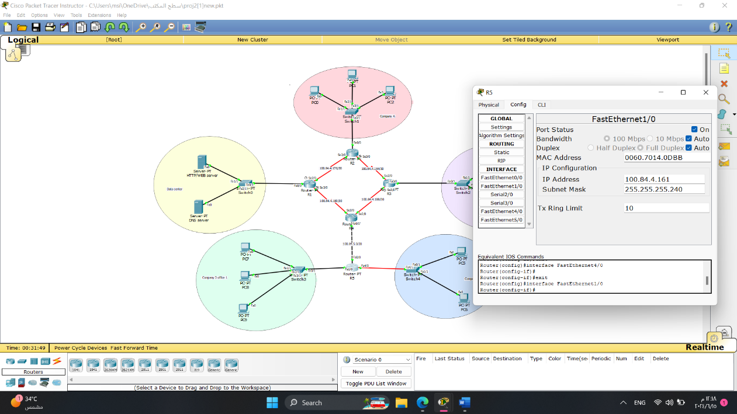

For Router R5 – fa1/0, we assigned the first IP address after the network IP (**100.84.4.161**) with a subnet mask of **255.255.255.240**.

1. End devices (i.e. PCs and Servers) in the datacentre and companies’ networks are getting their IPs in a static manner based on the assigned subnet IPs.

* **Data Centre**

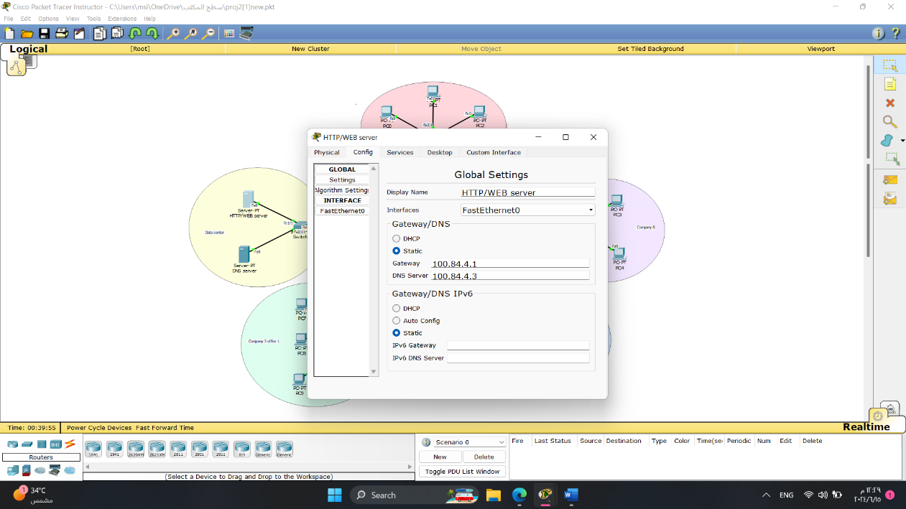

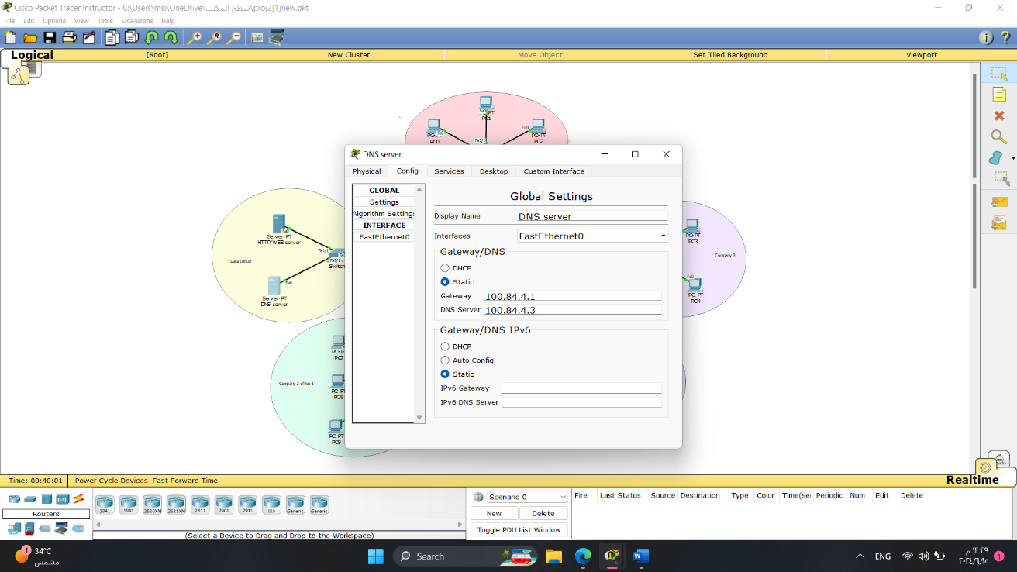

* **Company A**

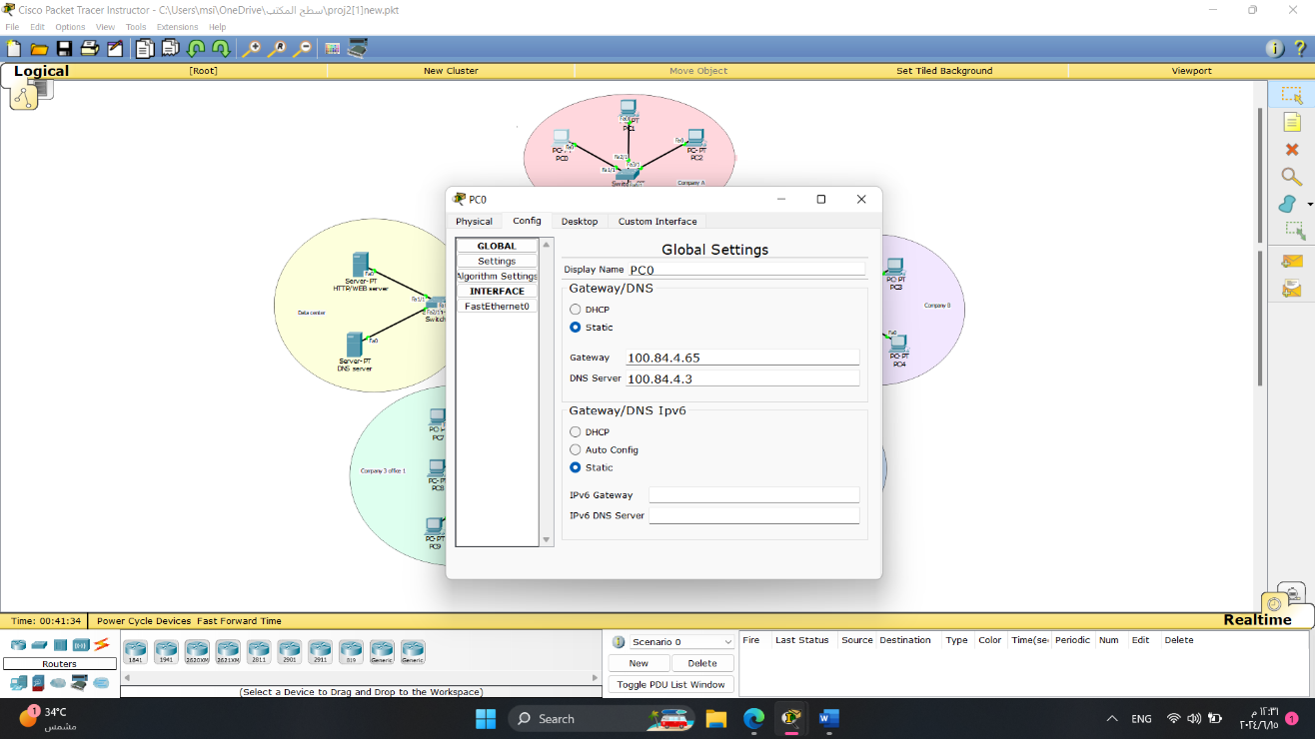

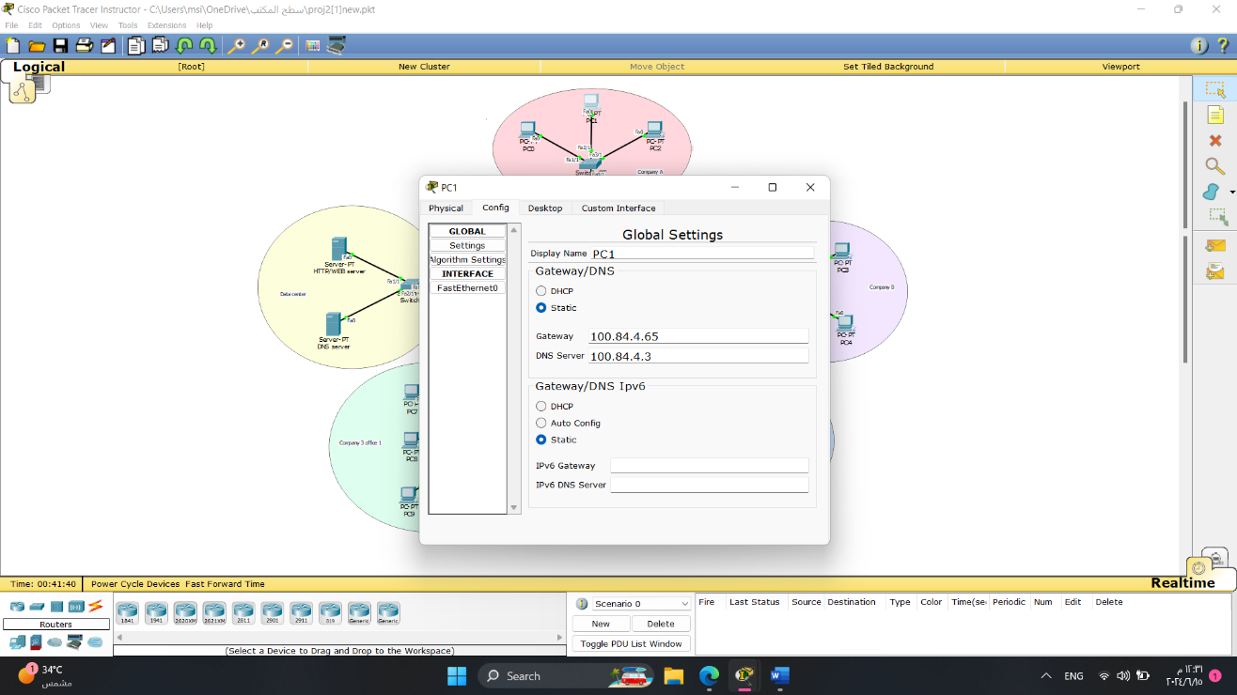

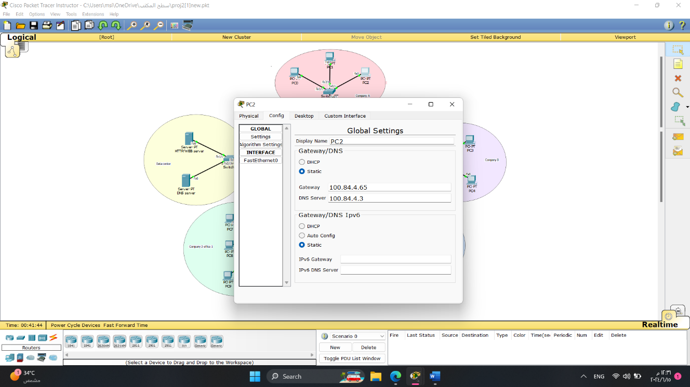

* **Company B**

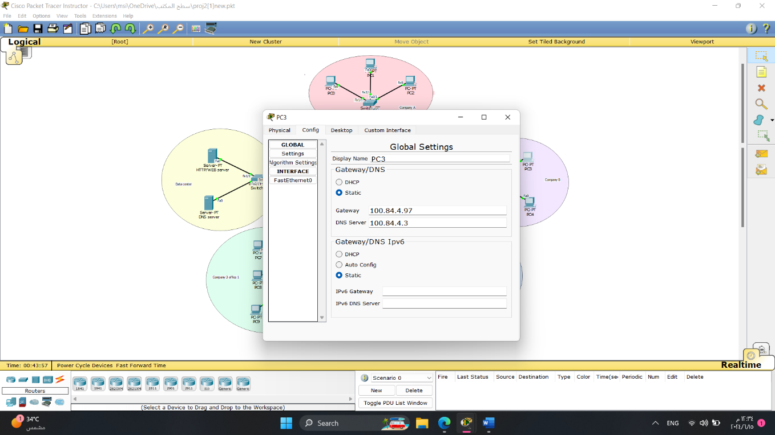

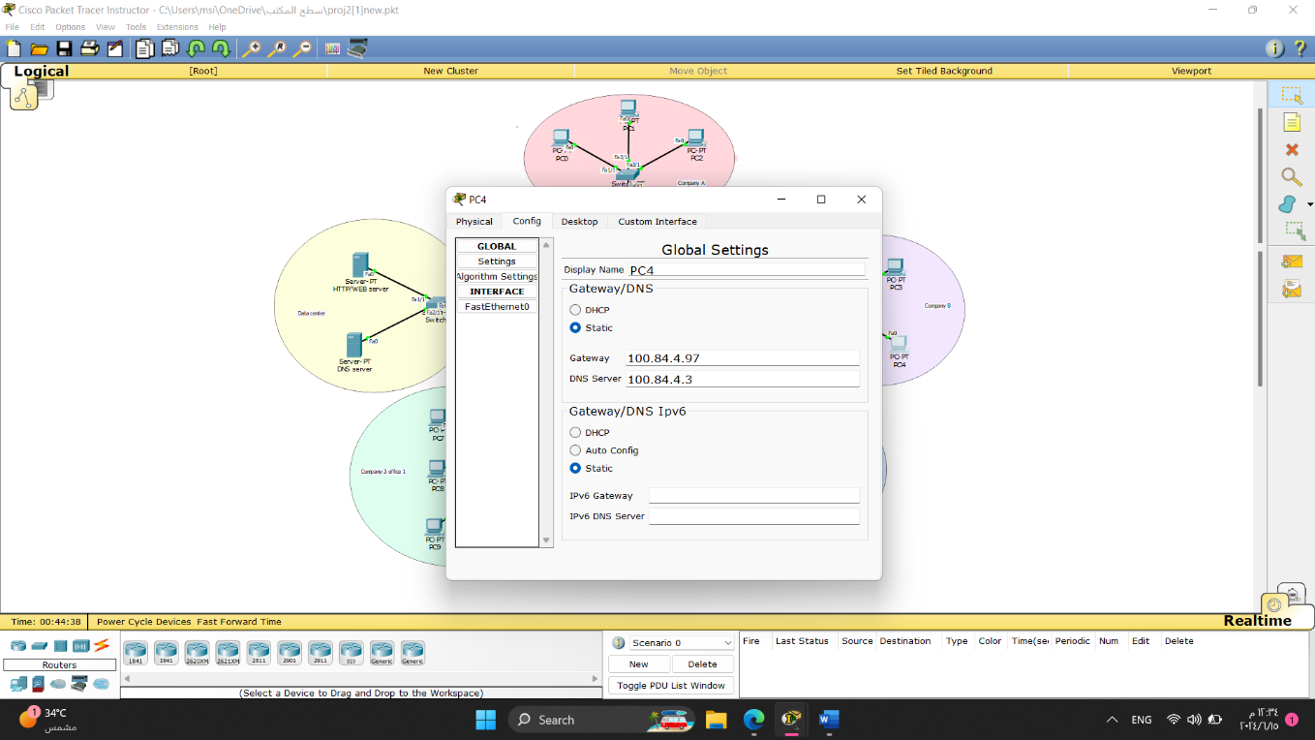

* **Company C Office One**

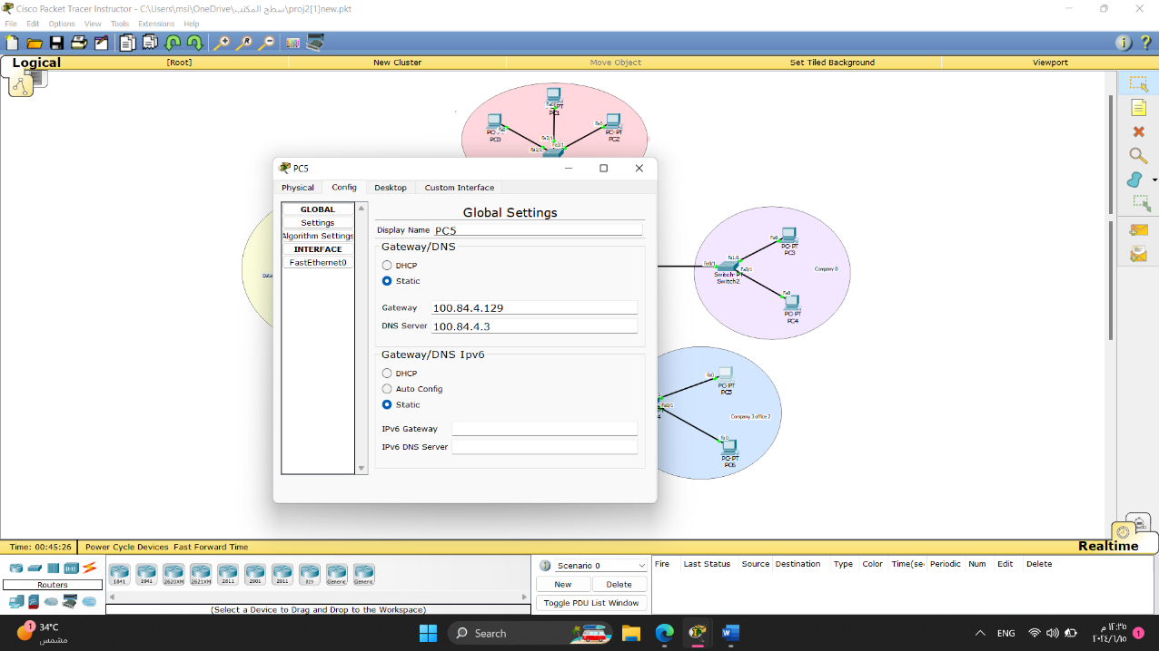

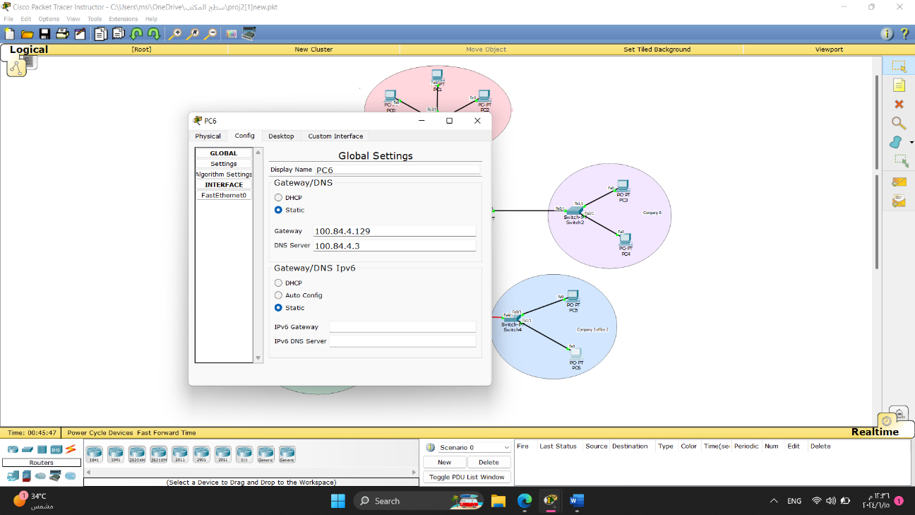

* **Company C Office Two**

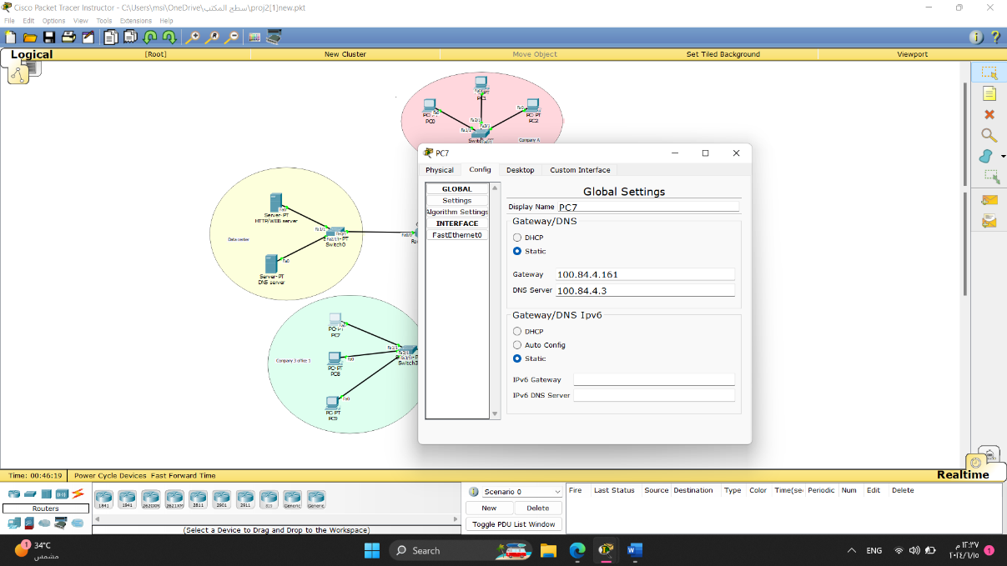

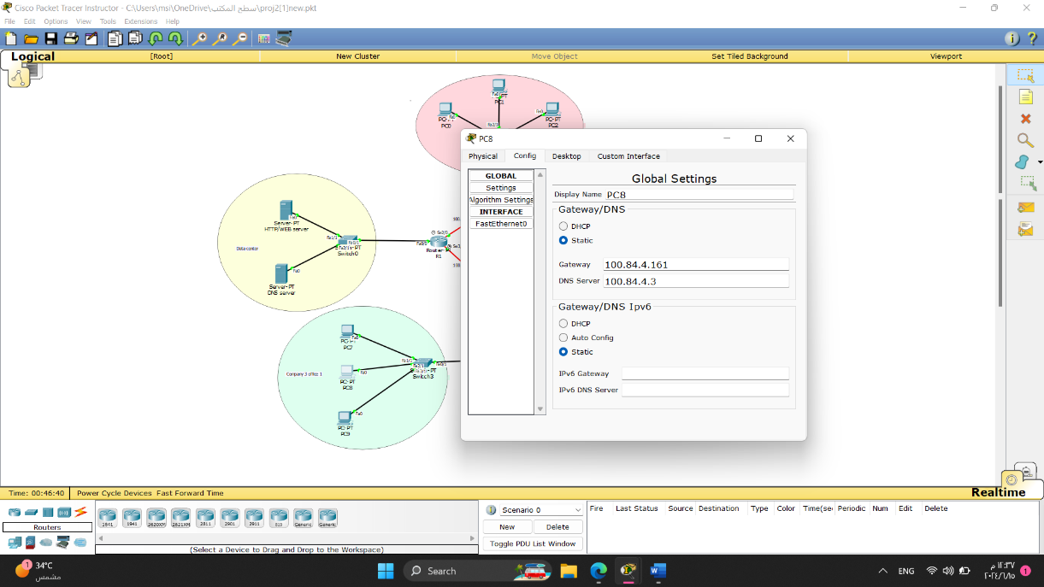

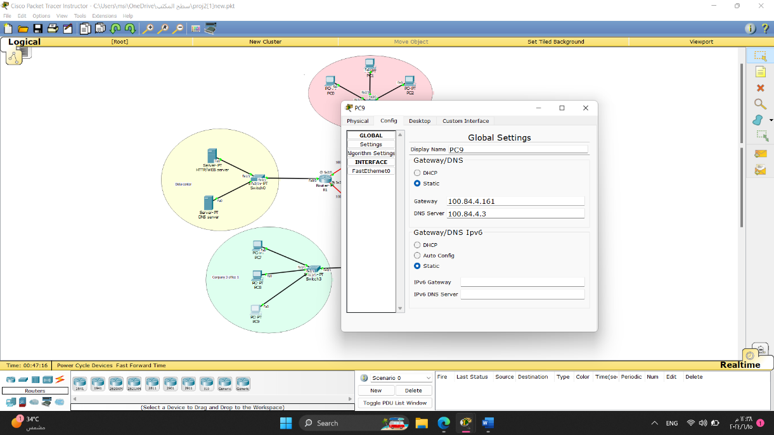

### Part 2.2: Configuring Servers

1. Two servers are used in this topology: HTTP/WEB server and DNS server in Data Centre network.
2. Configure the DNS server and WEB server with domain name www.ENCS3320.com
3. Create your website by modifying the index.html file in the HTTP server. Your website should contain:

* “ENCS3320-Course Website” in the title.
* “Welcome to Computer Networks course” (part of the phrase is in Red).
* Group members’ names and IDs.
* Try to make the page looks nice.

**In this part, we configured the services for the servers. We set up the DNS server and the WEB server with a domain name.**

#### HTTP Server

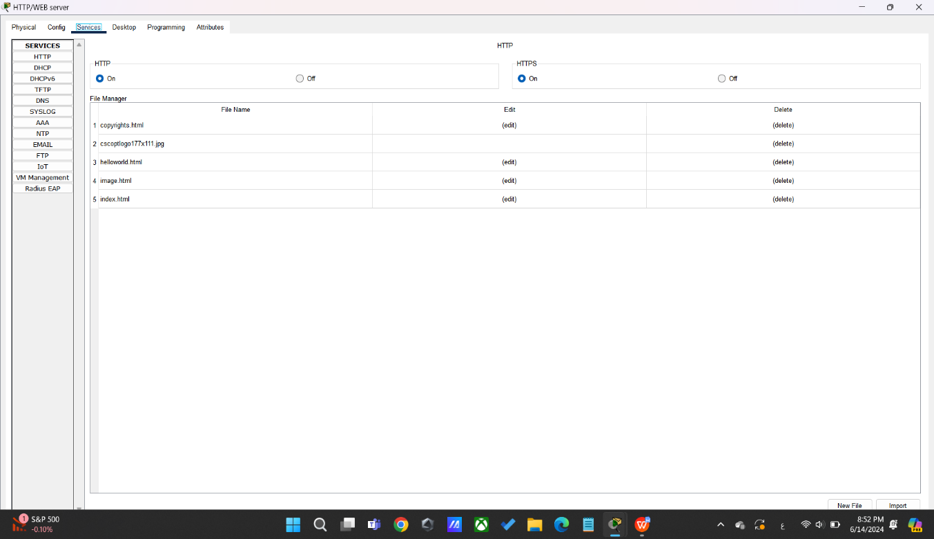

For this server, we turned on the HTTP and HTTPS protocols, since they are web protocols, then we created our website by modifying the index.html file in the HTTP server.

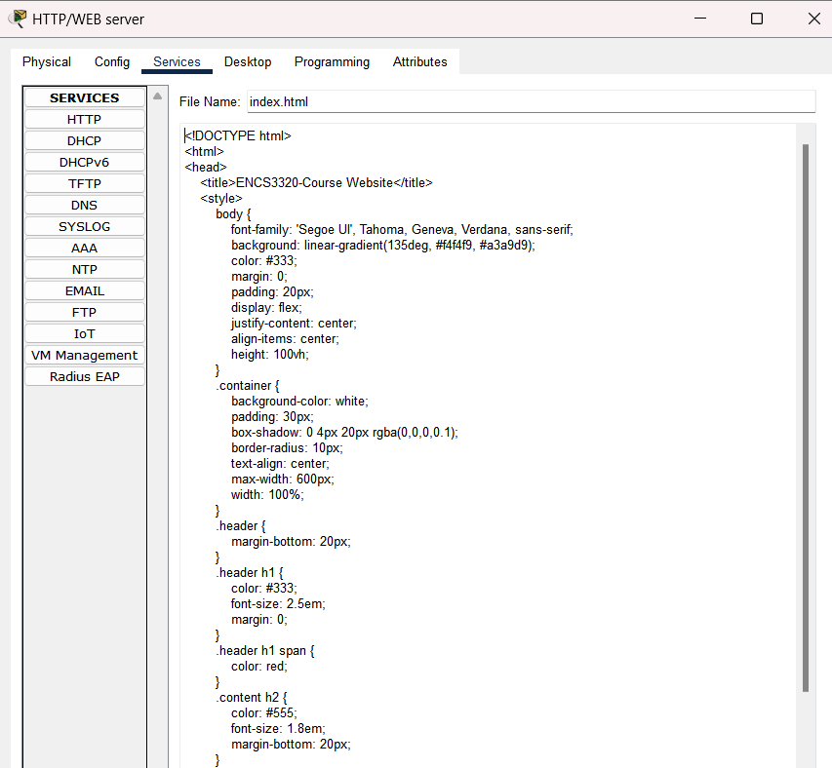

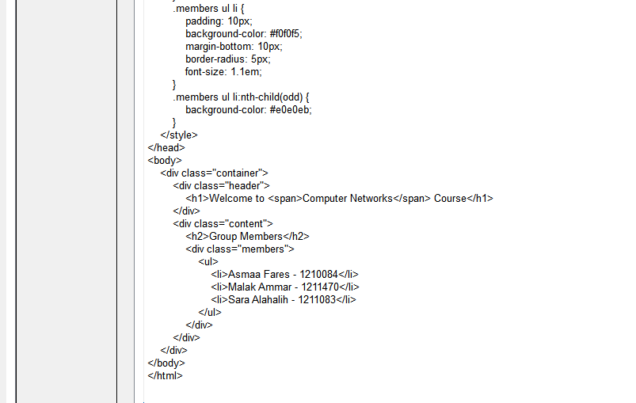

#### DNS server

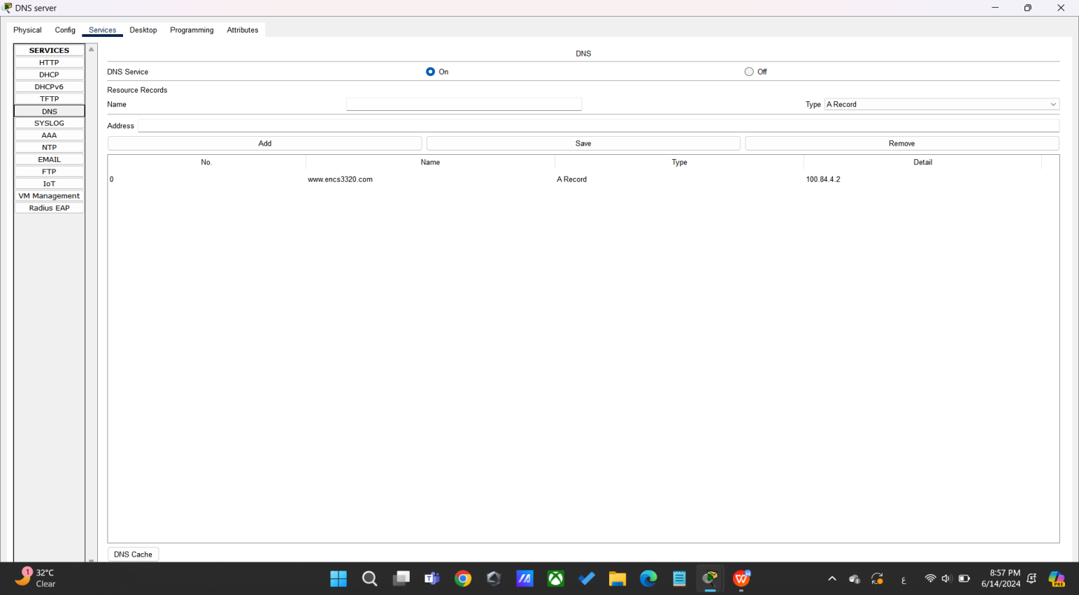

For this server, we turned on the DNS protocol, since it is a DNS server, then we configured the DNS server, and the HTTP server with domain name **www.ENCS3320.com**, with IP 100.84.4.2“HTTP server’s IP address”.

### Part 2.3: Routing Protocols

Use single area open shortest path first protocol (OSPF) on all routers.

**In this part, we implemented the Open Shortest Path First (OSPF) protocol on all routers using process ID 1, enabling connectivity across all routers.**

* **Router R1**

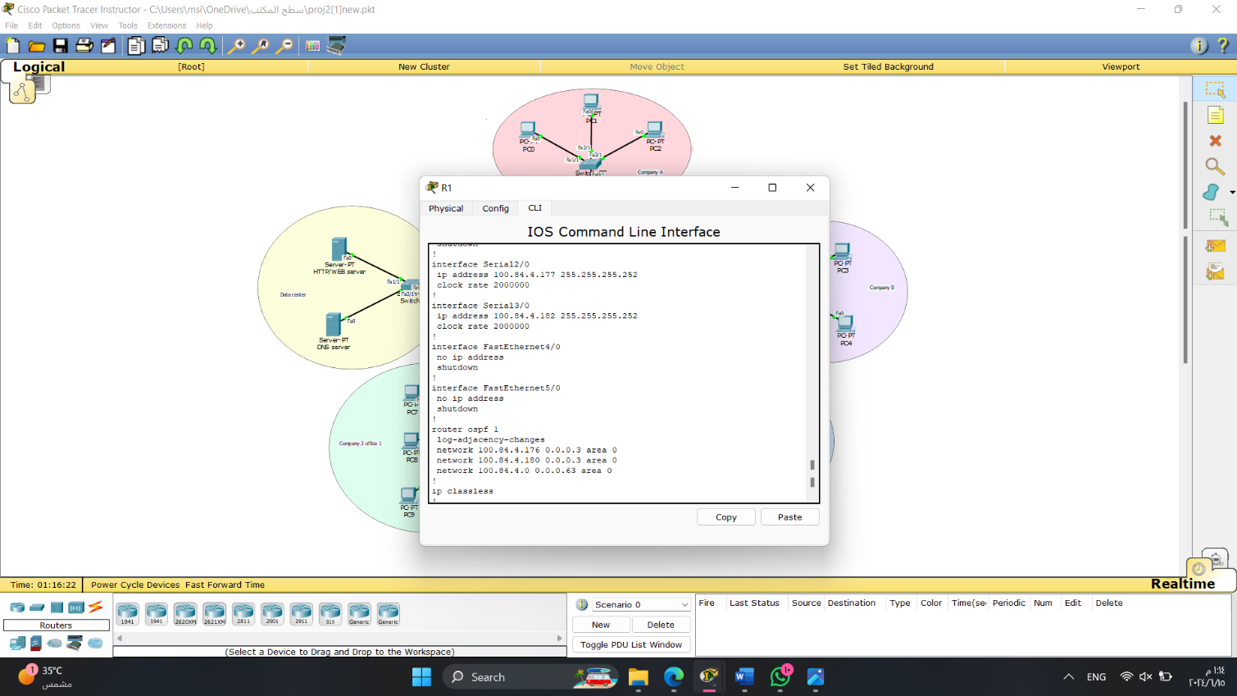

* **Router R2**

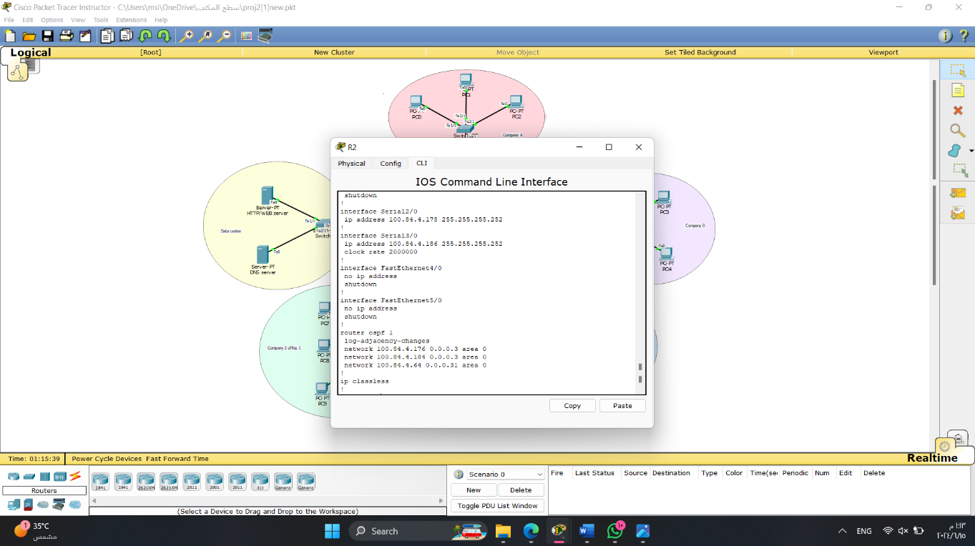

* **Router R3**

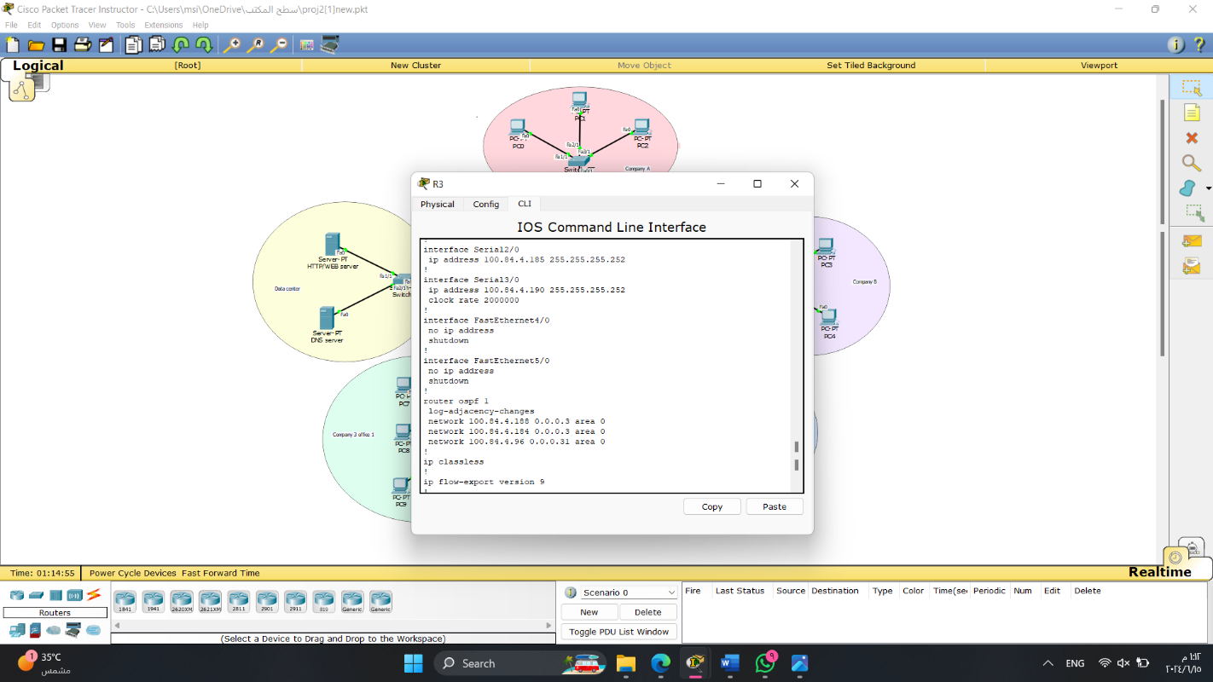

* **Router R4**

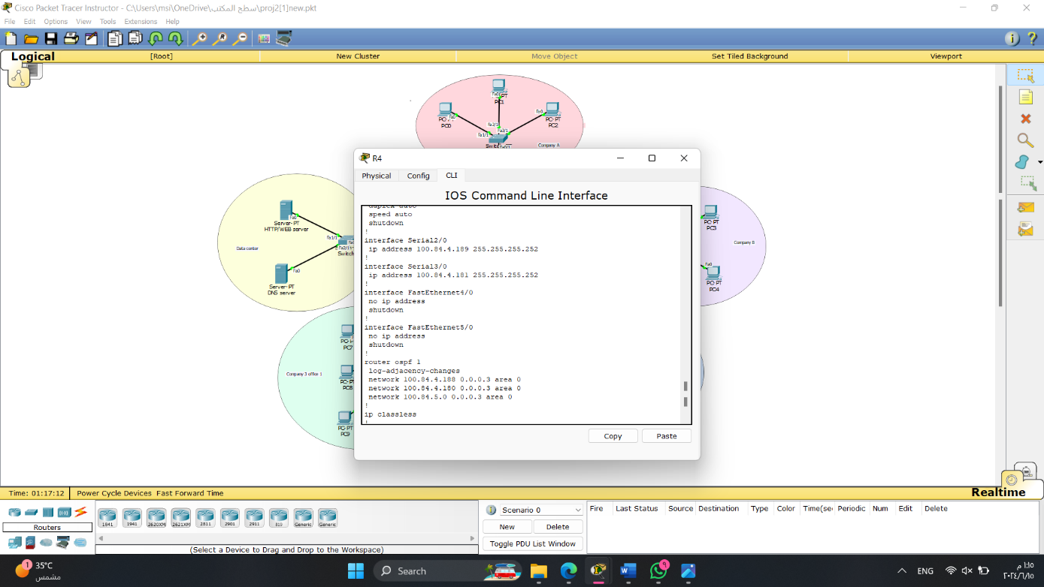

* **Router R5**

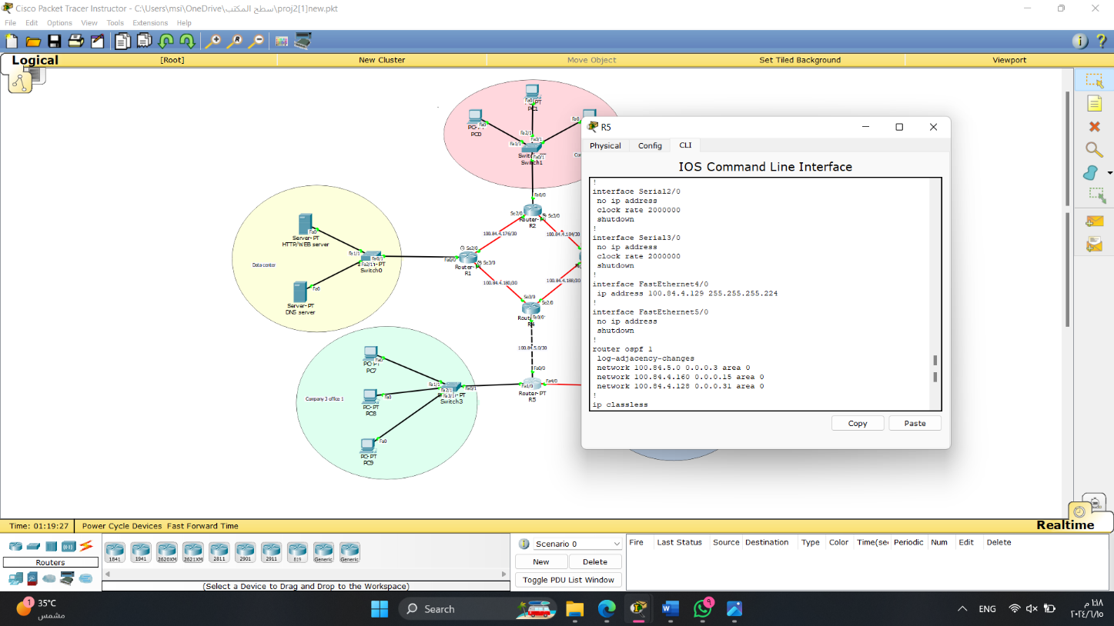

### Part 2.4: Testing & Troubleshooting

1. Test the connectivity between all PCs. You need to make **snapshots** of the results for ping and tracert commands between all PCs.
2. Access www.ENCS3320.com from all PCs, make **snapshots** for all cases.
3. Show the outputs of 1 and 2 as **snapshots** and record them in your report with detailed explanations.

* **Test the connectivity between all PCs**

In this part, we employed CMD commands such as "**ping**" and "**tracert**" to examine the connectivity between computers. These commands help assess the accessibility of devices within the network. Tracert, in particular, allows us to trace the path taken by a packet as it journeys towards its destination.

* **Company A**
* **PC0**

**Ping**

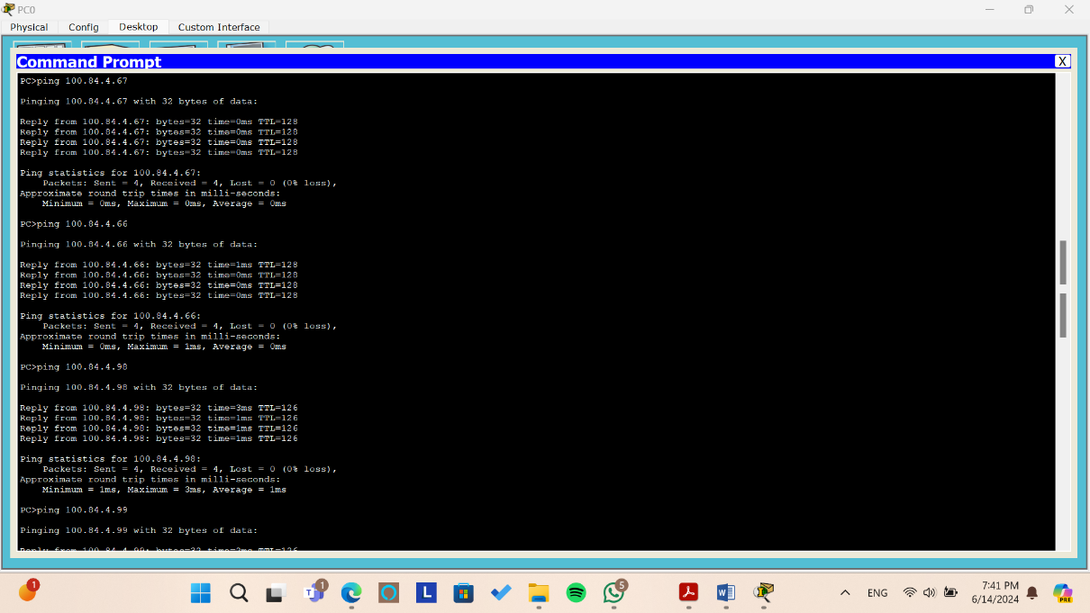

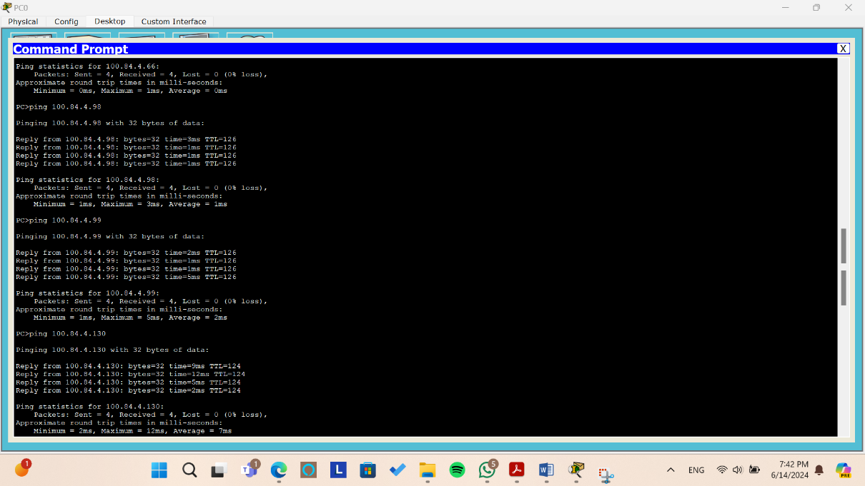

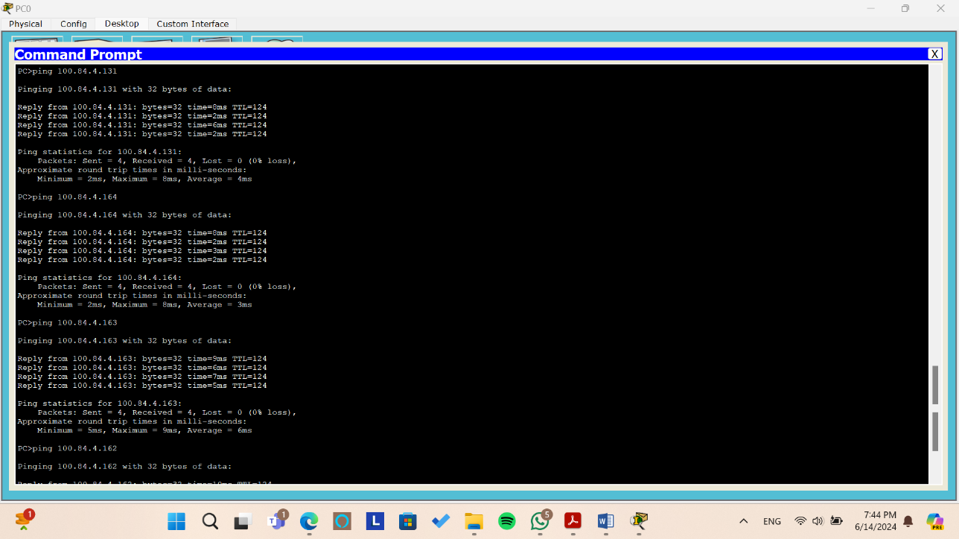

*Figure: Testing the ping command from PC0*

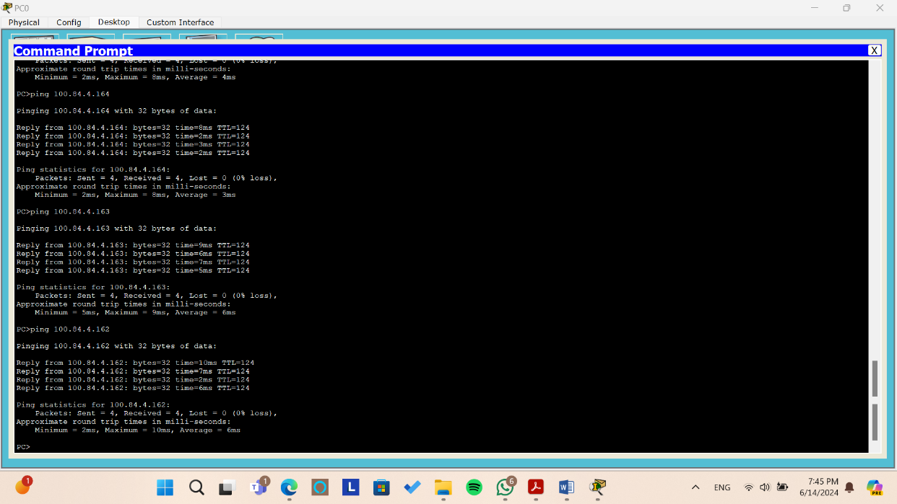

*Figure: Testing the ping command from PC0*

From the above pictures, we try to ping to all pcs from PC0 by sending 4 packets and we can see that all packets arrive without and lost packet or requested out.

**Tracert**

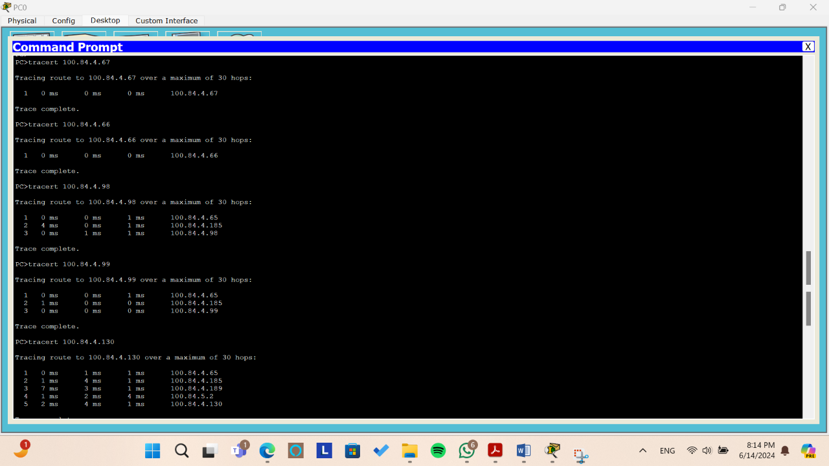

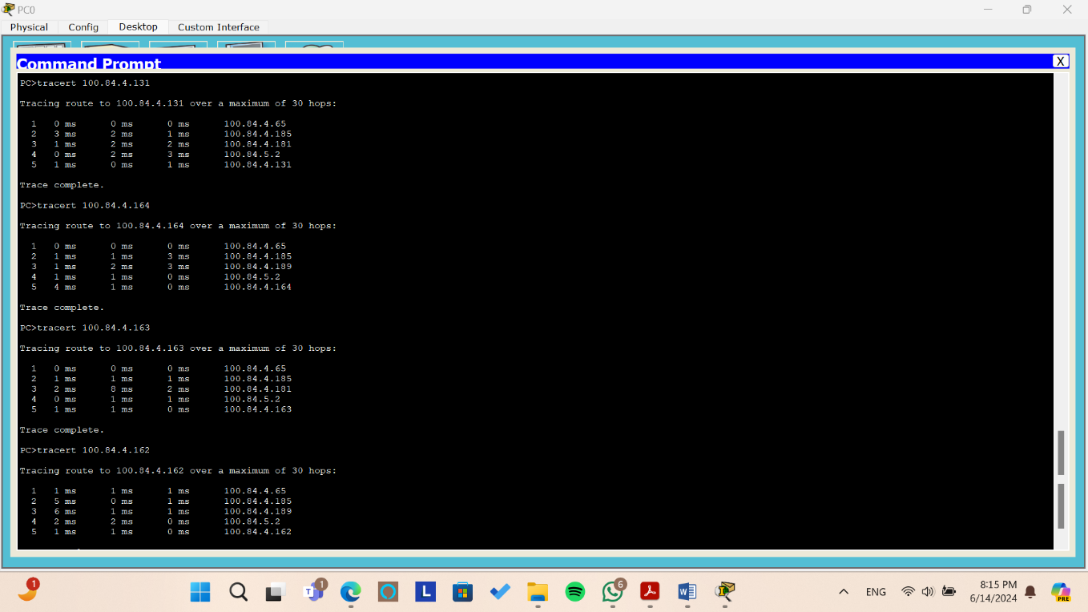

*Figure: Testing the tracert command from PC0*

When we use tracert between PC0 and other PCs it gives us the path between PC0 and the other pcs.

* + To PC1 and PC2 the packets arrives directly since they are in the same network area.
  + To PC3 first we get through the gateway of the area 100.84.4.65 then through the interface 100.84.4.185 in the core network then to PC3.
  + To PC4 (same PC3 path)
  + To PC5 first we get through the gateway of the area 00.84.4.65 then through the interface

100.84.4.185, then through the interface 100.84.4.189, then through the interface 100.84.5.2 in the core network then to PC5.

* To PC6 first we get through the gateway of the area 00.84.4.65 then through the interface 100.84.4.185, then through the interface 100.84.4.181, then through the interface 100.84.5.2 in the core network then to PC5.
  + To PC7 first we get through the gateway of the area 00.84.4.65 then through the interface

100.84.4.185, then through the interface 100.84.4.189, then through the interface 100.84.5.2 in the core network then to PC7.

* To PC8 first we get through the gateway of the area 00.84.4.65 then through the interface 100.84.4.185, then through the interface 100.84.4.181, then through the interface 100.84.5.2 in the core network then to PC8.
  + To PC9 first we get through the gateway of the area 00.84.4.65 then through the interface

100.84.4.185, then through the interface 100.84.4.189, then through the interface 100.84.5.2 in the core network then to PC9.

* + **PC1**

**Ping**

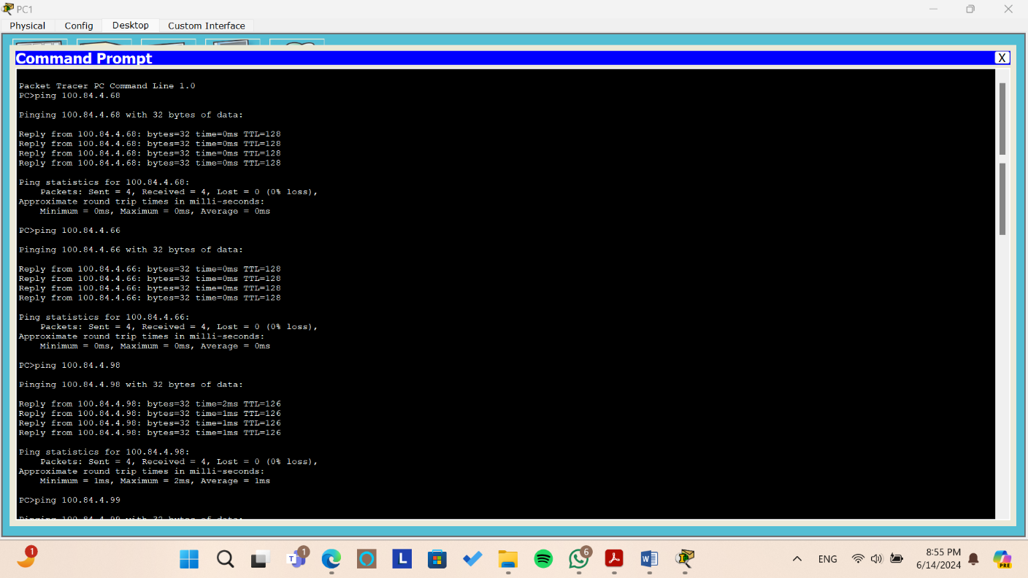

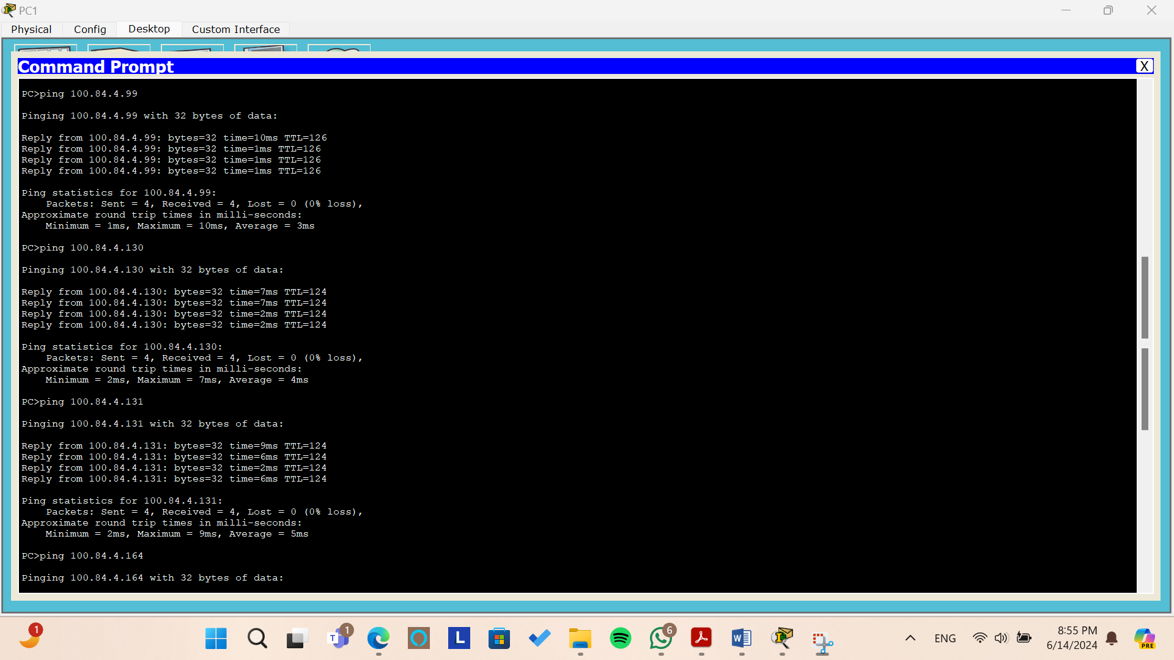

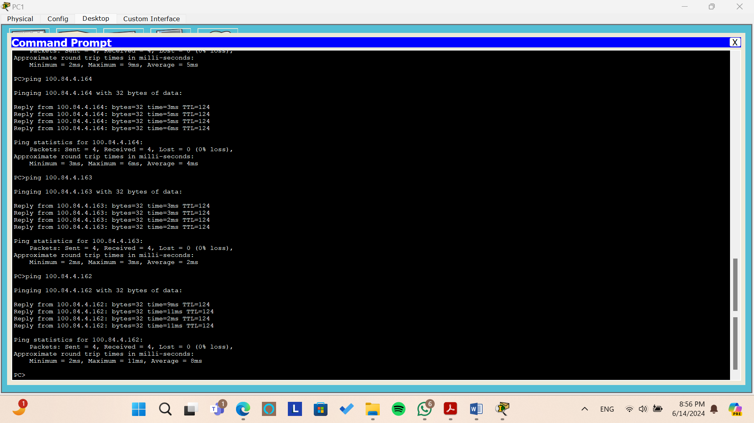

*Figure: Testing the ping command from PC1*

From the above pictures, we try to ping to all pcs from PC1 by sending 4 packets and we can see that all packets arrive without and lost packet or requested out.

**Tracert**

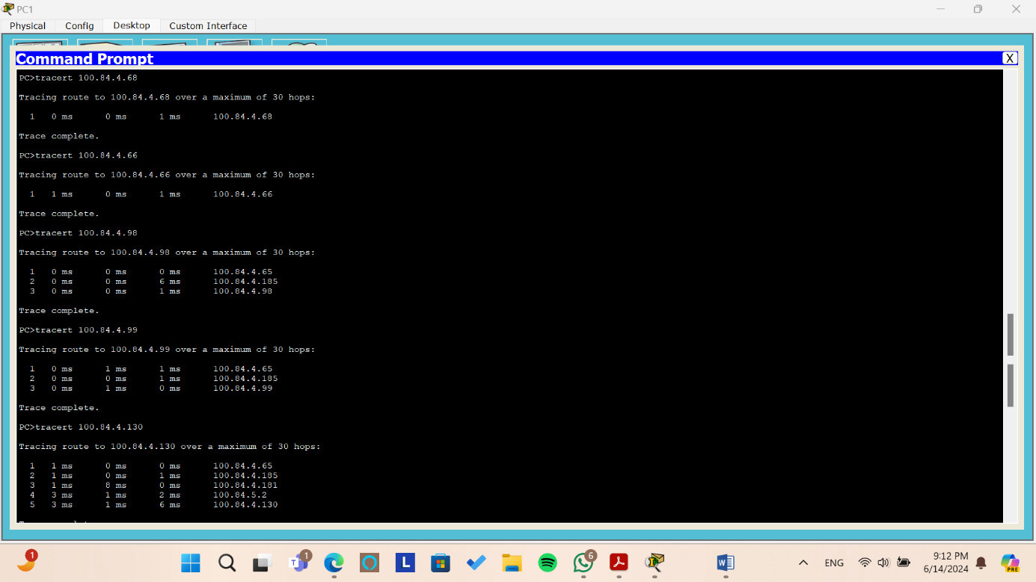

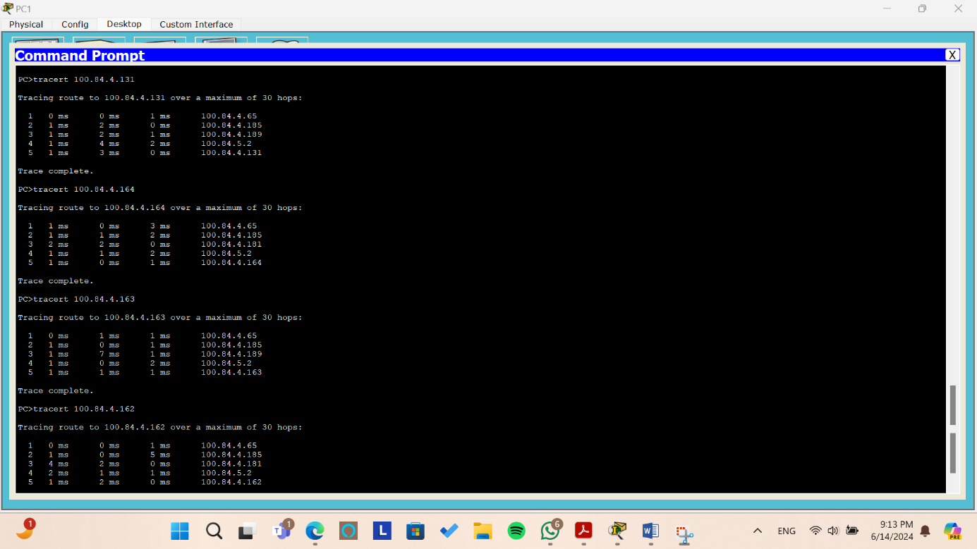

*Figure: Testing the tracert command from PC1*

When we use tracert between PC1 and other PCs it gives us the path between PC1 and the

other pcs.

* + To PC0 and PC2 the packets arrives directly since they are in the same network area.
  + To PC3 first we get through the gateway of the area 100.84.4.65 then through the interface 100.84.4.185 in the core network then to PC3.
  + To PC4 (same as PC3 path)
  + To PC5 first we get through the gateway of the area 00.84.4.65 then through the interface

100.84.4.185, then through the interface 100.84.4.181, then through the interface 100.84.5.2 in the core network then to PC5.

* To PC6 first we get through the gateway of the area 00.84.4.65 then through the interface 100.84.4.185, then through the interface 100.84.4.189, then through the interface 100.84.5.2 in the core network then to PC5.
  + To PC7 (same as PC5 path)
* To PC8 (same as PC6 path)
  + To PC9 (same as PC5 path)
  + **PC2**

**Ping**

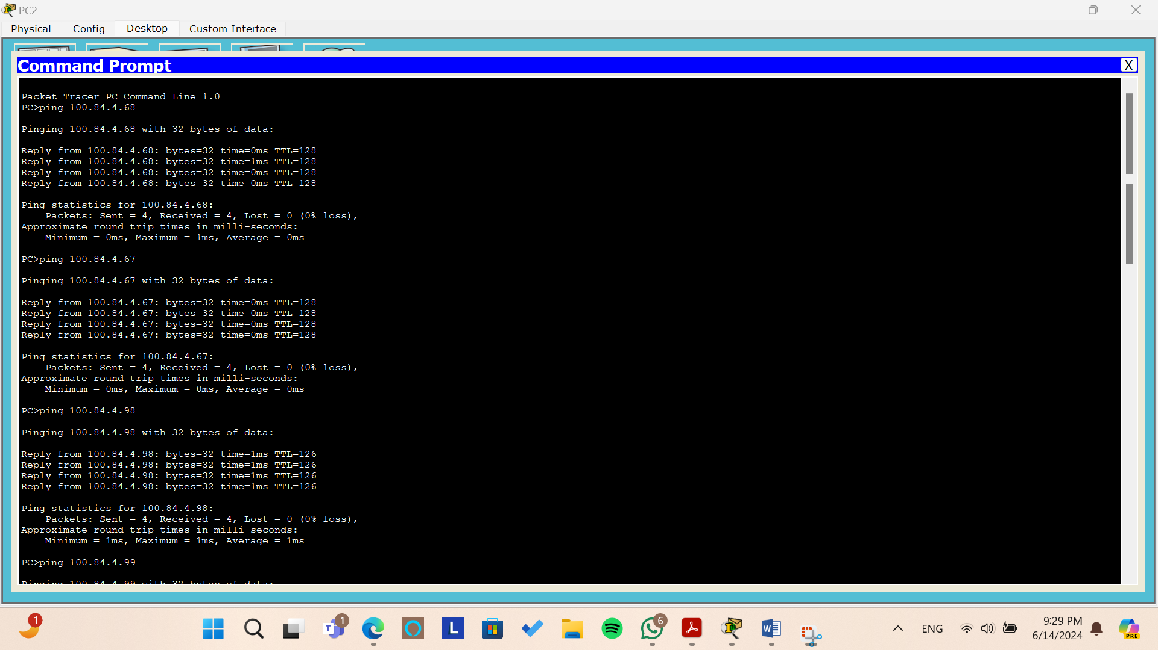

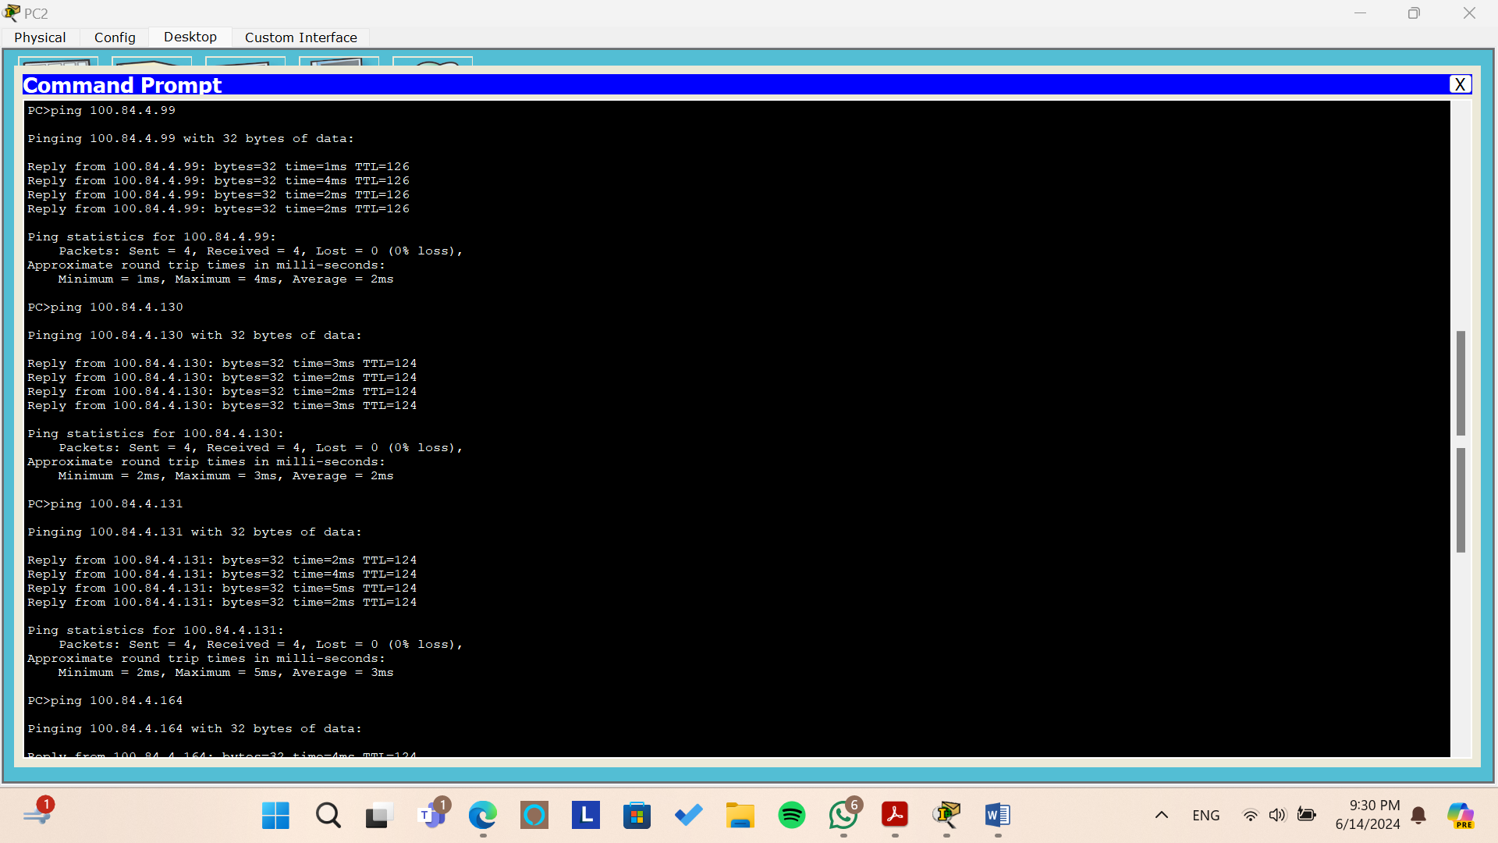

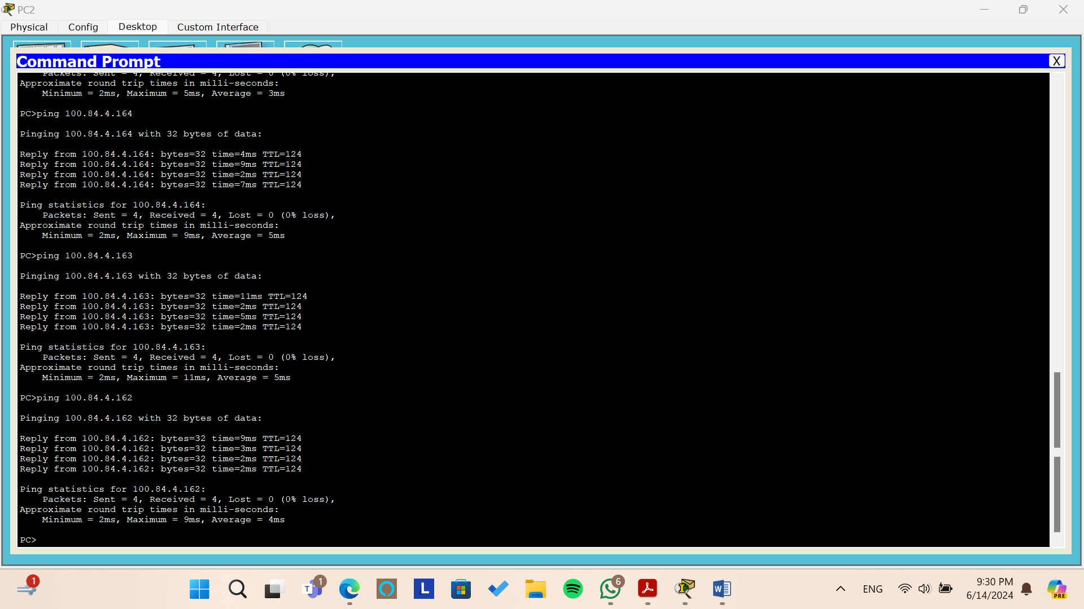

*Figure: Testing the ping command from PC2*

From the above pictures, we try to ping to all pcs from PC2 by sending 4 packets and we can see that all packets arrive without and lost packet or requested out.

**Tracert**

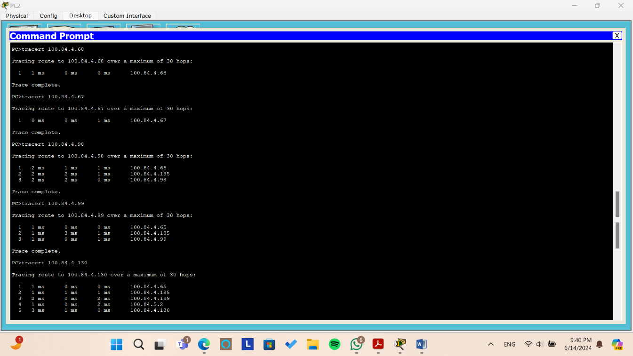

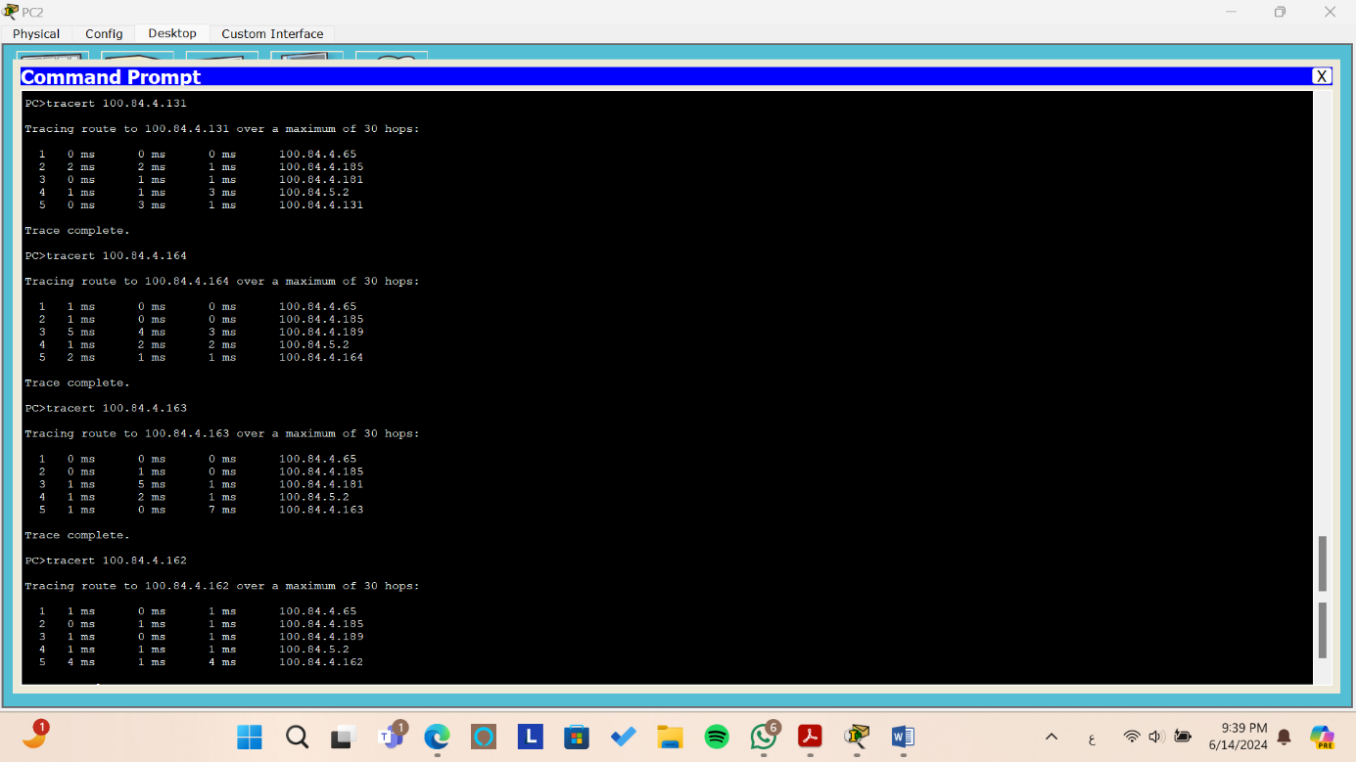

*Figure: Testing the tracert command from PC2*

When we use tracert between PC2 and other PCs it gives us the path between PC2 and the other

pcs.

* + To PC0 and PC1 the packets arrives directly since they are in the same network area.
  + To PC3 first we get through the gateway of the area 100.84.4.65 then through the interface 100.84.4.185 in the core network then to PC3.
  + To PC4 (same as PC3 path)
  + To PC5 first we get through the gateway of the area 00.84.4.65 then through the interface

100.84.4.185, then through the interface 100.84.4.189, then through the interface 100.84.5.2 in the core network then to PC5.

* To PC6 first we get through the gateway of the area 00.84.4.65 then through the interface 100.84.4.185, then through the interface 100.84.4.181, then through the interface 100.84.5.2 in the core network then to PC6.
  + To PC7 (same as PC5 path)
* To PC8 (same as PC6 path)
  + To PC9 (same as PC5 path)
* **Company B**
* **PC3**

**Ping**

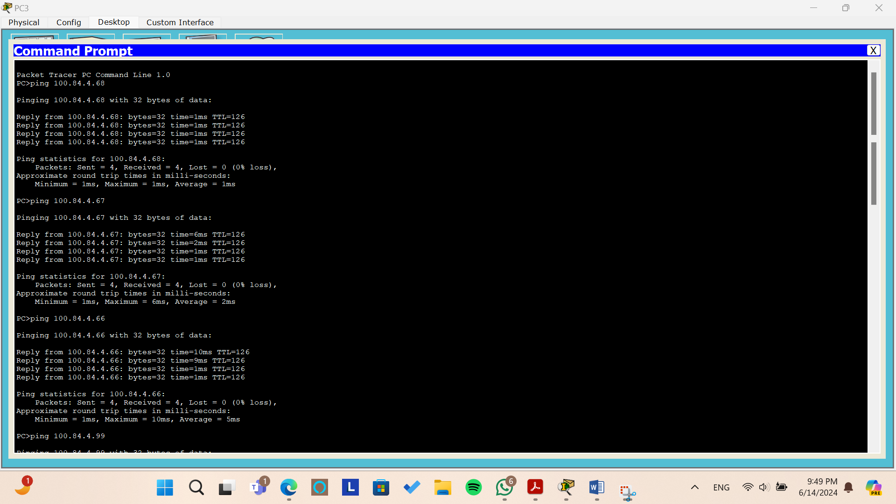

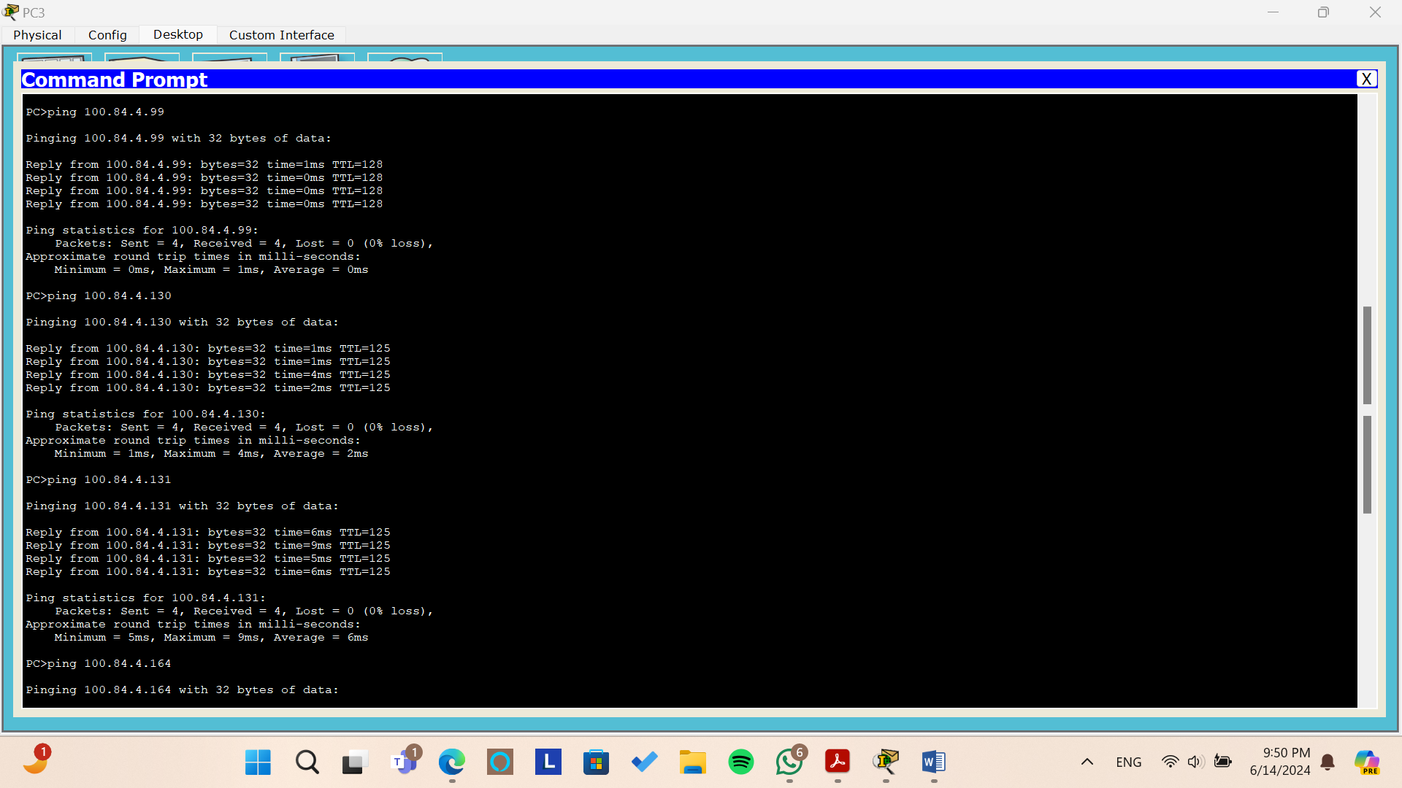

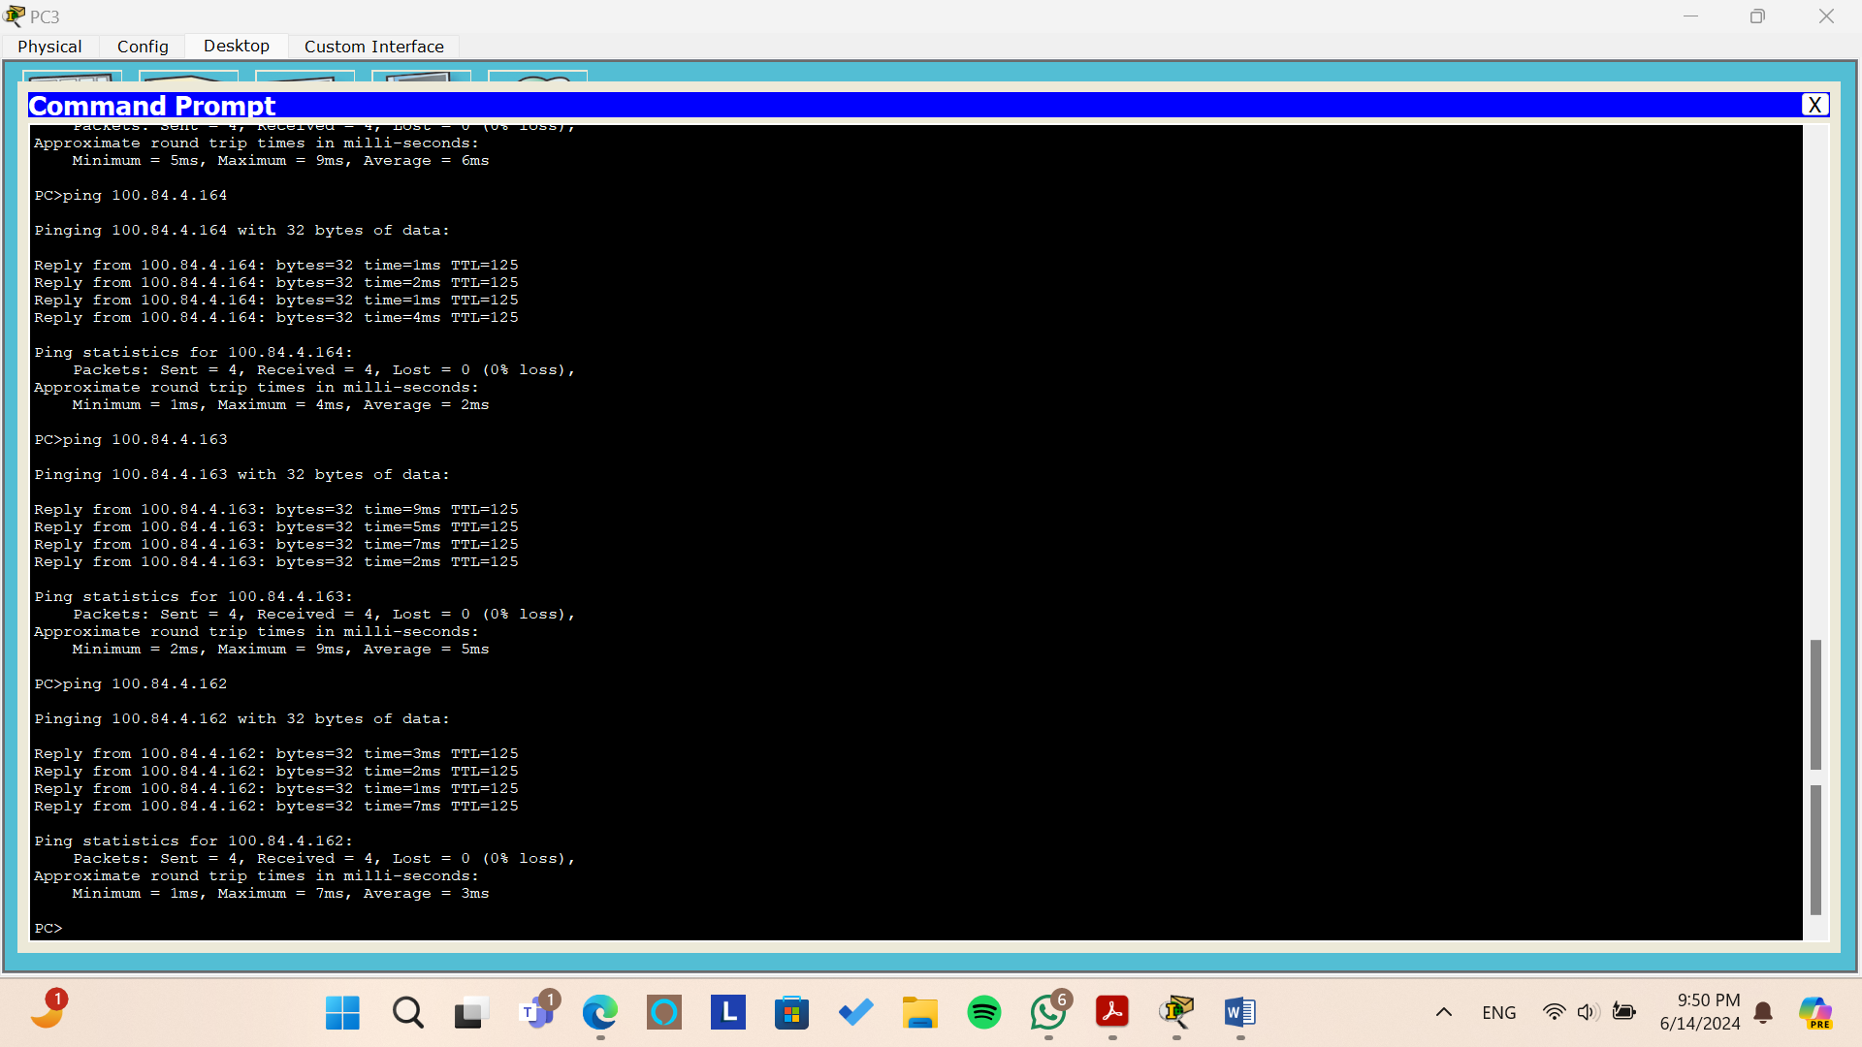

*Figure: Testing the ping command from PC3*

From the above pictures, we try to ping to all pcs from PC3 by sending 4 packets and we can see that all packets arrive without and lost packet or requested out.

**Tracert**

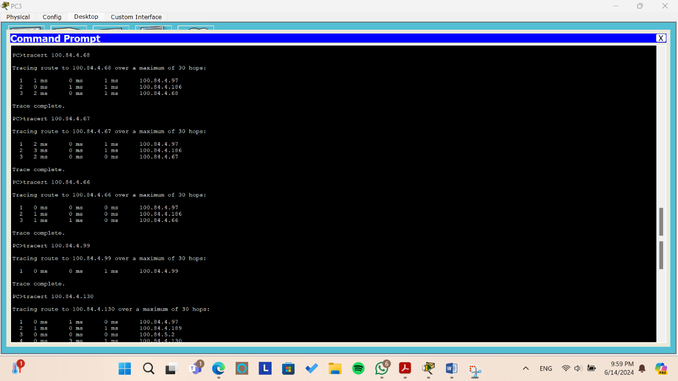

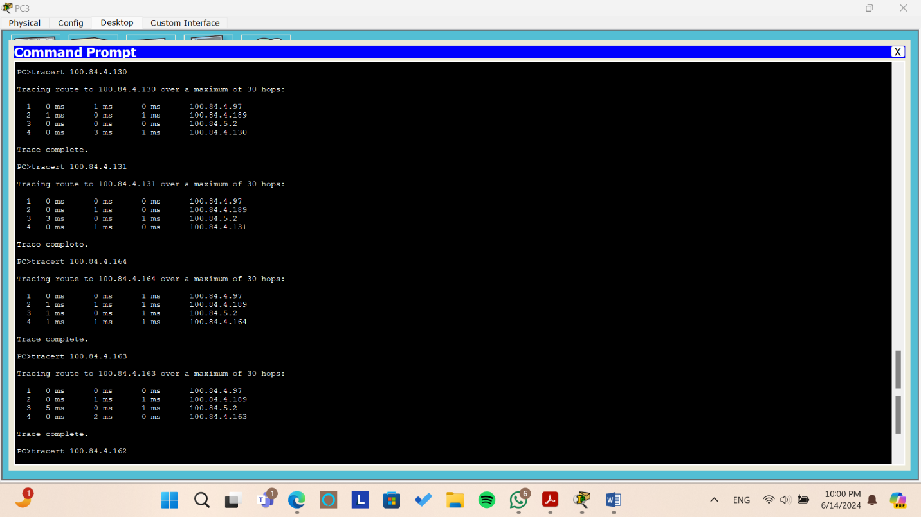

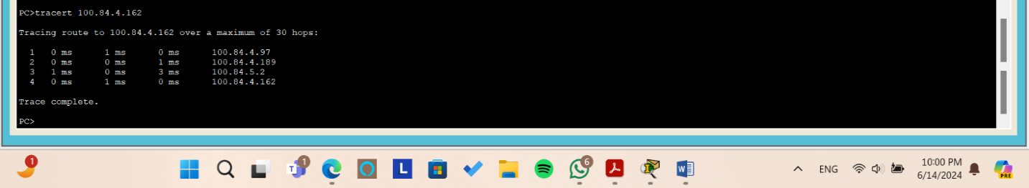

*Figure: Testing the tracert command from PC3*

When we use tracert between PC3 and other PCs it gives us the path between PC3 and the other pcs.

* + To PC0 first we get through the gateway of the area 100.84.4.97 then through the interface 100.84.4.186 in the core network then to PC0.
  + To PC1 (same as PC0 path)
  + To PC2 (same as PC0 path)
  + To PC4 the packets arrives directly since they are in the same network area.
  + To PC5 first we get through the gateway of the area 00.84.4.97, then through the interface 100.84.4.189, then through the interface 100.84.5.2 in the core network then to PC5.
* To PC6 (same as PC5 path)
  + To PC7 (same as PC5 path)
* To PC8 (same as PC5 path)
  + To PC9 (same as PC5 path)
  + **PC4**

**Ping**

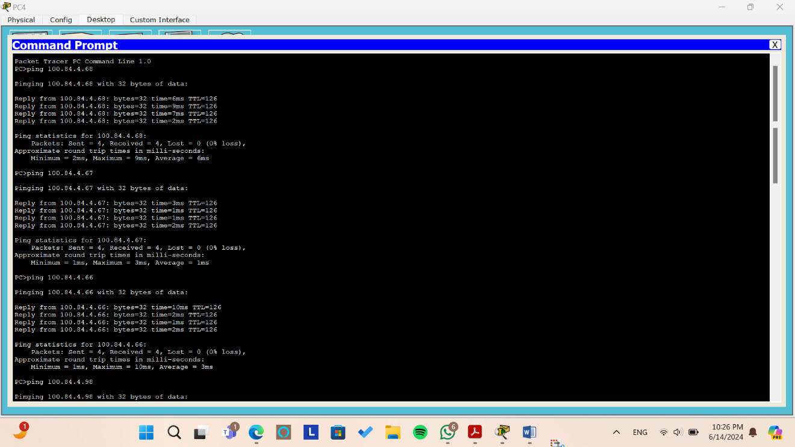

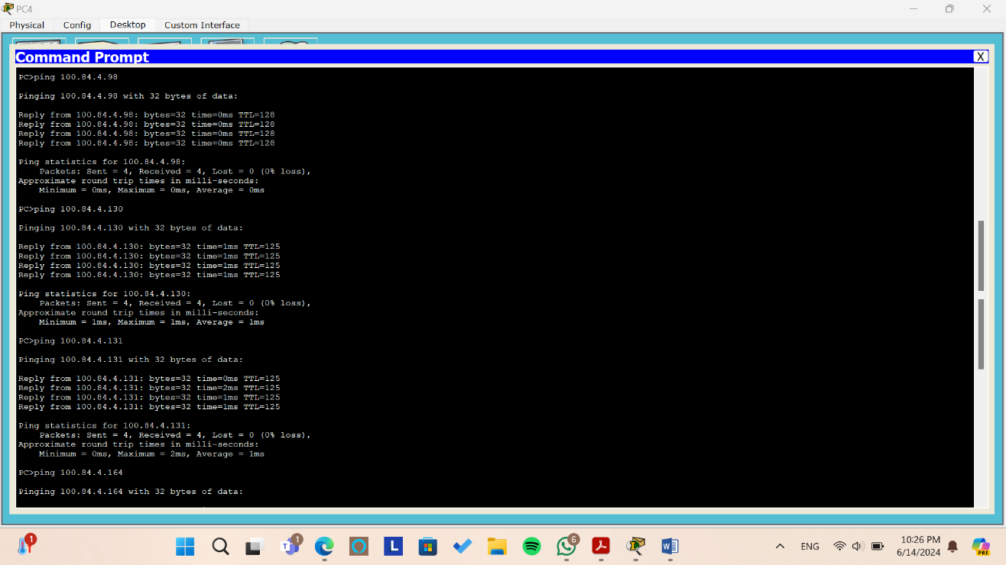

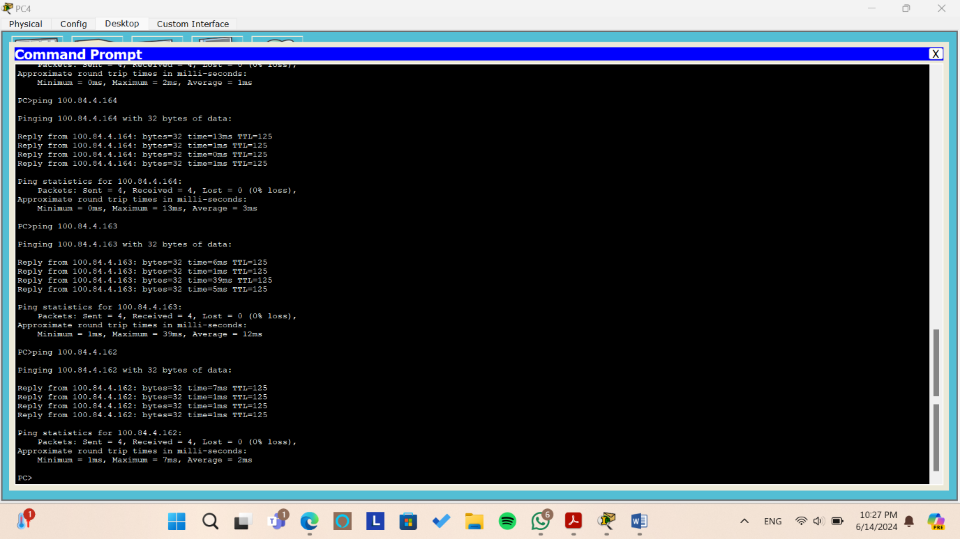

*Figure: Testing the ping command from PC4*

From the above pictures, we try to ping to all pcs from PC4 by sending 4 packets and we can see that all packets arrive without and lost packet or requested out.

**Tracert**

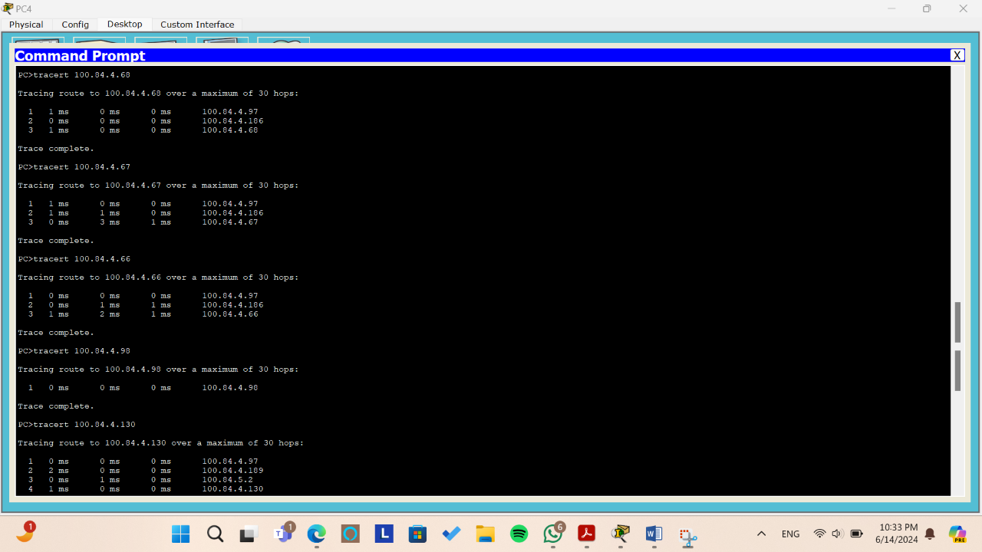

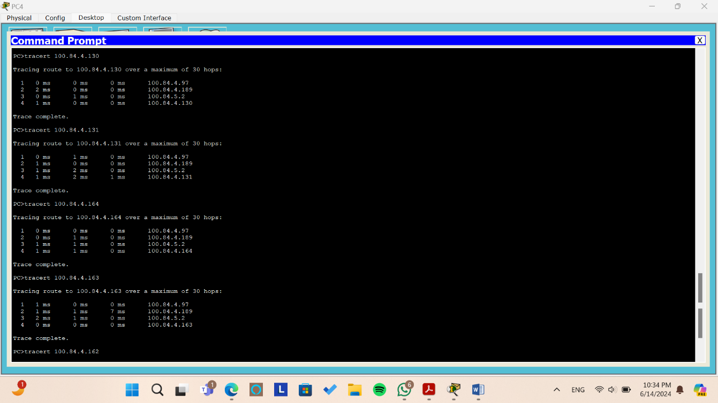

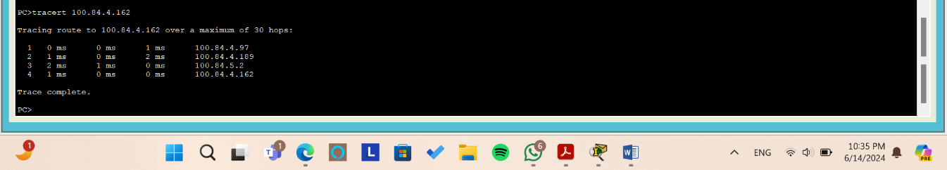

*Figure: Testing the tracert command from PC4*

When we use tracert between PC4 and other PCs it gives us the path between PC4 and the other pcs.

* + To PC0 first we get through the gateway of the area 100.84.4.97 then through the interface 100.84.4.186 in the core network then to PC0.
  + To PC1 (same as PC0 path)
  + To PC2 (same as PC0 path)
  + To PC3 the packets arrives directly since they are in the same network area.
  + To PC5 first we get through the gateway of the area 00.84.4.97, then through the interface 100.84.4.189, then through the interface 100.84.5.2 in the core network then to PC5.
* To PC6 (same as PC5 path)
  + To PC7 (same as PC5 path)
* To PC8 (same as PC5 path)
  + To PC9 (same as PC5 path)
* **Company C_Office 2**
* **PC5**

**Ping**

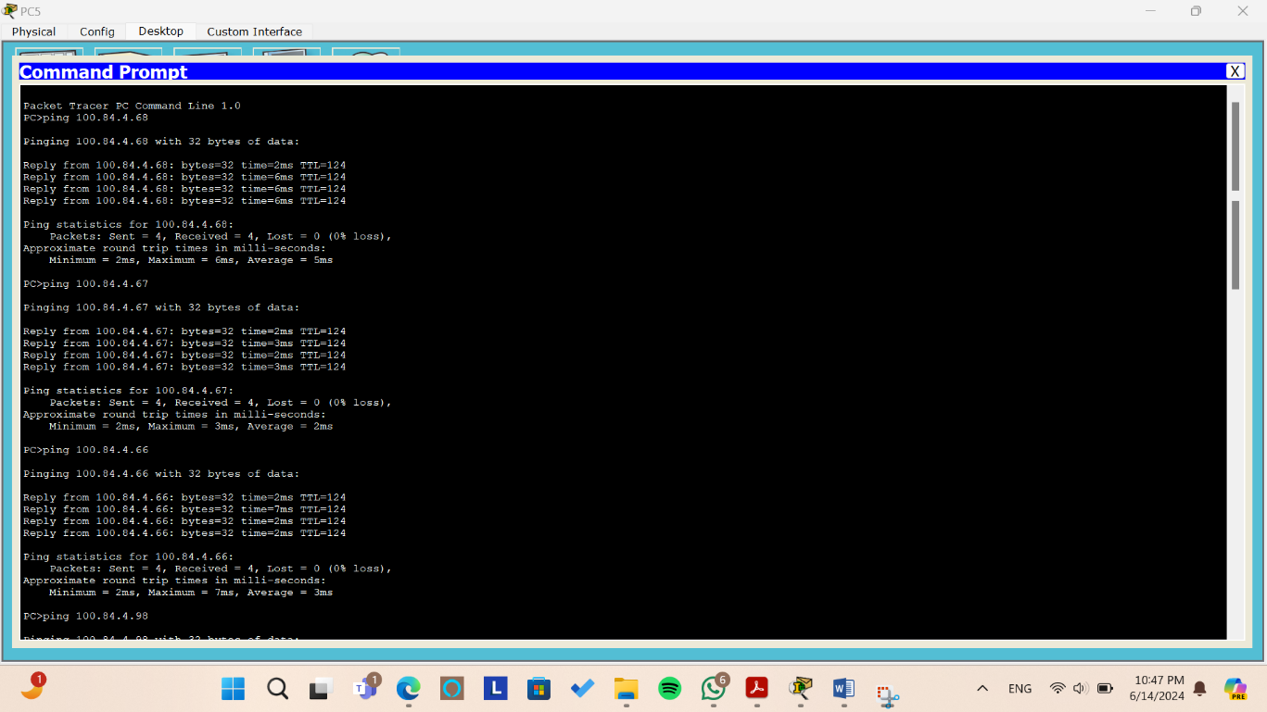

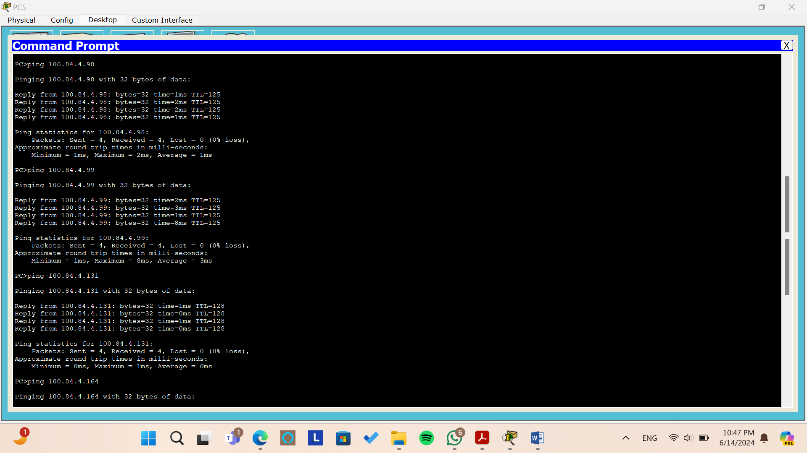

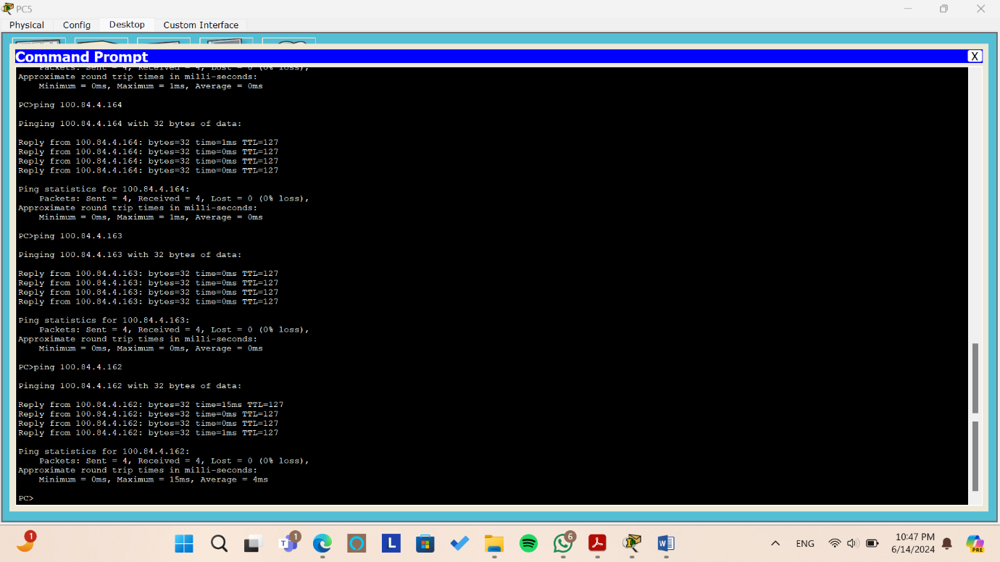

*Figure: Testing the ping command from PC5*

From the above pictures, we try to ping to all pcs from PC5 by sending 4 packets and we can see that all packets arrive without and lost packet or requested out.

**Tracert**

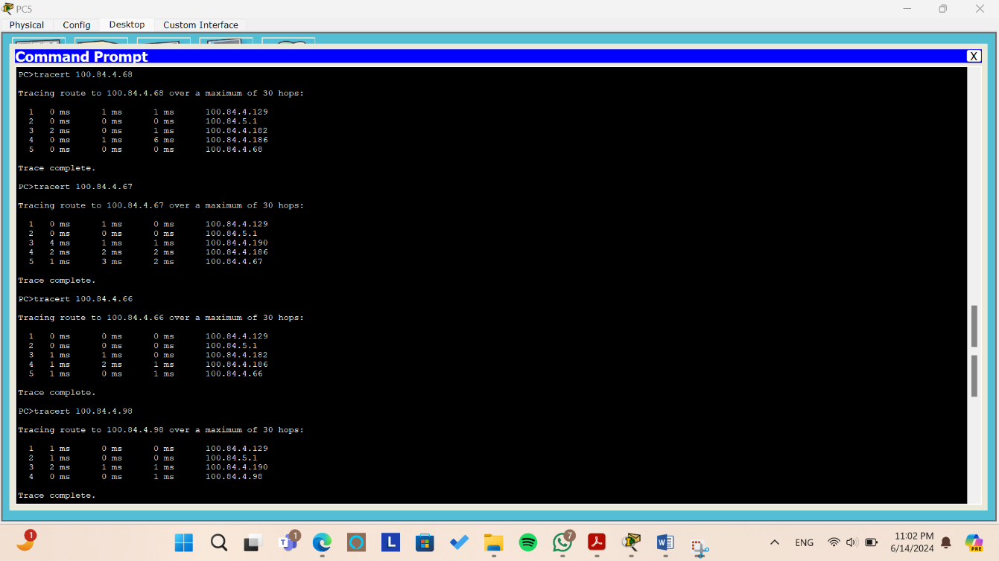

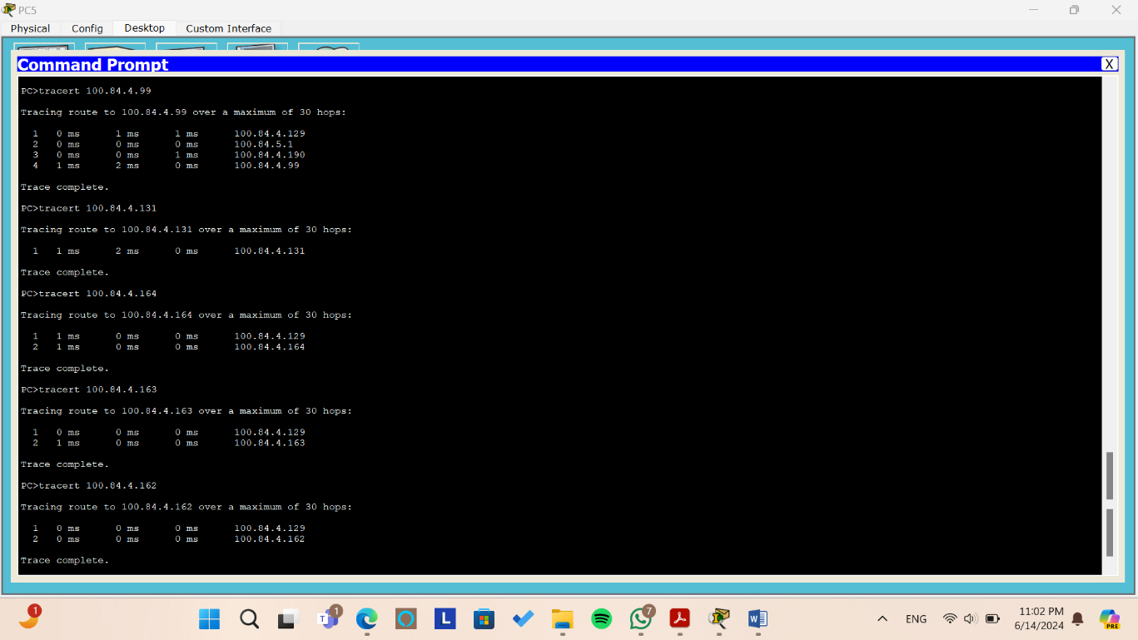

*Figure: Testing the tracert command from PC5*

When we use tracert between PC5 and other PCs it gives us the path between PC5 and the other pcs.

* + To PC0 first we get through the gateway of the area 100.84.4.129, then through the interface 100.84.5.1, then through the interface 100.84.4.182, then through the interface 100.84.4.186 in the core network then to PC0.
  + To PC1 first we get through the gateway of the area 100.84.4.129, then through the interface 100.84.5.1, then through the interface 100.84.4.190, then through the interface 100.84.4.186 in the core network then to PC1.
  + To PC2 (same as PC0 path)
  + To PC3 first we get through the gateway of the area 00.84.4.129, then through the interface 100.84.5.1, then through the interface 100.84.4.190 in the core network then to PC3.
  + To PC4 (same as PC3 path)
  + To PC6 the packets arrives directly since they are in the same network area.
  + To PC7 first we get through the gateway of the area 00.84.4.129 to PC7
* To PC8 first we get through the gateway of the area 00.84.4.129 to PC8
  + To PC9 first we get through the gateway of the area 00.84.4.129 to PC9
  + **PC6**

**Ping**

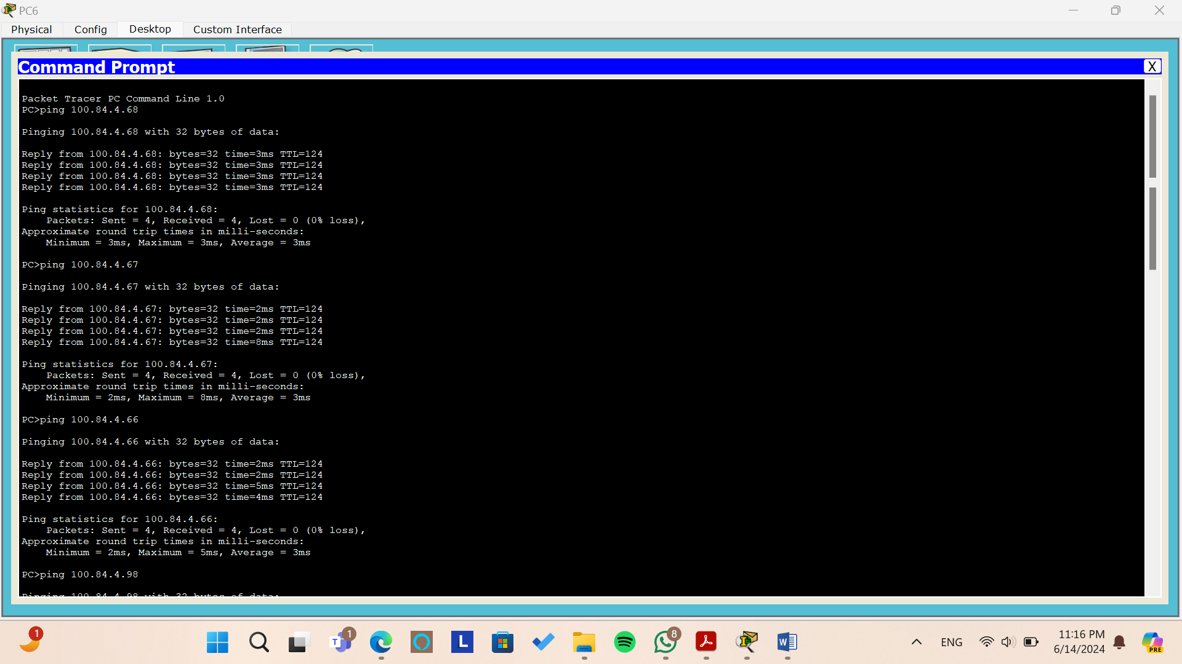

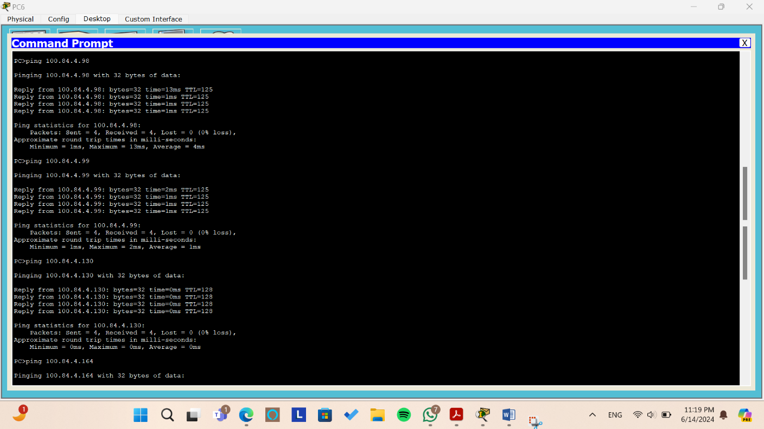

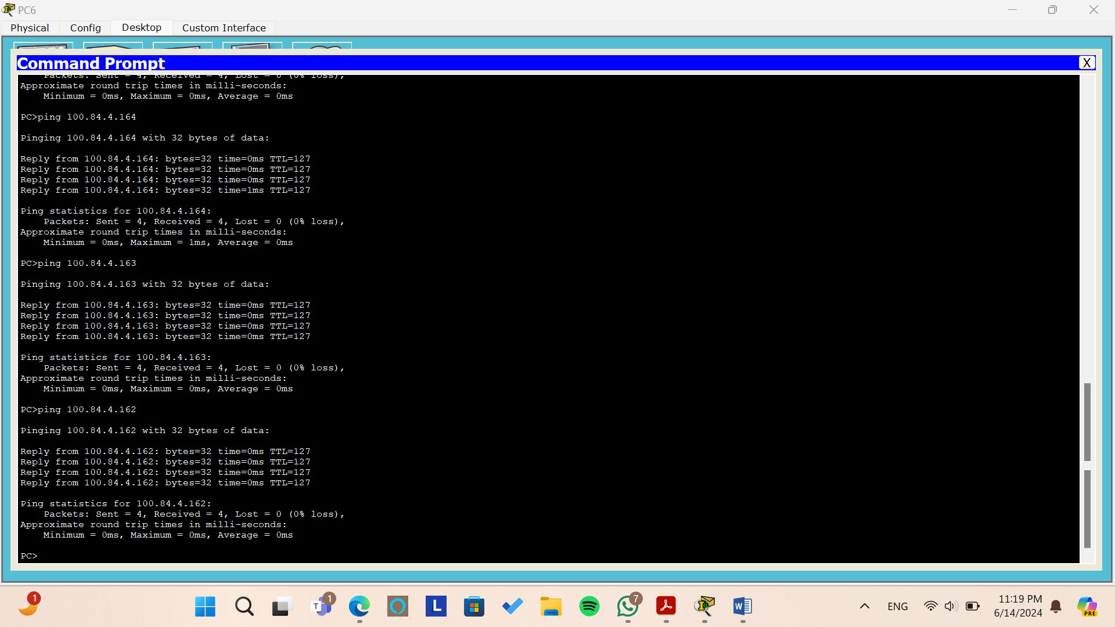

*Figure: Testing the ping command from PC6*

From the above pictures, we try to ping to all pcs from PC6 by sending 4 packets and we can see that all packets arrive without and lost packet or requested out.

**Tracert**

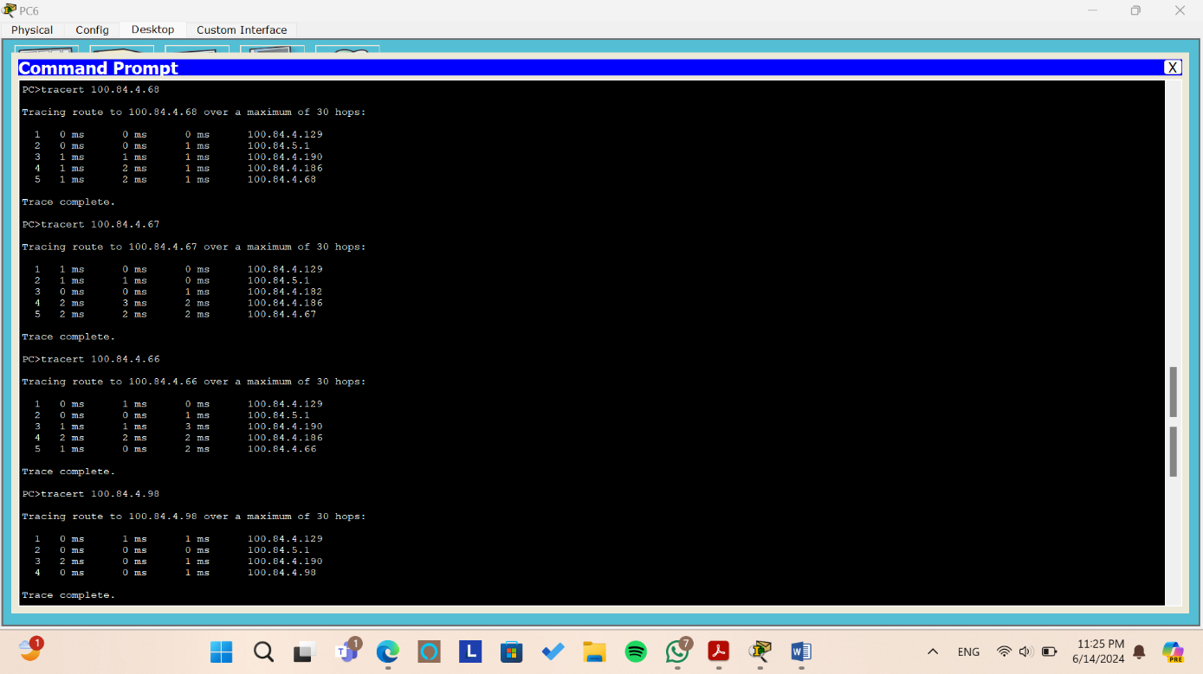

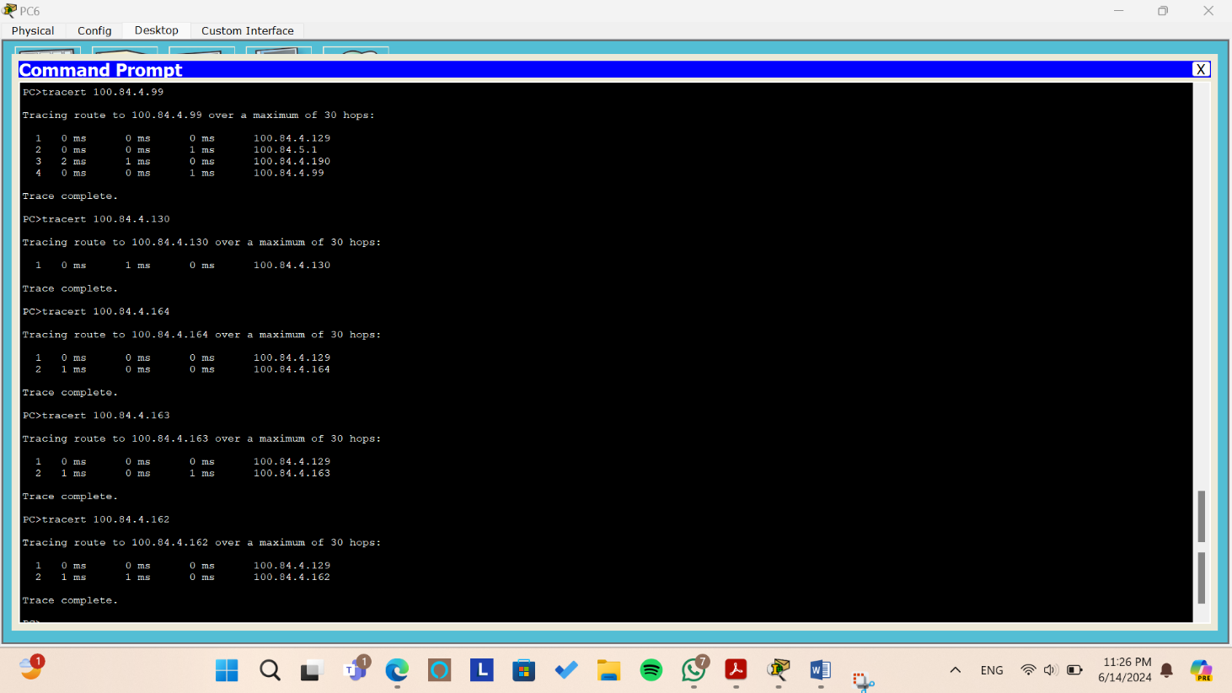

*Figure: Testing the tracert command from PC6*

When we use tracert between PC6 and other PCs it gives us the path between PC6 and the other pcs.

* + To PC0 first we get through the gateway of the area 100.84.4.129, then through the interface 100.84.5.1, then through the interface 100.84.4.190, then through the interface 100.84.4.186 in the core network then to PC0.
  + To PC1 first we get through the gateway of the area 100.84.4.129, then through the interface 100.84.5.1, then through the interface 100.84.4.182, then through the interface 100.84.4.186 in the core network then to PC1.
  + To PC2 (same as PC0 path)
  + To PC3 first we get through the gateway of the area 00.84.4.129, then through the interface 100.84.5.1, then through the interface 100.84.4.190 in the core network then to PC3.
  + To PC4 (same as PC3 path)
  + To PC5 the packets arrives directly since they are in the same network area.
  + To PC7 first we get through the gateway of the area 00.84.4.129 to PC7
* To PC8 first we get through the gateway of the area 00.84.4.129 to PC8
  + To PC9 first we get through the gateway of the area 00.84.4.129 to PC9
* **Company C_Office 1**
* **PC7**

**Ping**

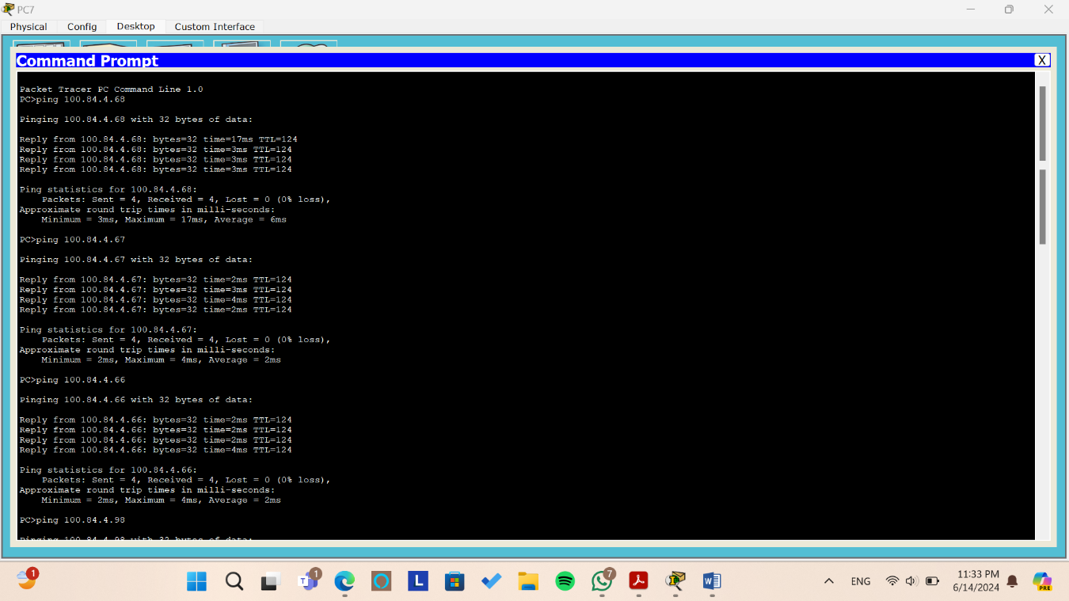

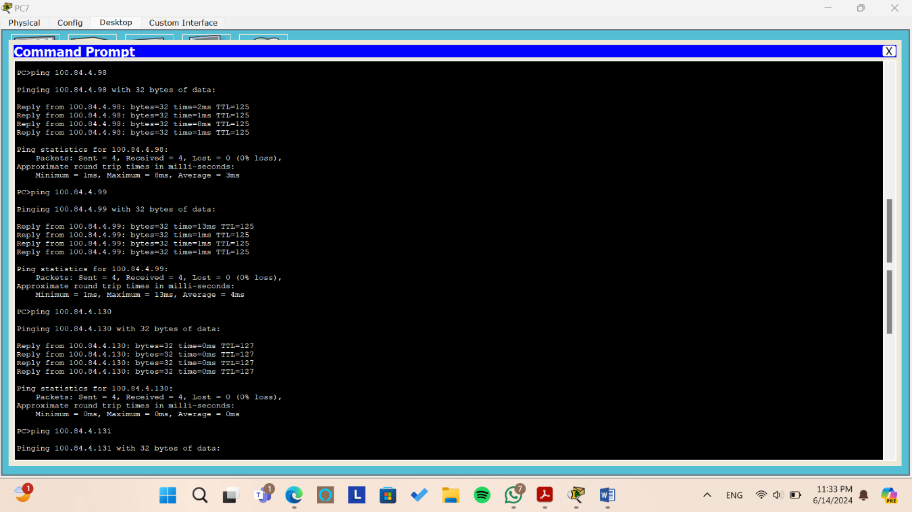

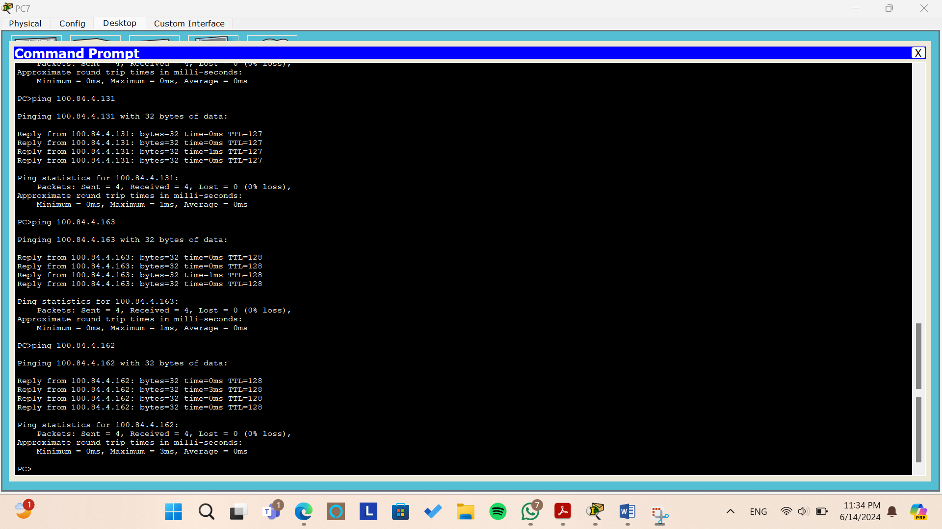

*Figure: Testing the ping command from PC7*

From the above pictures, we try to ping to all pcs from PC7 by sending 4 packets and we can see that all packets arrive without and lost packet or requested out.

**Tracert**

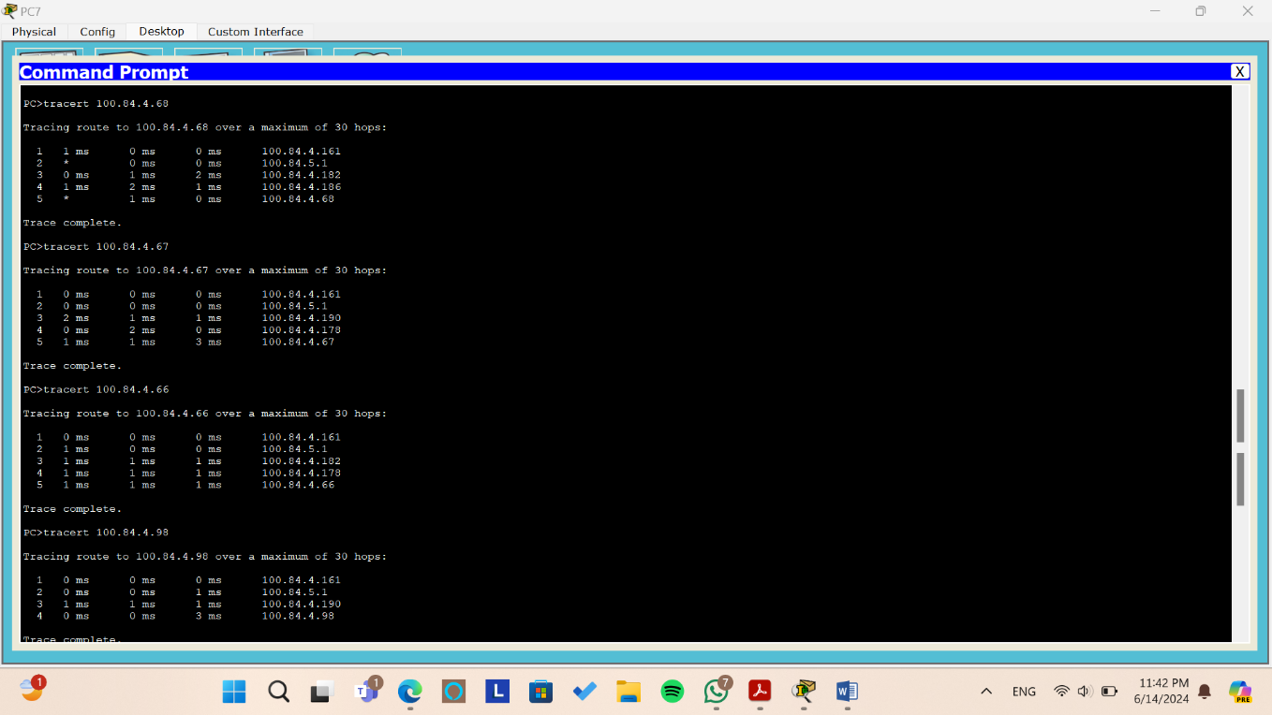

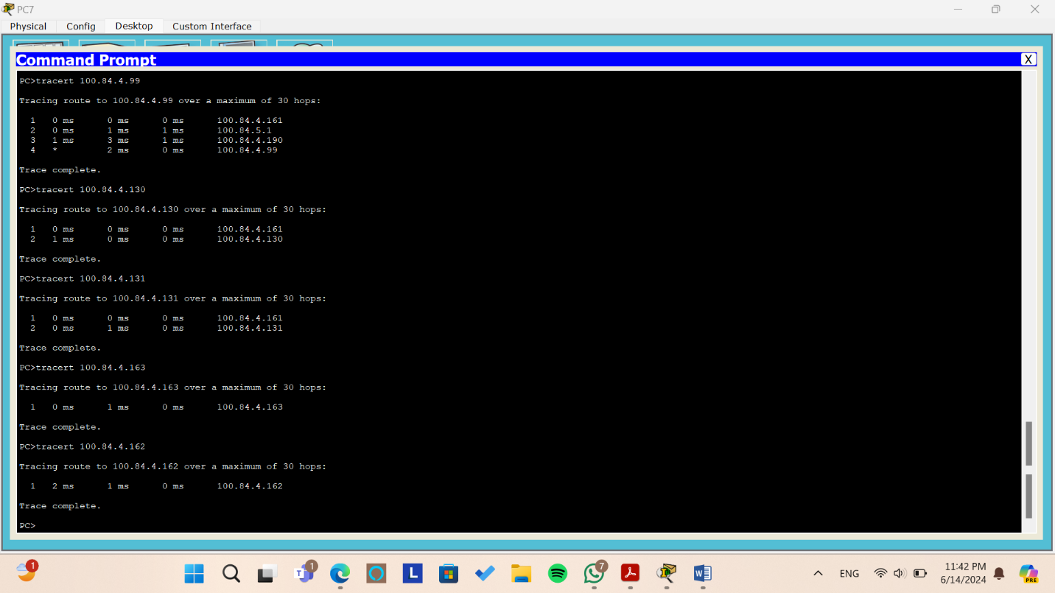

*Figure: Testing the tracert command from PC7*

When we use tracert between PC7 and other PCs it gives us the path between PC7 and the other pcs.

* + To PC0 first we get through the gateway of the area 100.84.4.161, then through the interface 100.84.5.1, then through the interface 100.84.4.182, then through the interface 100.84.4.186 in the core network then to PC0.
  + To PC1 first we get through the gateway of the area 100.84.4.161, then through the interface 100.84.5.1, then through the interface 100.84.4.190, then through the interface 100.84.4.178 in the core network then to PC1.
  + To PC2 first we get through the gateway of the area 100.84.4.161, then through the interface 100.84.5.1, then through the interface 100.84.4.182, then through the interface 100.84.4.178 in the core network then to PC2.
  + To PC3 first we get through the gateway of the area 00.84.4.161, then through the interface 100.84.5.1, then through the interface 100.84.4.190 in the core network then to PC3.
  + To PC4 (same as PC3 path)
  + To PC5 first we get through the gateway of the area 00.84.4.161 to PC5
  + To PC6 first we get through the gateway of the area 00.84.4.161 to PC6
* To PC8 and PC9 the packets arrives directly since they are in the same network area.
* **PC8**

**Ping**

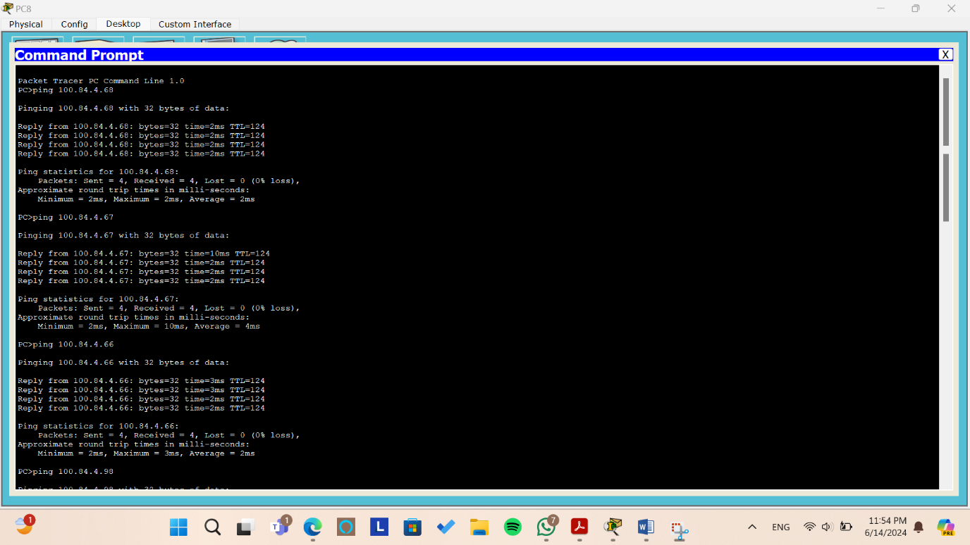

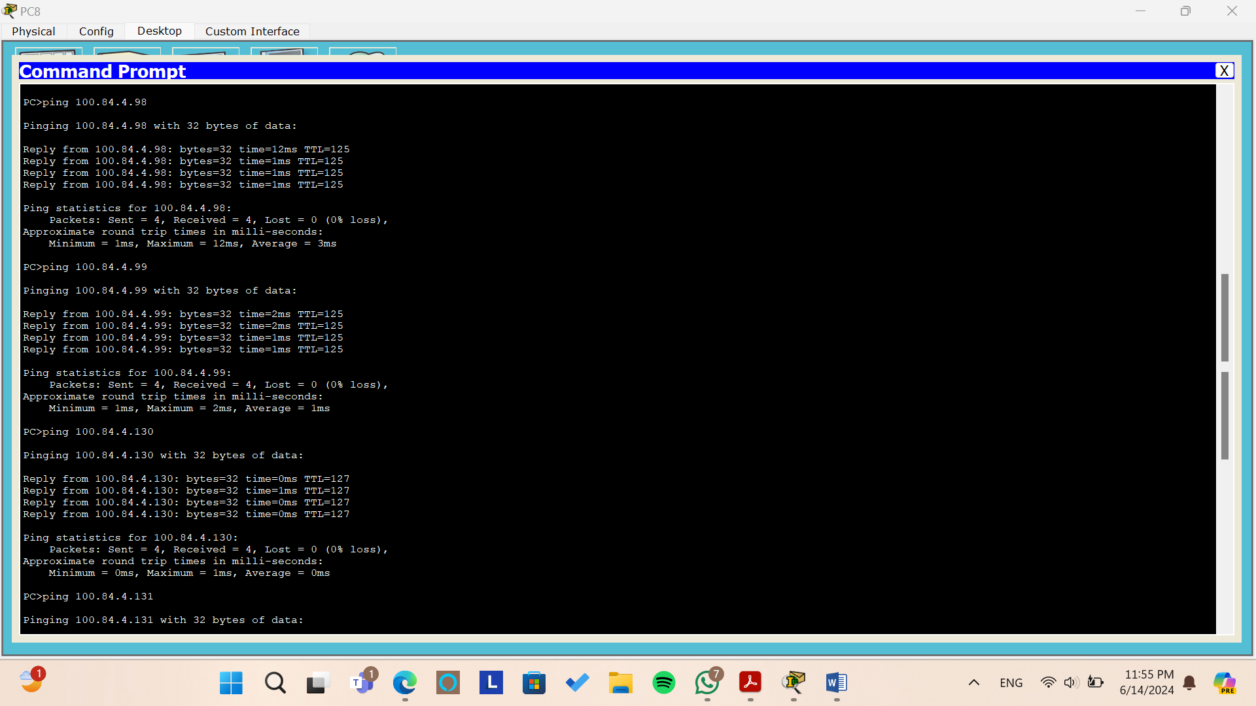

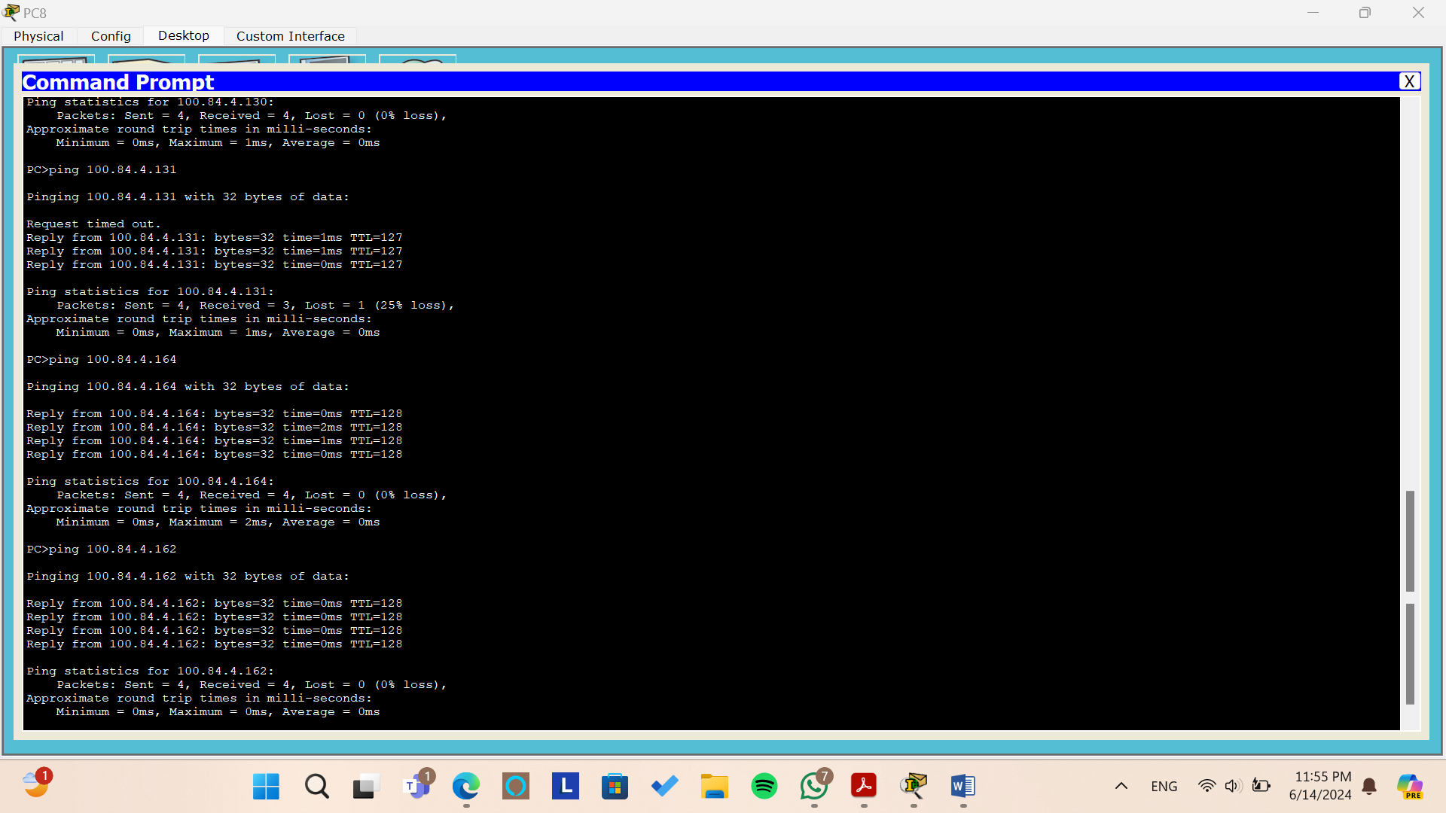

*Figure: Testing the ping command from PC8*

From the above pictures, we try to ping to all pcs from PC8 by sending 4 packets and we can see that all packets arrive without and lost packet or requested out.

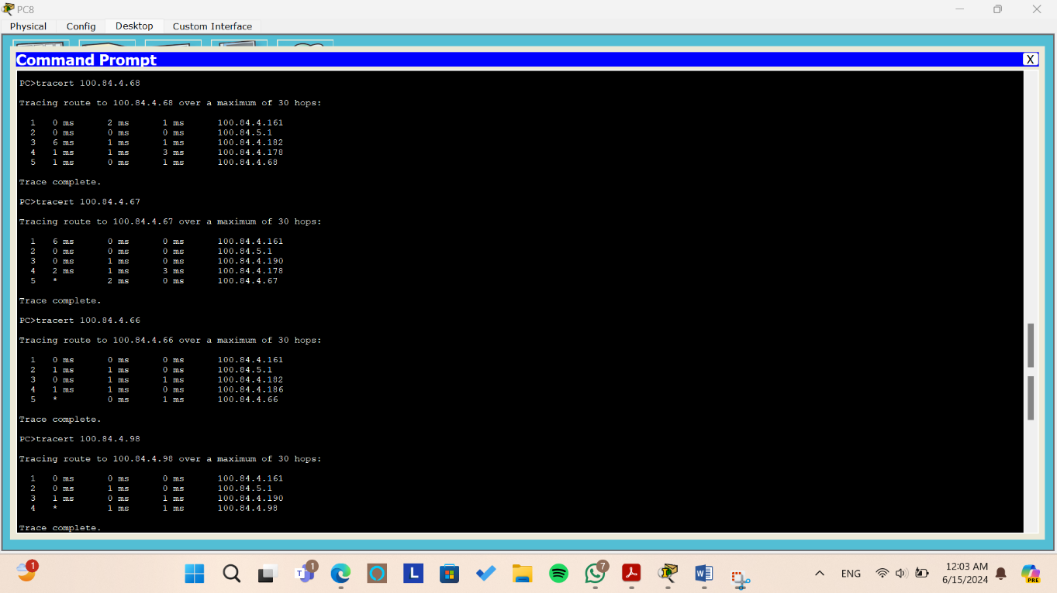**Tracert**

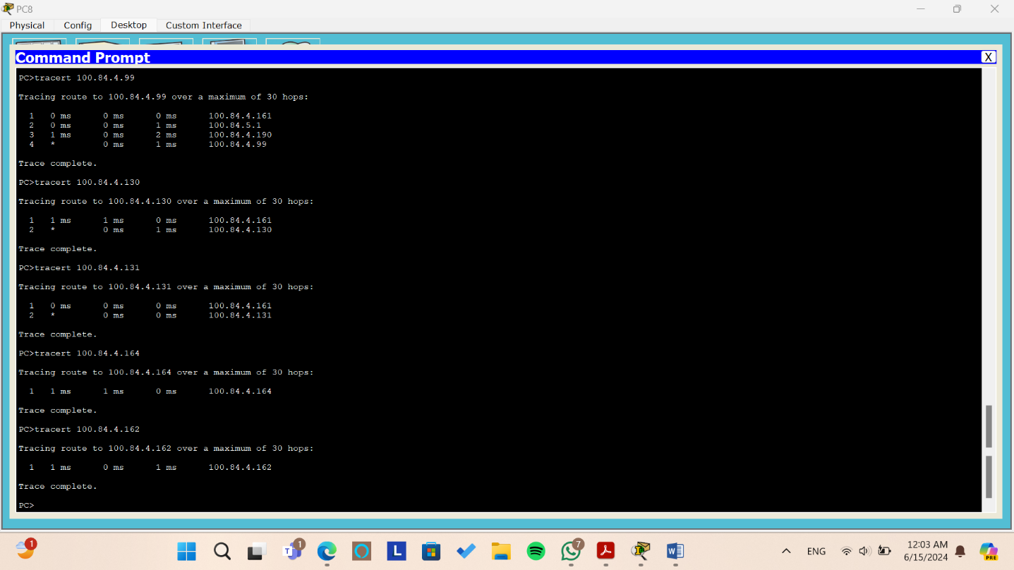

*Figure: Testing the tracert command from PC8*

When we use tracert between PC8 and other PCs it gives us the path between PC8 and the other pcs.

* + To PC0 first we get through the gateway of the area 100.84.4.161, then through the interface 100.84.5.1, then through the interface 100.84.4.182, then through the interface 100.84.4.178 in the core network then to PC0.
  + To PC1 first we get through the gateway of the area 100.84.4.161, then through the interface 100.84.5.1, then through the interface 100.84.4.190, then through the interface 100.84.4.178 in the core network then to PC1.
  + To PC2 first we get through the gateway of the area 100.84.4.161, then through the interface 100.84.5.1, then through the interface 100.84.4.182, then through the interface 100.84.4.186 in the core network then to PC2.
  + To PC3 first we get through the gateway of the area 00.84.4.161, then through the interface 100.84.5.1, then through the interface 100.84.4.190 in the core network then to PC3.
  + To PC4 (same as PC3 path)
  + To PC5 first we get through the gateway of the area 00.84.4.161 to PC5
  + To PC6 first we get through the gateway of the area 00.84.4.161 to PC6
* To PC7 and PC9 the packets arrives directly since they are in the same network area.
* **PC9**

**Ping**

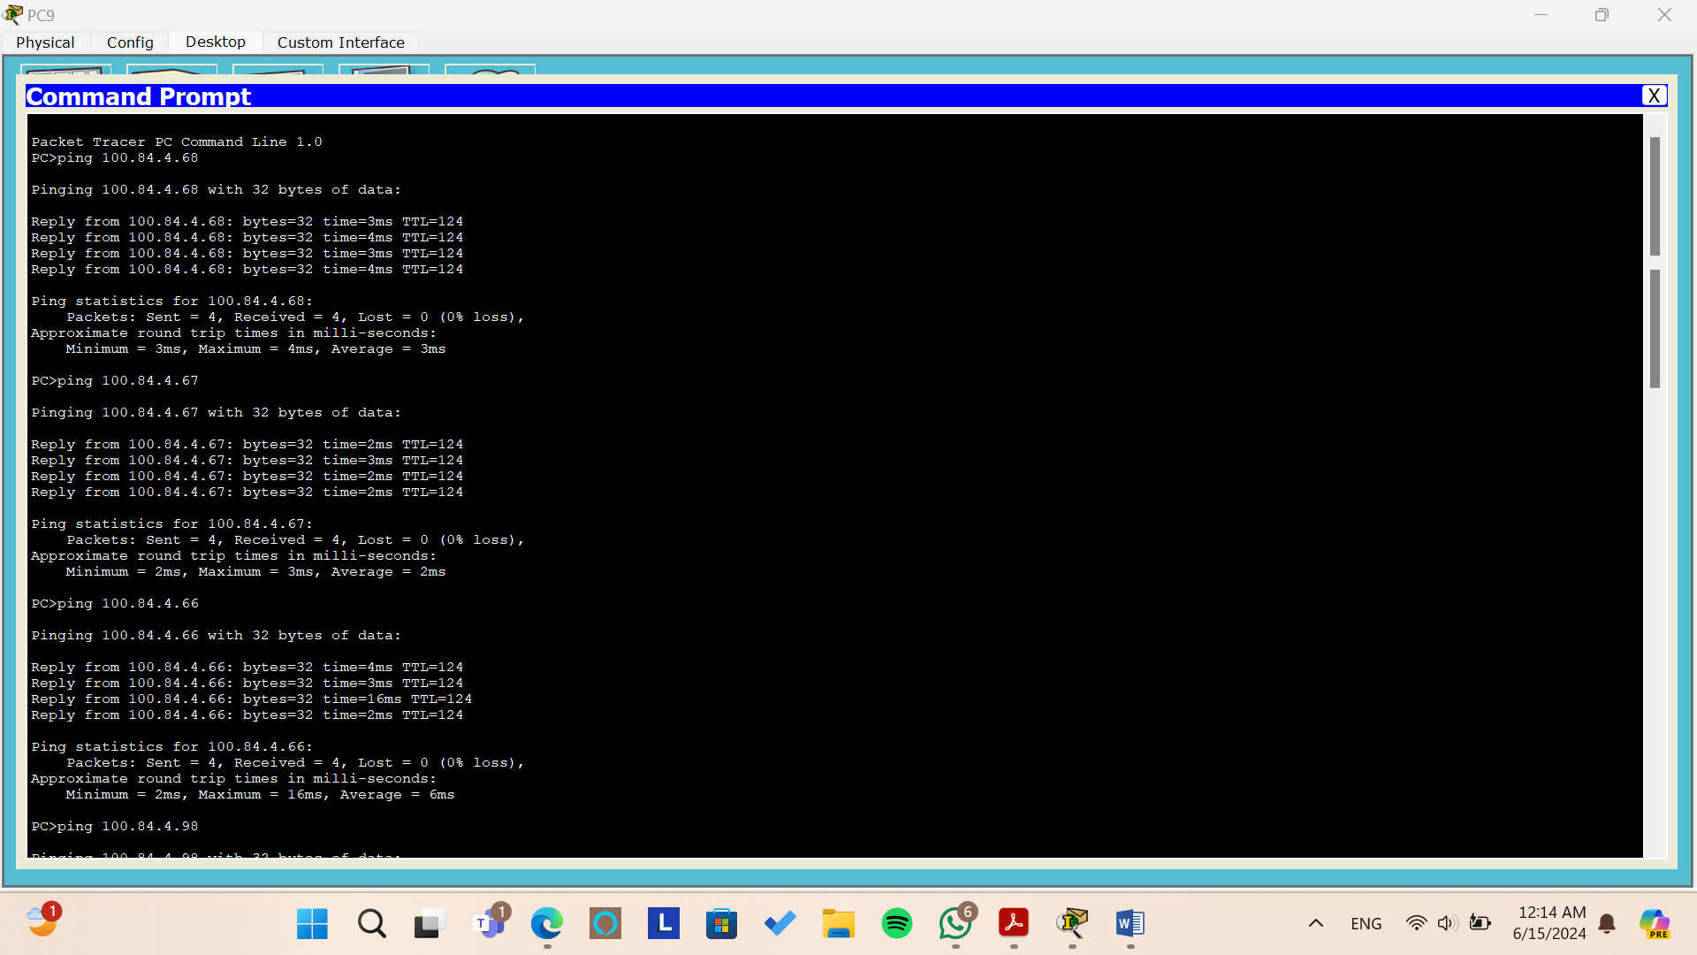

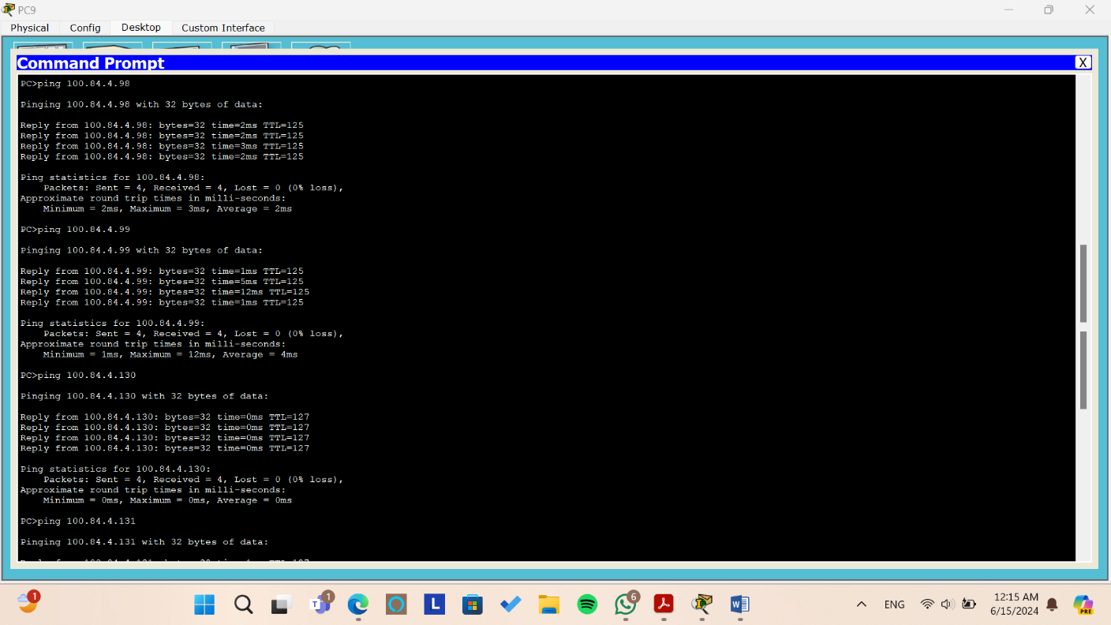

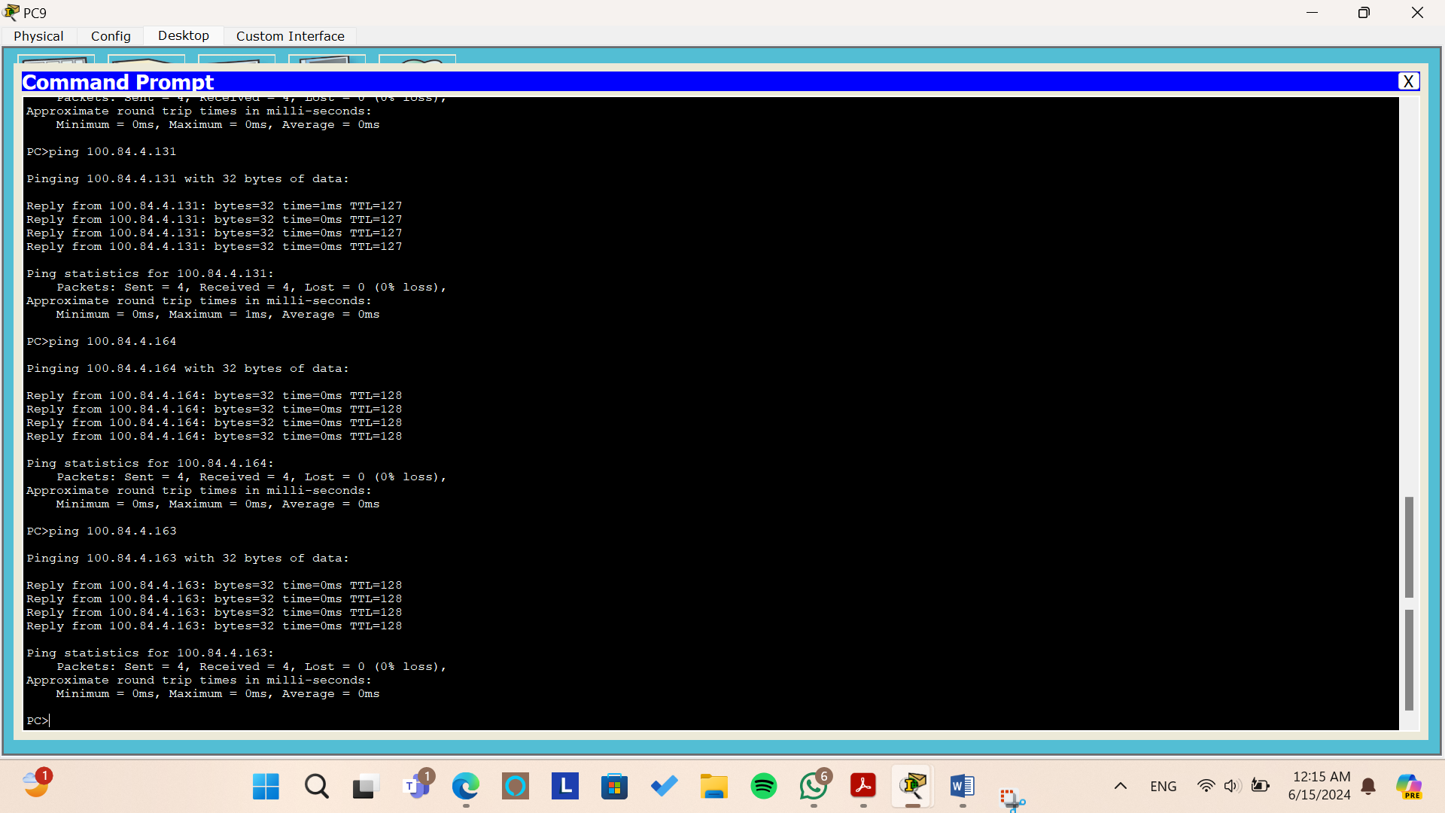

*Figure: Testing the ping command from PC9*

From the above pictures, we try to ping to all pcs from PC9 by sending 4 packets and we can see that all packets arrive without and lost packet or requested out.

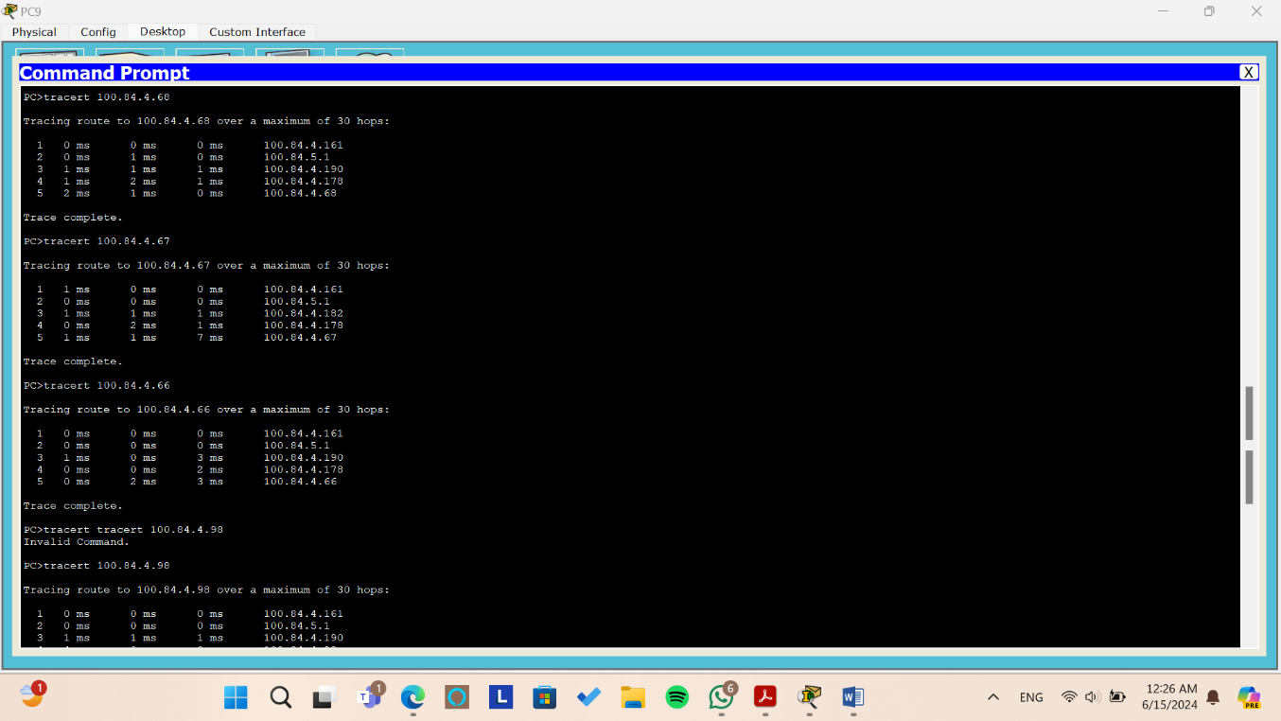**Tracert**

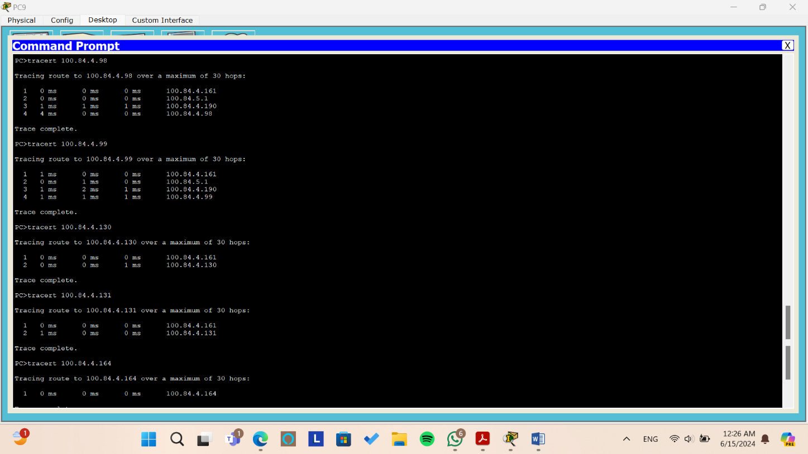

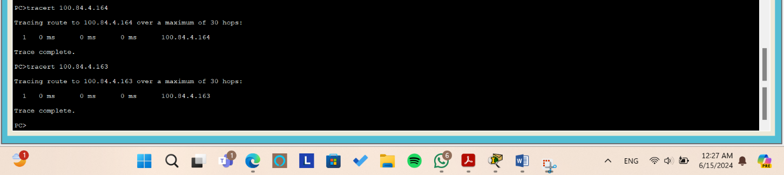

*Figure: Testing the tracert command from PC9*

When we use tracert between PC9 and other PCs it gives us the path between PC9 and the other pcs.

* + To PC0 first we get through the gateway of the area 100.84.4.161, then through the interface 100.84.5.1, then through the interface 100.84.4.190, then through the interface 100.84.4.178 in the core network then to PC0.
  + To PC1 first we get through the gateway of the area 100.84.4.161, then through the interface 100.84.5.1, then through the interface 100.84.4.182, then through the interface 100.84.4.178 in the core network then to PC1.
  + To PC2 first we get through the gateway of the area 100.84.4.161, then through the interface 100.84.5.1, then through the interface 100.84.4.190, then through the interface 100.84.4.178 in the core network then to PC2.
  + To PC3 first we get through the gateway of the area 100.84.4.161, then through the interface 100.84.5.1, then through the interface 100.84.4.190 in the core network then to PC3.
  + To PC4 (same as PC3 path)
  + To PC5 first we get through the gateway of the area 100.84.4.161 to PC5
  + To PC6 first we get through the gateway of the area 100.84.4.161 to PC6
* To PC7 and PC8 the packets arrives directly since they are in the same network area.
* **Access** [**www.ENCS3320.com**](http://www.ENCS3320.com) **from all PC’s**

**In this part, we tried to access the web site we created www.ENCS3320.com, to make sure that we can connect with HTTP server and DNS server.**

* **Company A Devices**
* **PC0**

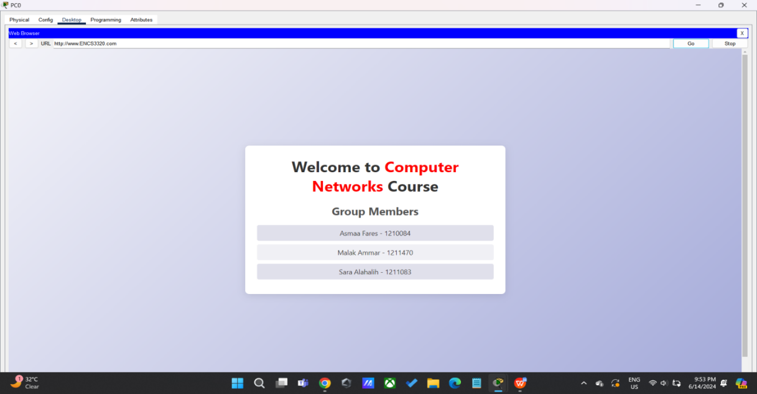

* **PC1**

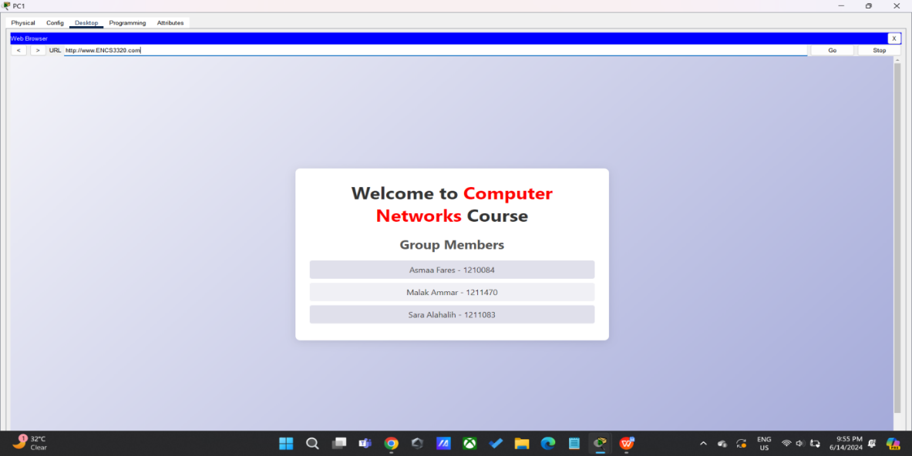

* **PC2**

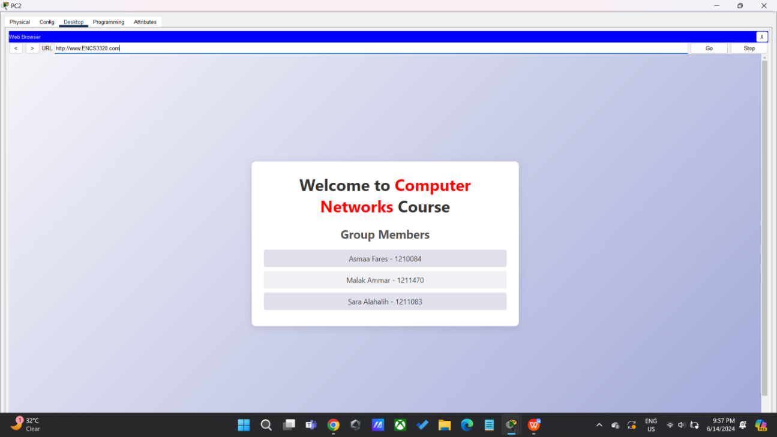

* **Company B Devices**
* **PC3**

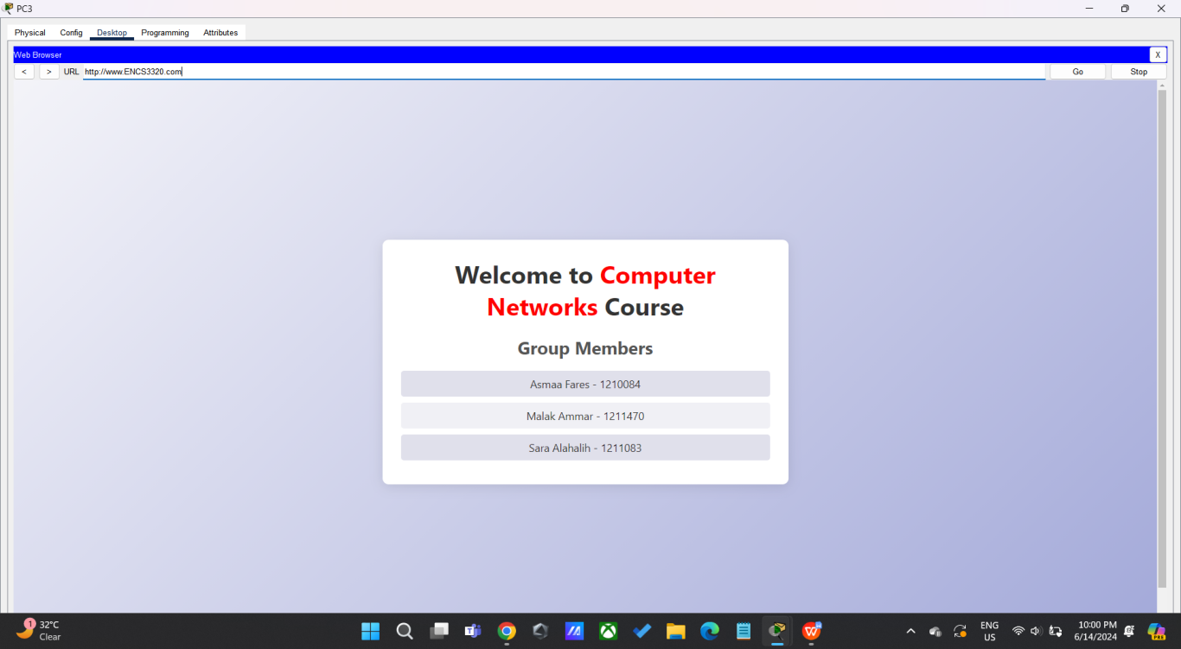

* **PC4**

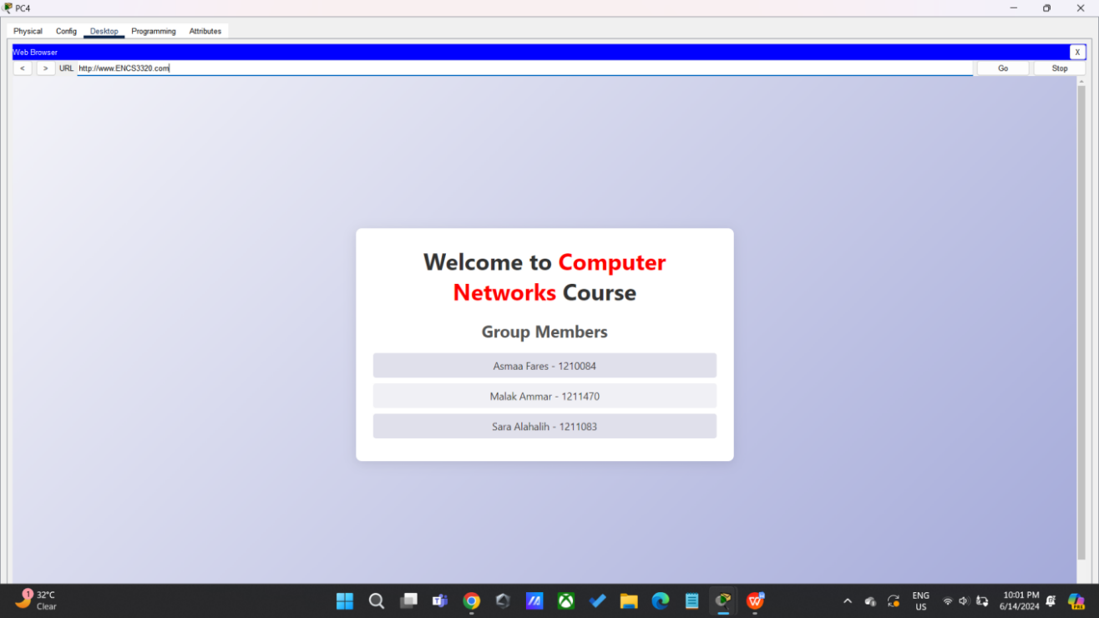

* **Company C Office Two Devices**
* **PC5**

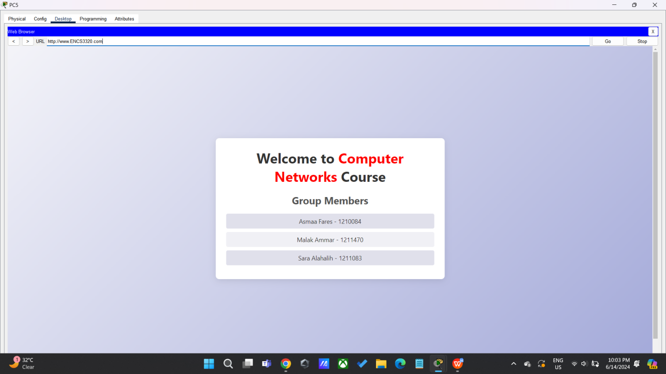

* **PC6**

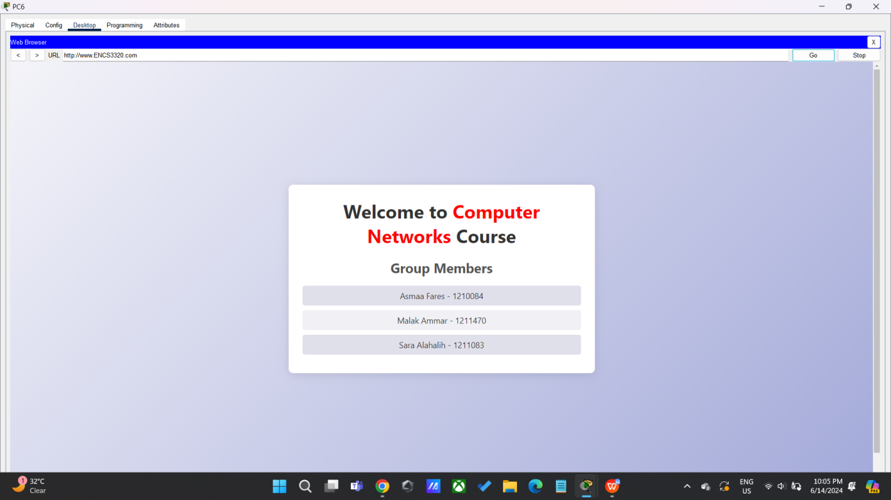

* **Company C Office One Devices**
* **PC7**

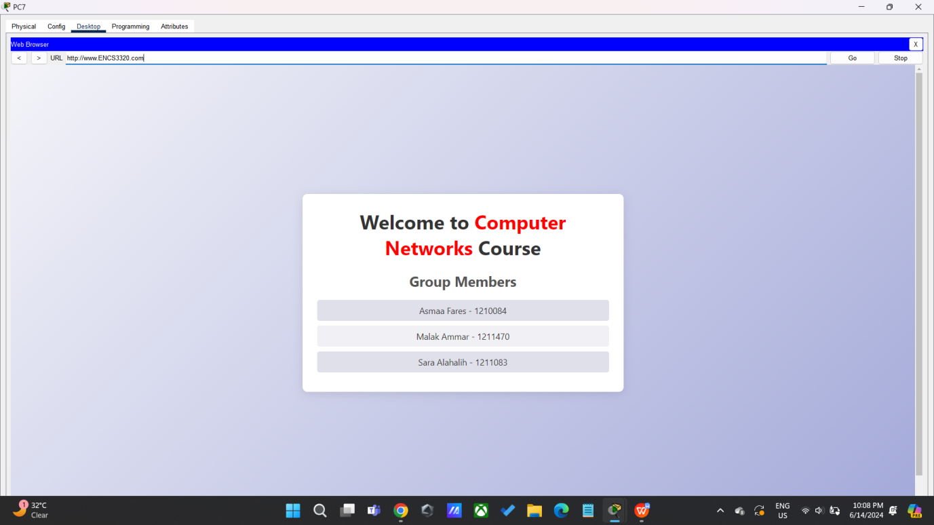

* **PC8**

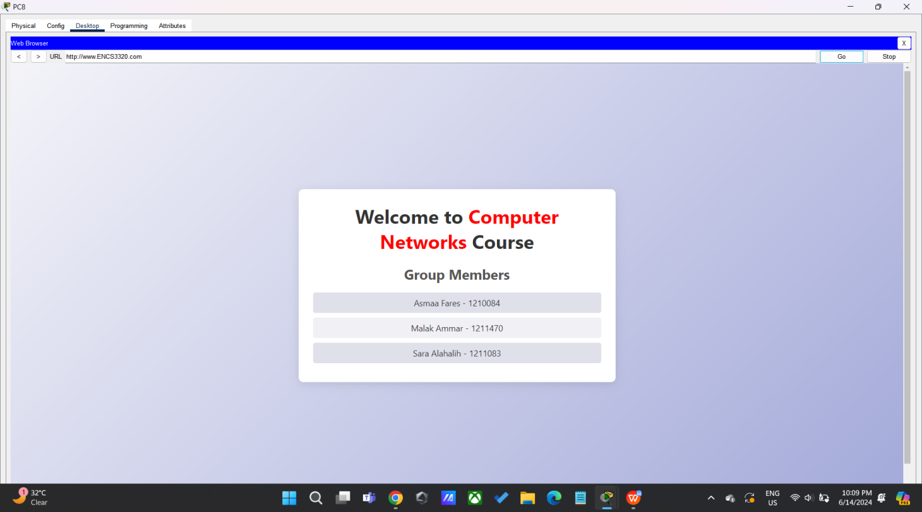

* **PC9**

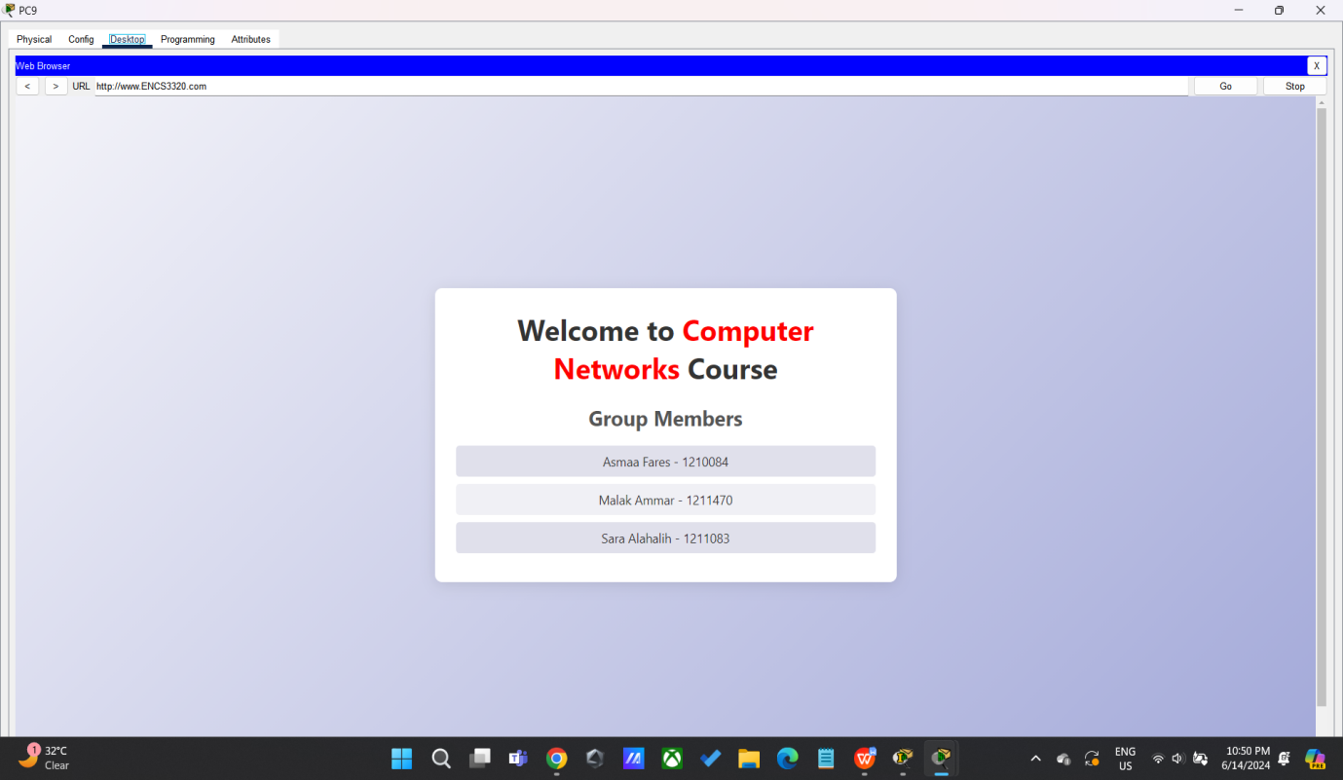

* **Check the IPs of the end systems**

During this phase, we employed the "**ipconfig**" command to inspect the IP configurations of each PC.

* 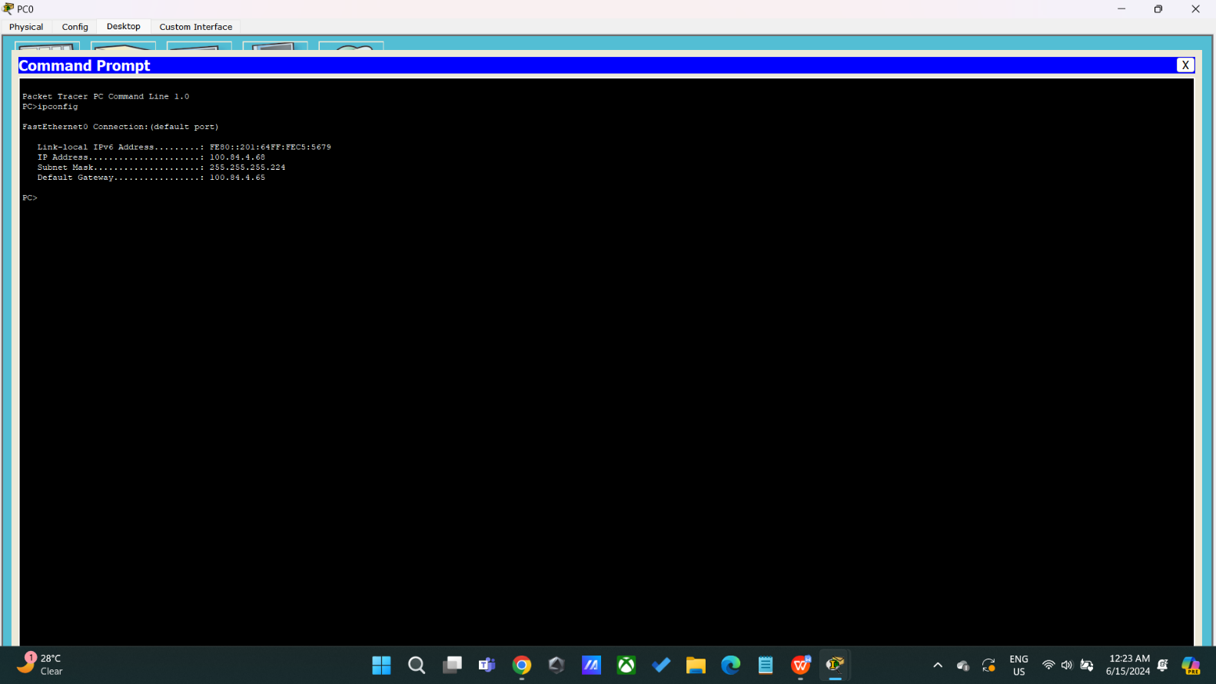**PC0**

As shown in the figure, all results for PC0 were **correct** and as expected:

* **IP address**: 100.84.4.68
* **Subnet Mask**: 255.255.255.224
* **Default gateway**: 100.84.4.65
* 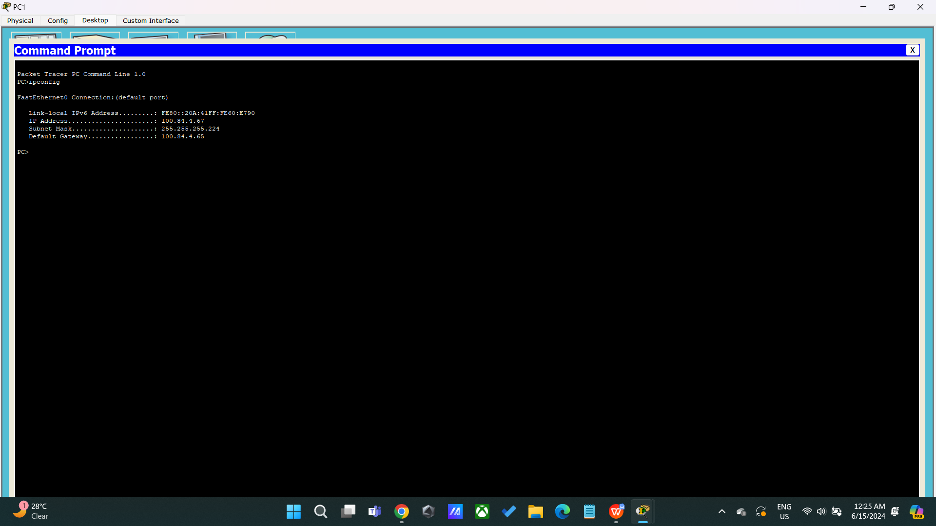**PC1**

*As shown in the figure, all results for PC*1 were***correct*** *and as expected:*

* ***IP address****: 100.84.4.*67
* ***Subnet Mask****: 255.255.255.224*
* ***Default gateway****: 100.84.4.65*
* 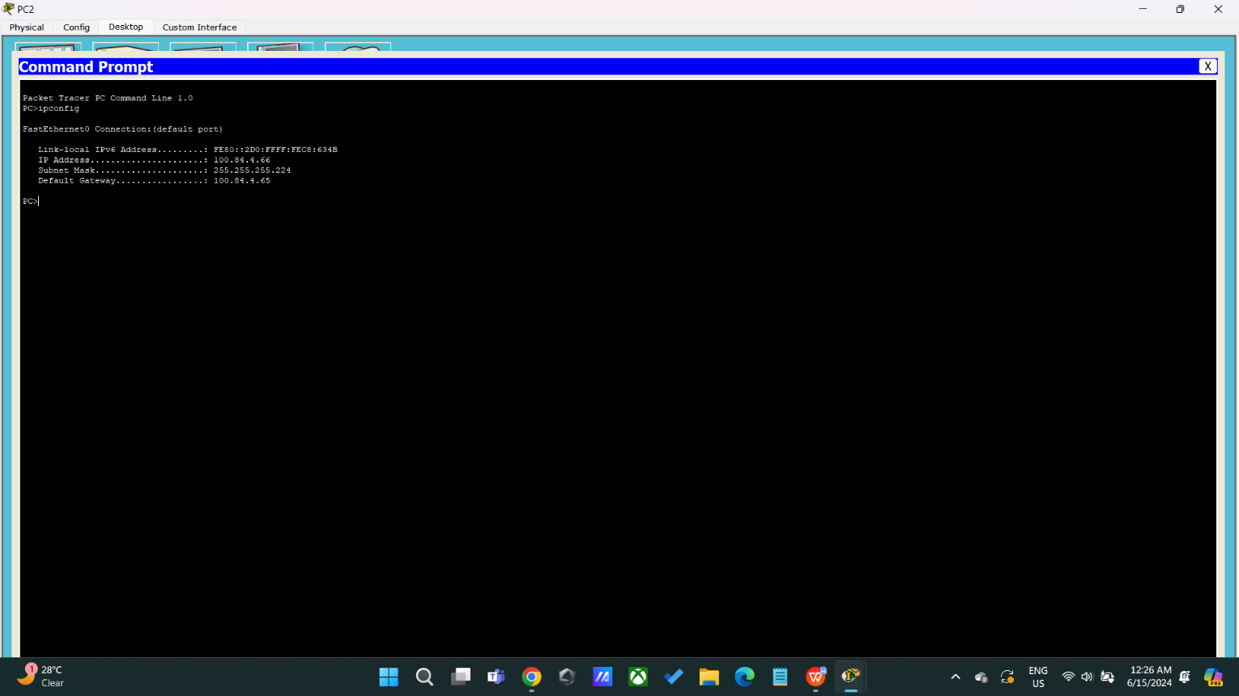**PC2**

*As shown in the figure, all results for PC*2 were***correct*** *and as expected:*

* ***IP address****: 100.84.4.*66
* ***Subnet Mask****: 255.255.255.224*
* ***Default gateway****: 100.84.4.65*
* **PC3**

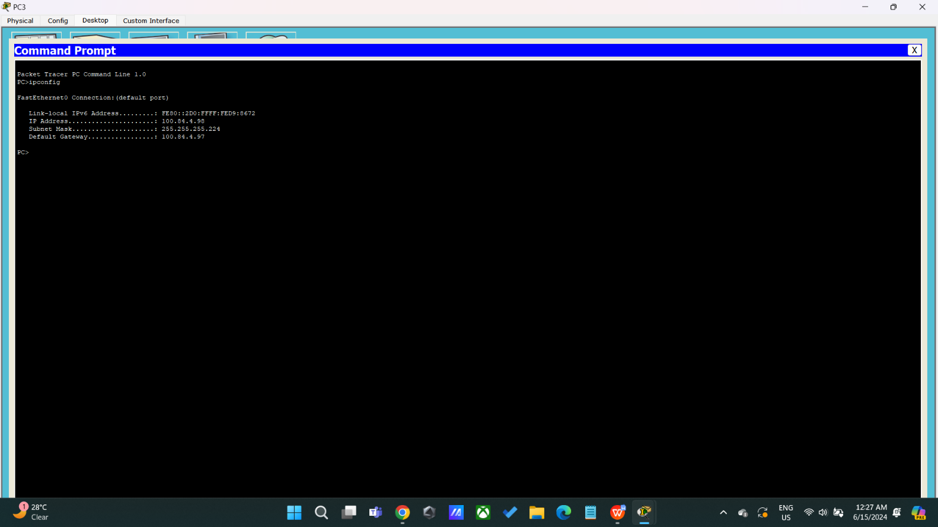

*As shown in the figure, all results for PC*3 were***correct*** *and as expected:*

* ***IP address****: 100.84.4.*98
* ***Subnet Mask****: 255.255.255.224*
* ***Default gateway****: 100.84.4.*97
* 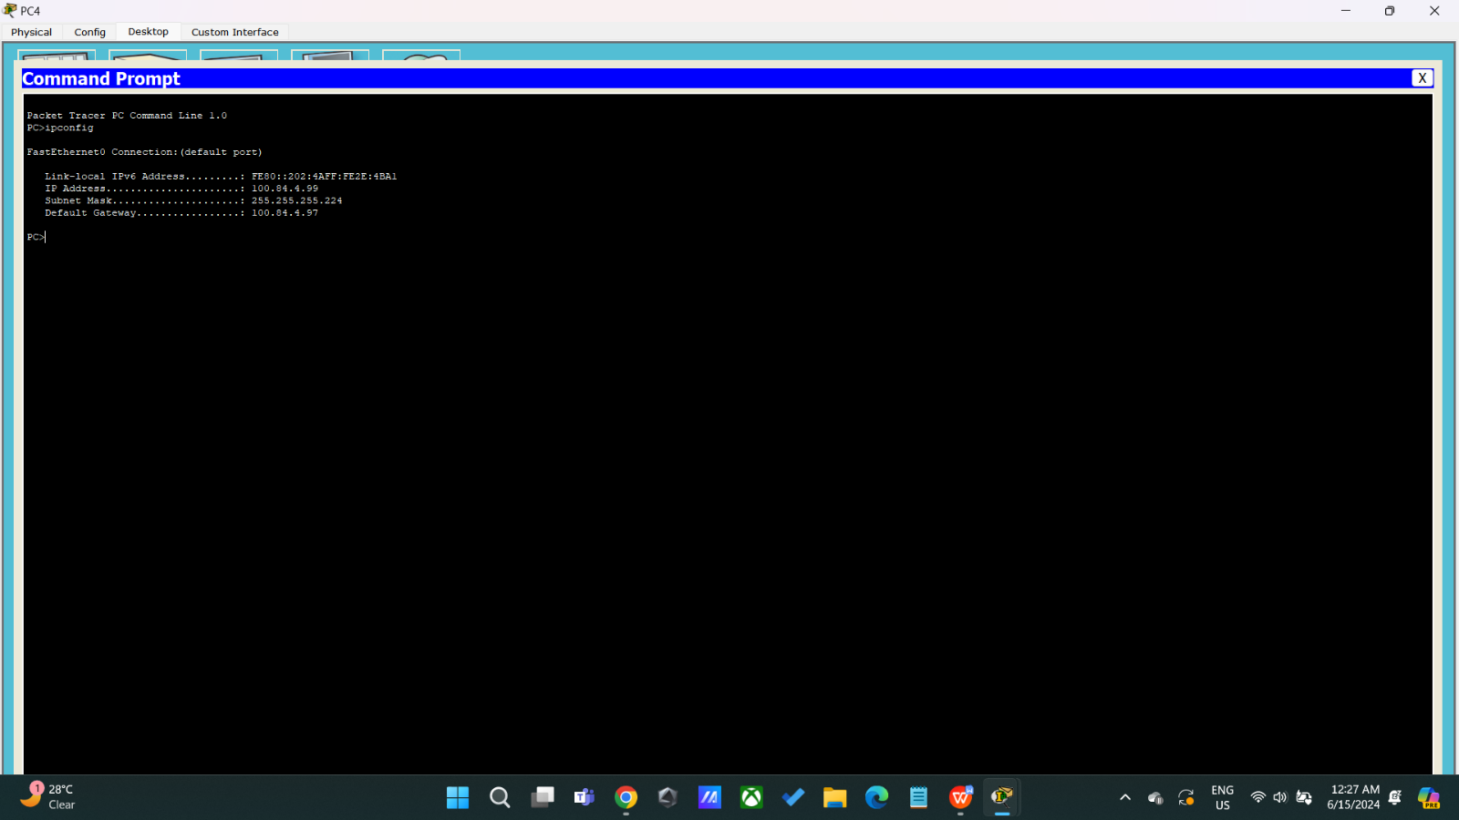**PC4**

*As shown in the figure, all results for PC*4 were***correct*** *and as expected:*

* ***IP address****: 100.84.4.*99
* ***Subnet Mask****: 255.255.255.224*
* ***Default gateway****: 100.84.4.*97
* 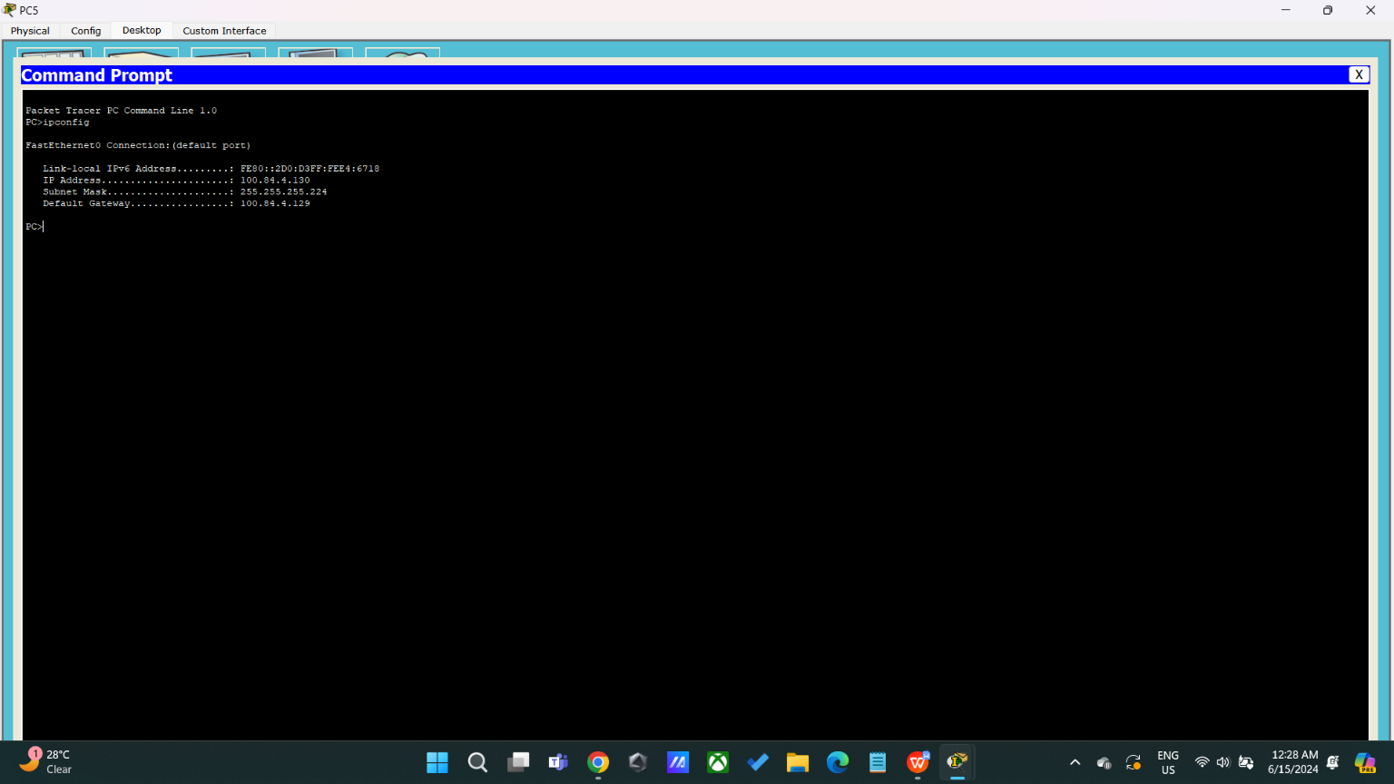**PC5**

*As shown in the figure, all results for PC*5 were***correct*** *and as expected:*

* ***IP address****: 100.84.4.*130
* ***Subnet Mask****: 255.255.255.224*
* ***Default gateway****: 100.84.4.*129
* 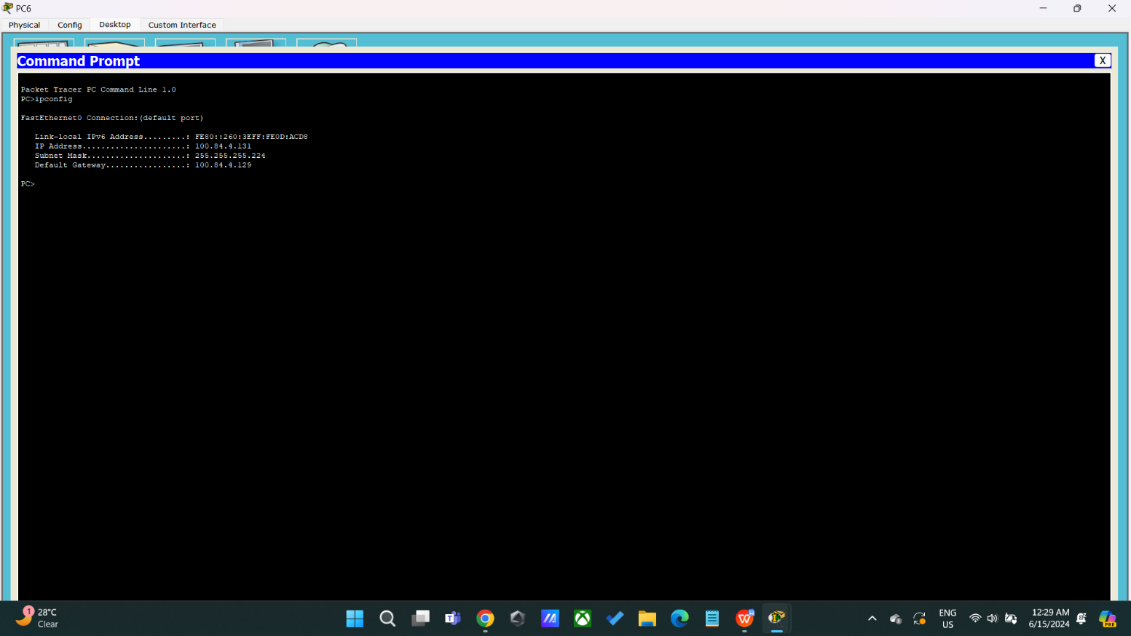**PC6**

*As shown in the figure, all results for PC*6 were***correct*** *and as expected:*

* ***IP address****: 100.84.4.*131
* ***Subnet Mask****: 255.255.255.224*
* ***Default gateway****: 100.84.4.*129
* 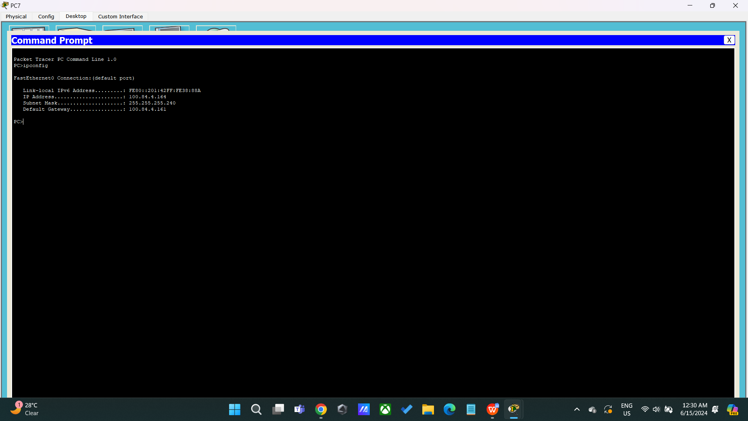**PC7**

*As shown in the figure, all results for PC*7 were***correct*** *and as expected:*

* ***IP address****: 100.84.4.*164
* ***Subnet Mask****: 255.255.255.*240
* ***Default gateway****: 100.84.4.*161
* **PC8**

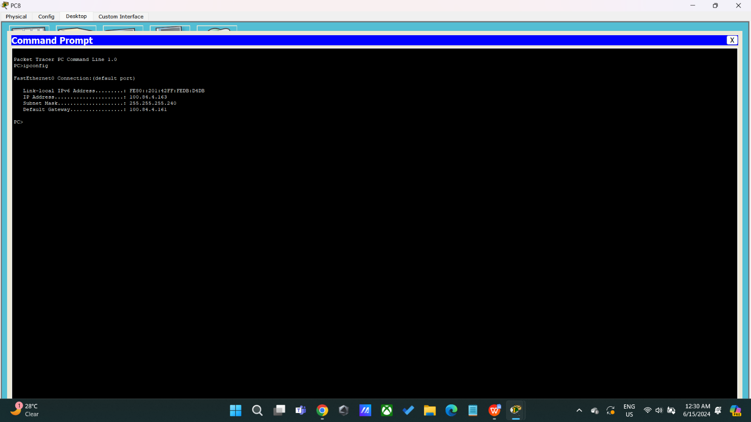

*As shown in the figure, all results for PC*8 were***correct*** *and as expected:*

* ***IP address****: 100.84.4.*163
* ***Subnet Mask****: 255.255.255.*240
* ***Default gateway****: 100.84.4.*161
* 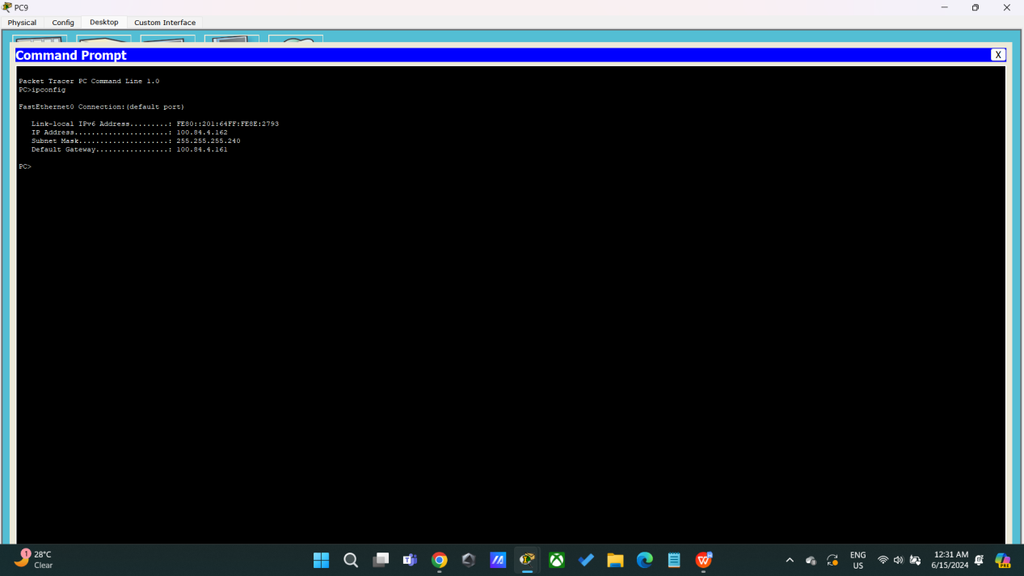**PC9**

*As shown in the figure, all results for PC*9 were***correct*** *and as expected:*

* ***IP address****: 100.84.4.*162
* ***Subnet Mask****: 255.255.255.*240
* ***Default gateway****: 100.84.4.*161

# Conclusion

In conclusion, this group project serves as a comprehensive exercise in applying networking principles using Packet Tracer. By utilizing a student ID to determine the IP addressing scheme, the project emphasizes the importance of IP subnetting in designing a scalable and efficient network. The inclusion of servers and end devices in various subnetworks enhances the complexity of the topology, requiring meticulous configuration and routing setup. The utilization of the OSPF routing protocol, with designated areas for different segments of the network, showcases a real-world scenario where routing algorithms play a crucial role in efficient data transmission. Configuring DNS and web servers adds a practical dimension by simulating services commonly found in enterprise networks. The testing phase, encompassing connectivity tests and website access, validates the network's effectiveness. Through this project, students gain hands-on experience in troubleshooting, testing, and documenting network configurations. Overall, the project not only reinforces theoretical knowledge but also equips students with practical skills vital for success in the dynamic and evolving field of computer networking. The collaborative nature of the group project encourages teamwork, enhancing communication and problem-solving abilities.